Program Name: | Natural Gas Cooling Replacement Program
Program Number: | SCG3538
Quarter: | Second Quarter 2008

- Program description

Gas cooling units are installed in homes and small businesses throughout the SCG service territory. These units are old and may fail soon, so customers are entering the market and may replace the units. The market share for gas cooling has been on the decline over the years due to a variety of factors including rising gas rates, lower costs for the electric alternative product, high equipment prices for the gas units, limited product choice (few manufacturers) poor market strategy by the upstream players, and lack of quality assurance for the product and lack of qualified installers. This program will work to ensure the replacement of these old existing units and transition to new high efficiency gas AC equipment instead of alternative technologies.

- Administrative activities (describe)

Received approval to increase eligible units to 100 tons.
- Marketing activities
- Discussions with Yazaki to obtain from them a list of existing customers to target communications
- Working with Thermax and Tecogen to attempt to identify possible existing customers to target
- Ongoing customer site qualifications to determine interest and feasibility of gas cooling replacements

- Direct Implementation: Submitted 2 Robur units for inspection

- Program performance/program status (describe)

Program is on target
Program is exceeding expectations
Program is falling short of expectations
Explanation:

There are two areas that currently are important components of assessing program expectations. The first is therm savings and the second is to begin building up the gas cooling market channel which has been in decline for the last 5 + years.

SCG3538 | 3P Gas Cooling Upgrade
Plan Total Therms | 761,139
Actual as 7/31/08 | 18,597

Therms saved in replacing old gas units for new ones are a result only after actions by customers, contractors /distributors and manufacturers promoting gas AC units and then, a customer’s choosing to purchase gas replacement units. The program is restricted in its market in that new construction opportunities are not available, only the replacement market is available.

In order to put the performance of both therm savings and the state of the gas replacement market channel in context it is important to consider the following:
- The market share for smaller tonnage (5 – 50 tons) gas cooling has been on the decline over the last 5 years
- Customers are concerned about rising/fluctuating gas rates
- The mainstream technology (electric air conditioning ) has much lower costs (3 -4 times less) for both equipment & installation prices for the gas units
- There are limited product choice (few manufacturers & distributors in SCG service territory)
- There has been a lack of qualified Gas AC installers– most focus on electric
- Historically there has been poor market strategy by the upstream players including a lack of quality assurance for the products and after market support
- An additional factor for gas cooling is the absence of robust utility incentive programs and gas AC rates as compared to the electric AC alternatives
- The significant benefit of Gas Cooling in reducing California peak electrical energy, its advantage over eclectic in TDV energy usage, T24 energy budget and source emissions has not been promoted

Summary Table: Combined SWOT and market opportunity/growth perspective

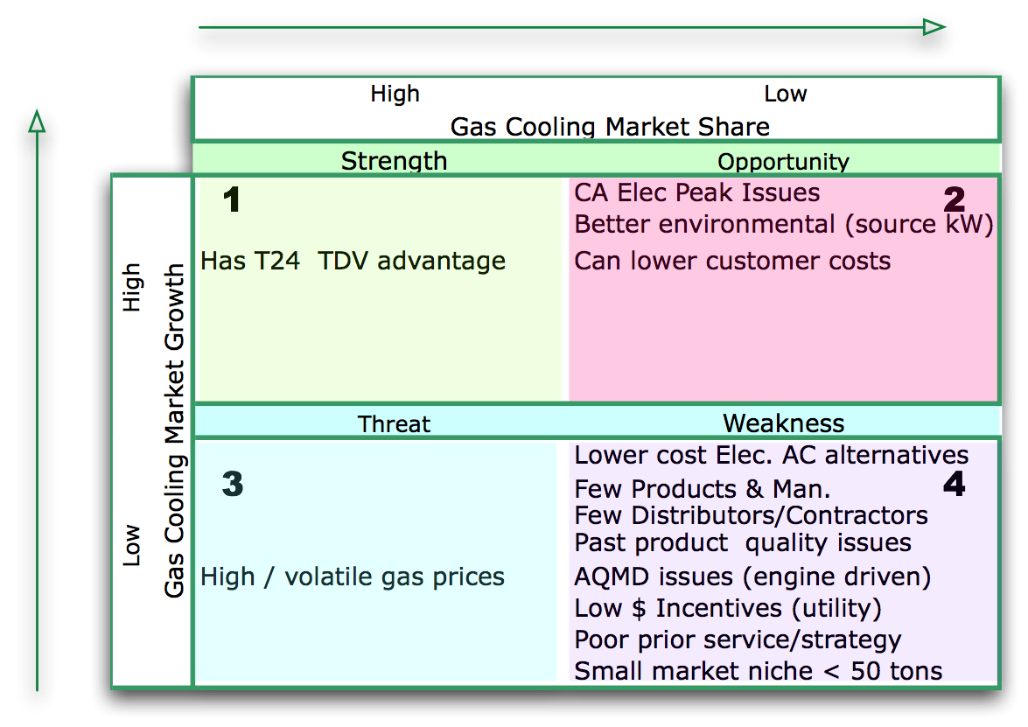

- On the horizontal axis: relative market share for AC - this serves as a measure of Gas Cooling strength in the market
- On the vertical axis: market growth - this provides a measure of market attractiveness
- The primary focus of the replacement program is to begin to address the weakness identified in item #4.

A key issue has been the limited availability of product for the under 50 ton size limit which up until April ’08 has been the size the program has been able to focus upon. For the vast majority of existing units there has been only 1 manufacturer. We had anticipated that a major distributor Summit Energy Efficiency Recourses would obtain the rights to distribute Robur, Broad, Aisen and their own product called GEDAC thereby expanding product choices. However they have not managed to gain those distribution rights and in the case of Aisen and GEDAC still are working on final UL, AQMD requirements and CEC approvals. It is anticipated that these may be obtained in fall of ’08 or early ’09.

The gas cooling customer and delivery channel was found to have significantly deteriorated in the past five years. Many gas cooling contractors had abandoned the gas cooling option and their customers have converted gas cooling units to an electric alternative. In one example a California Community College replaced all of their 5 ton gas units (over 80 units) to electric. In another case a Palm Desert customer decided to not go ahead with gas cooling even if the unit equipment cost was free. The install costs and lack net savings did not meet their hurdle rate.

There is a lack of an identified usable existing data base (valid customer names/addresses, tonnage installed, contractor, etc) of current gas air conditioning customers from either the utility, manufacturers or contractors. We mailed a program brochure / inquire to a list of 100 well-qualified customers who had verified existing old gas units. No customers responded. A related issue is the need to re-build the contractor’s confidence in selling gas units. They need to be able to obtain consistent revenue from sales and often the easiest path is to sell eclectic and even down play the value of gas and attempt to replace units that could be maintained. As mentioned over the last 5 years there have been a very significant portfolio of incentives for electric AC equipment which certainly has had an effect of diminishing the gas AC alternative.

The feedback we have received regarding the rebate is mixed. Although the market channel does welcome the effort and that there is finally a rebate, the amount of the rebate does not cover enough of the customer’s costs for replacement. Typically we are seeing the rebate cover from 3% to 5% of the replacement costs. The customers and contractors have indicated that this rebate amount does not prevent a customer from replacing their Gas AC unit with an electric AC unit or even upgrade a poorly functioning unit.

Example from unit replacement invoices:

Cost | Cost /Ton | Total Rebate | Rebate % of Cost
$16,250 | $3,250 | $500 | 3%
$77,787 | $2,593 | $2,000 | 3%
$7,180 | $1,436 | $375 | 5%
$37,700 | $2,513 | $1,875 | 5%
$130,800 | $2,616 | $5,000 | 4%

The program had suggested increasing the size of available units and consequently the available market size to customers with systems up to 100 tons in size. We had requested an increase to 200 tons in the summer ’07 because of the lack of available product in the market in the 5- 25 ton range. It was determined by the utility that a 200 ton limit was not acceptable but that an increase to 100 tons might be accepted.

Starting in late summer and through fall of ’07 and spring of ‘08 based on discussions and revised work papers we anticipated that 100 tons would be accepted once all final questions and clarifications of the revised 100 ton work paper were answered. Approval was completed in April ’08. We look forward to the increase in available unit size. This may help over program participation due to the increased availability of more product from more manufacturers.

Another gap in expectations has been the lack of product distribution and support from manufacturers and distributors for the 5 – 25 ton range. We had expected that 4 manufactures would be aggressive participators in the program. Currently there is only 1 manufacturer (Robur) participating but still not aggressively marketing their product. We assisted 3 manufacturers (Robur and Broad in 5 – 25ton and Yazaki for the up to 100 ton) in gaining CEC certification. The others (Aisen and GEDAC) will not be ready in the CA market according the planned distributor for the products until perhaps late ’08 or early ‘09. Currently there is no CA distributor for the 5- 25 ton Broad products.

- Program achievements (non-resource programs only):

N/A

- Changes in program emphasis, if any, from previous quarter (new program elements, less or more emphasis on a particular delivery strategy, program elements discontinued, measure discontinued, budget changes, etc.).

The small, (5 – 10 ton) market does not have enough product currently. Broad although CEC certified, does not have distribution in CA for the units currently approved in the program. We have worked with Yazaki to get them CEC certified but need final approval form SCG to go after customers up to 100 tons. Robur does not seem to be aggressively marketing in CA. Aisen is not CEC certified nor is the GEDAC unit based on their technology. Both had been anticipated early in ’07 but now the target is late ’08 or ’09.

- Discussion of near-term plans for program over the coming months (e.g., marketing and outreach efforts that are expected to significantly increase program participation, etc.)

It was determined that the gas rebate program would not be approved up to 200 tons. However, up to 100 tons has been approved. This would expand the market for potential replacements. Again, there is 1 manufacture currently available to the program – Robur. By expanding and adding Yazaki, Thermax, Tecogen and the Broad units that do have distribution we could increase penetration.

- Changes to staffing and staff responsibilities, if any

None

- Changes to contracts, if any

- Changes to contractors and contractor responsibilities, if any
None

- Number of customer complaints received
None

- Revisions to program theory and logic model, if any

None

Basic: Replace old natural gas air conditioning (AC) units and transition to new high efficiency gas AC equipment within Company’s service territory.

For example, PGE, SCE and SDG&E have had HVAC equipment upgrade & maintenance programs for electric AC residential and small commercial customers worth hundreds of million dollars over the last 5 years.
SWOT is an abbreviation for Strengths, Weaknesses, Opportunities and Threats

