QUESTION PZS3-1:

On page 6 at Lines 8-10, SoCalGas states “In late 1992, in D.92-12-058, the Commission adopted an LRMC methodology for the three gas utilities – Pacific Gas & Electric Company (PG&E), SoCalGas, and SDG&E. All gas utilities were required to adopt the LRMC methodology for implementation by early 1993.” In that decision, the Commission states that “It is not enough for a utility to use just any combination of resources to meet the needs of customers. An appropriately planned system meets customers’ needs at the lowest total cost.” (FOF#2) On page 9, at Lines 2-3, testimony states “SoCalGas and SDG&E are proposing that the embedded cost method be used for allocating all base margin costs to customers.” Please explain how the utilities’ proposed change to embedded cost method from the mandatory LRMC methodology would ensure that the utility would meet its customers’ needs at the lowest total cost as the Commission expressed in D.92-12-058.

RESPONSE PZS3-1:

The total costs allocated using embedded costs vs. LRMC are the same because under both cost allocation methodologies the utility is authorized to recover the same revenue requirement. That said, if an economically efficient LRMC-based cost allocation methodology based on cost causality were used to allocate costs among customer classes, then the different customer classes would receive the proper price signals to use gas service efficiently. The utility could then design its system more optimally and thereby reduce total utility costs which would then translate into lower costs and rates to customers overall. However, since the Commission decided to use a hybrid LRMC, embedded cost, and social ratemaking methodology to allocate cost among customer classes, using embedded cost would be the next best alternative cost allocation methodology to optimize the utilities total cost and therefore also reduce customers’ rates over time. LRMC resource planning has rarely if ever resulted in actual facility improvement on the SoCalGas and SDG&E gas systems. In actual practice, system improvements have been driven by market demand. SoCalGas and SDG&E have always striven to minimize costs as the gas systems have been improved to meet changing market conditions, and this practice will not change with the adoption of ECM.
QUESTION PZS3-2:

In D.92-12-058, the Commission states “It is our belief that accurate marginal cost methods will lead to clearer signals when marginal cost-based prices are implemented, thereby providing the opportunity for customers to purchase economically efficient levels of service.” (p.16 of D.92-12-058). On page 11, at Lines 11-12, SoCalGas states “SoCalGas’ embedded cost allocation studies are based on recorded historical costs from calendar year 2006. Therefore, they exactly reflect the actual historical costs for this time period.” Please explain how the use of the utility’s recorded (or actual historical) costs in the embedded cost method can provide customers with clearer price signals to help them purchase economically efficient levels of service.

RESPONSE PZS3-2:

Using recorded embedded costs to design rates for customer classes exactly reflects the cost to provide that service during 2006. That is a good benchmark of costs for the 2009-2011 BCAP period. SoCalGas/SDG&E do not expect total cost by customer class to vary significantly from the 2006 base year and therefore using 2006 actual costs as a benchmark to allocate costs in the 2009-2011 BCAP period is preferable to the current LRMC methodology. Since embedded costs are equal to average cost in any given year, and since LRMC are equal to average cost in an equilibrium condition, SoCalGas/SDG&E believe embedded costs provide clearer price signals to customers compared to using the Commission-adopted LRMC cost allocation methodology. Total costs and rates will rise year-to-year based on increases in base margin authorized by the Commission in the SoCalGas/SDG&E General Rate Case minus any PBR savings shared with customers.
QUESTION PZS3-3:

On page 11 at Line 21, SoCalGas states “Validation is therefore much simpler using recorded embedded costs.” Further, on pp.21-22 starting at Line 19, SoCalGas provides a summary of the basis for allocating each major cost element as follows:
Customer-Related O&M Expenses
- Distribution Operations Customer Services – number of dispatched field service orders;
- Distribution Operations Meter & House Regulators – unit meter cost times the number of meters by size;
- Distribution Operations Service Lines – service line footage by class;
- Customer Accounts – special study of the activities within this area by class.
Customer-Related Capital Costs
- Distribution Land, Structures & Improvements – distribution O&M expenses by class;
- Services – special study of investment by type, size, and footage by class;
- Meters and Customer Installations – special study of investment by type and size by class;
- GEMS – special study of the number and cost of GEMS equipment by class;
- Regulators – special study of types of regulators and their associated meter sizes;
- Gauges – number of above-standard pressure meters by class.
Distribution-Related Costs
- High Pressure – cold-year coincident peak month demand by class;
- Medium Pressure – cold-year peak day demand by class.
Backbone Transmission-Related Costs – Cold-year annual throughput by class.
Local Transmission-Related Costs – Cold-year peak month demand by class.
Customer Information & Service Expenses – Special study of the activities within this area by class.
- Please briefly describe the decision criteria involved in selecting the allocators that served as the basis for allocating each major cost element as listed above, that is, how you decided on the allocators listed above especially for those that involved special studies.
- Besides those listed above, were there any other allocators considered that SoCalGas may have ultimately decided against using? If so, can you briefly describe those and why you decided against them.
- Please identify the entity or entities that performed the special studies as listed above and indicate the dates (month/year) when those studies were actually done for SoCalGas.

- What kind of historical information did SoCalGas review in determining each of the allocators that would be the basis for allocating each major cost element?
- Please cite the specific reference to the SoCalGas workpapers that validate the use of the above allocators as the basis for allocating each major cost element.

RESPONSE PZS3-3:

(a) Please briefly describe the decision criteria involved in selecting the allocators that served as the basis for allocating each major cost element as listed above, that is, how you decided on the allocators listed above especially for those that involved special studies.

The allocators are based on the best fit of cost causality to provide service to the different customer classes.

- Besides those listed above, were there any other allocators considered that SoCalGas may have ultimately decided against using? If so, can you briefly describe those and why you decided against them.

The only “other” allocator that was discussed was the use of cold year throughput to allocate all transmission costs vs. separating transmission costs into backbone and local transmission service and using different allocators for each. Since the Commission adopted peak month as the local transmission service allocator for PG&E and since SoCalGas has separated the use of its transmission system into backbone and local transmission service, SoCalGas decided to follow the Commission-adopted cost allocation methodology and allocate local transmission service on a peak month rather than a cold year throughput basis. Please refer to the testimonies of Mr. Schwecke and Mr. Bisi concerning the use of the transmission system for backbone and local transmission service and the rational for determining the capacities for backbone and local transmission service.

- Please identify the entity or entities that performed the special studies as listed above and indicate the dates (month/year) when those studies were actually done for SoCalGas.

The following are the departments in the company that provided the data. The time period is generally indicated as between June 2007 to December 2007.

Customer-Related O&M Expenses
- Distribution Operations Customer Services – number of dispatched field service orders;

Business Planning and Budgeting Department and Customer Services Department – June through November 2007

- Distribution Operations Meter & House Regulators – unit meter cost times the number of meters by size;
Gas Engineering Department - June through November 2007

- Distribution Operations Service Lines – service line footage by class;

Plant Accounting Department - June through November 2007

- Customer Accounts – special study of the activities within this area by class.

Business Planning and Budgeting Department and Customer Accounts Department – June through November 2007

Customer-Related Capital Costs
- Distribution Land, Structures & Improvements – distribution O&M expenses by class;
Plant Accounting Department – June through November 2007
- Services – special study of investment by type, size, and footage by class;

Plant Accounting Department – June through November 2007

- Meters and Customer Installations – special study of investment by type and size by class;
Plant Accounting Department – June through November 2007

- GEMS – special study of the number and cost of GEMS equipment by class;
Plant Accounting Department – June through November 2007

- Regulators – special study of types of regulators and their associated meter sizes;
Plant Accounting Department – June through November 2007

- Gauges – number of above-standard pressure meters by class.
Plant Accounting Department – June through November 2007

Distribution-Related Costs
- High Pressure – cold-year coincident peak month demand by class;
Customer Services and Information Staff using billing data – June through November 2007

- Medium Pressure – cold-year peak day demand by class
Customer Services and Information Staff using billing data – June through December 2007

Backbone Transmission-Related Costs – Cold-year annual throughput by class.

Customer Services and Information Staff using billing data – June through December 2007

Local Transmission-Related Costs – Cold-year peak month demand by class.

Customer Services and Information Staff using billing data – June through December 2007

Customer Information & Service Expenses – Special study of the activities within this area by class.
Business Planning and Budgeting Department – June through November 2007

- What kind of historical information did SoCalGas review in determining each of the allocators that would be the basis for allocating each major cost element?

Year 2006 data was used.

- Please cite the specific reference to the SoCalGas workpapers that validate the use of the above allocators as the basis for allocating each major cost element.
The references are in the Embedded Cost Allocation model provided as part of the Work Papers. There is no other validation.

QUESTION PZS3-4:

On page 25 at Lines 2-8, SoCalGas provides a general description of the calculation of its base margin for 2008.

- Please provide a description on a step by step basis of how SoCalGas calculated its base margin for 2008.
- Further, please provide the detailed base margin calculation in excel that will allow DRA to verify that the calculation is based on the formula adopted in D.05-02-023. If this kind of verification was included in the SoCalGas workpapers, please cite the specific reference so that we can locate it. Please identify any assumptions used in the calculation.

RESPONSE PZS3-4:

- Please see Mr. Lenart’s work papers page 21 of 153.
- The spreadsheet is attached below.

QUESTION PZS3-5:

On page 25 at Lines 26-28 through page 26 Lines 1-2, SoCalGas states, “The components of SoCalGas’ rate base by plant category was calculated by the Plant Accounting department as follows: intangible plant in service of $0.329 million was recorded in FERC accounts 301 and 302; underground storage plant was recorded in FERC accounts 350 through 363 and totaled $139 million; transmission plant was recorded in FERC accounts 365 through 371 and totaled $325 million distribution plant was recorded in FERC accounts 374 through 387 and totaled $1,868 million; general plant was recorded in FERC accounts 389 through 399 and totaled $144 million.” Table 4 on page 27 shows the corresponding net plant by functional category.

- Please verify whether FERC Accounts 359 through 363 were included in the $139 million total. Table 4 does not seem to show them.
- Please verify whether FERC Account 372 is included in any of the plant categories.
- Please verify whether FERC Account 388 is included in either the $1,868 million total or in the $144 million total.

RESPONSE PZS3-5:

- FERC Accounts 359 through 363 were not included in the $139 total because there is no plant recorded in these FERC Accounts. Please see the 2006 FERC Form 2 page 206. FERC Account 358 costs are also not included because these are asset retirement costs that are not part of Rate Base. Only the components of capital actually invested are part of Rate Base and therefore asset retirement costs are not part of the costs that ratepayers pay.
- FERC Account 372 Asset Retirement Costs are not included because these asset retirement costs are not part of Rate Base. Only the components of capital actually invested are part of Rate Base and therefore asset retirement costs are not part of the costs that ratepayers pay.
- FERC Account 388 Distribution Retirement Costs are not included because these asset retirement costs are not part of Rate Base. Only the components of capital actually invested are part of Rate Base and therefore asset retirement costs are not part of the costs that ratepayers pay.
QUESTION PZS3-6:

Table 8 on page 32 shows the calculation of income taxes to be collected in rates (including state and federal income taxes). Please provide the excel spreadsheet that shows the details of the calculation and verify how the values shown in Table 8 were arrived at by SoCalGas. If this is included in the SoCalGas workpapers please cite specific reference so we can locate them. Please include any assumptions made.

RESPONSE PZS3-6:

Please see Emmrich EC WP 48 Final. The calculation was prepared by the Tax Department.
QUESTION PZS3-7:

On page 33 at Lines 2-6, SoCalGas states, “In 2006, Gas Operations and Maintenance Expenses, including payroll taxes, totaling $924 million were recorded in FERC accounts 814 through 935 and Payroll taxes in FERC Form 2 p. 355. These expenses cover costs related to: Underground Storage; Transmission; Distribution; Customer Accounts; Customer Services and Information; and, Administrative and General Expenses.” The breakdown of the $924 million by functional category is shown in Table 10 on page 34.

- Please provide a similar breakdown to those shown in Table 10 that excludes the amount of the payroll taxes that were included in the total of $924 million.
- How much payroll taxes were included in the total?
- Please explain how the amount of payroll taxes in your response to (b) were allocated to the different categories of gas O&M expenses.

RESPONSE PZS3-7:

- The breakdown of costs excluding payroll taxes is shown in WP-1, the EC Model, in the “Base Margin & Allocation” tab in column E. The payroll taxes are shown in column G, “Other Adjustments”.
- Payroll taxes totaled $36.785 million as shown in FERC Form 2 page 263a.
- Payroll taxes were allocated based on the percentage of the distribution of wages and salaries shown in FERC Form 2 page 355 by service function as shown in the “Return” tab of the EC Model and the table below.
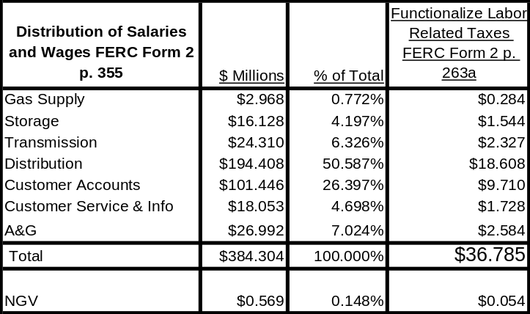

QUESTION PZS3-8:

On page 34, at Lines 11-13, SoCalGas states, “Distribution O&M Expenses included in FERC Accounts 870 through 894 including payroll taxes totaled $293 million in 2006. This total excluded $15 million of Hazardous Waste expenses, since these costs are not included in base margin.”

- Please provide the total amount of distribution O&M expenses included in FERC Accounts 870 through 894 that excludes any payroll taxes.
Information from FERC Form 2 submitted by SoCalGas to the CPUC for year-end 2006 indicates the amount of $289 million total for accounts 870 through 894. Please explain what could account for the difference of $4 million.
- Could the difference of $4 million ($293 minus $289) represent the payroll taxes included in distribution O&M expenses? If so, please explain how the amount of $4 million in payroll taxes were allocated to the distribution O&M expenses.

RESPONSE PZS3-8:

  - The breakdown of costs excluding payroll taxes is shown in WP-1, the EC Model, in the “Base Margin & Allocation” tab in column E. The payroll taxes are shown in column G, “Other Adjustments”.
  - Please see Column F and Column E of the “Base Margin & Allocation” Tab. Payroll taxes of $18.6 million are shown in cell G50 and a negative $16.467 million of Hazardous Waste costs are shown in F55. Hazardous waste expenses are not part of base margin and therefore had to be excluded from cost allocation. The net effect of these two adjustments is about $3.1 million. See Table in Response to PZS3-7 for allocation of payroll taxes.
QUESTION PZS3-9:

Table 12 on page 36 shows the functionalization of transmission O&M expenses in the total amount of $50 million, including payroll taxes. The information shown in FERC Form 2 at page 323 indicates the total amount of about $60 million for those same accounts.

- Please explain why there appears to be a discrepancy between the values in Table 12 and those in the FERC Form 2.
- Do the values in FERC Form 2 include payroll taxes and the $12.2 million in Transmission compressor station fuel which you describe on page 35? If so, please provide Table 12 with 2 additional columns, one indicating the amounts from FERC Form 2, and the second, showing the exclusions from those shown in FERC Form 2 that result in the amount of $50 million.

RESPONSE PZS3-9:

(a) and (b) Please see Column F and Column E of the EC Model “Base Margin & Allocation” Tab. Payroll taxes of $2.3 million are included in cell G32. In addition a negative $12.2 million of Transmission Compressor fuel is excluded from base margin as shown in cell F14 and $.711 million of Hazardous Waste costs are excluded from base margin costs as shown in cell F40. The net effect of these adjustments is about a $10.6 million reduction in base margin storage O&M costs. See Table in Response to PZS3-7 for allocation of payroll taxes.

QUESTION PZS3-10:

Table 13 on page 37 shows the functionalization of storage O&M expenses in the total amount of $35 million, including payroll taxes. Table 13 indicates storage O&M expenses are included in FERC Accounts 814 through 837. The information shown in FERC Form 2 at pages 320-321 indicates the total amount of about $51 million for those same accounts.

- Please explain why there appears to be a discrepancy between the values in Table 13 and those shown in FERC Form 2.
- Do the values in FERC Form 2 include those expenses specifically excluded from Table 13 that you discuss on page 36 such as the $13.4 million in Storage compressor stations fuel, since these costs are recovered in a Storage in-kind fuel charge under the Omnibus proposal and $0.419 million of gas losses costs that are allocated outside of base margin? If so, please provide Table 13 with 2 additional columns, one indicating the amounts from FERC Form 2, and the second, showing all the exclusions from those shown in FERC Form 2 that result in the amount of $35 million.

RESPONSE PZS3-10:

(a) and (b) Please see Column F and Column E of the EC Model “Base Margin & Allocation” Tab. Payroll taxes of $1.5 million are included in cell G9 and $4.256 million of Montebello storage O&M costs are excluded because there is a separate accounting for Montebello storage costs based on the decision to shut the field down and to withdraw the cushion gas per Decision 01-06-081. In addition, a negative $13.4 million of Storage Compressor fuel is excluded from base margin as shown in cell F14 and $.419 million of gas losses are excluded from base margin costs as shown in cell E17. The net effect of these adjustments is about a $16.5 million reduction in base margin storage O&M costs. See Table in Response to PZS3-7 for allocation of payroll taxes.
QUESTION PZS3-11:

Table 14 on page 37 shows the functionalization of customer accounts O&M expenses that are booked in FERC Accounts 901 through 905. The net costs shown in Table 14 that were included in the embedded cost allocation is in the amount of $184.331 million. Does the net amount include any payroll taxes? If so, please indicate the amount of payroll taxes included.

RESPONSE PZS3-11:

(a) Please see Column F and Column E of the EC Model “Base Margin & Allocation” Tab. Payroll taxes of $9.7 million are included in cell G67 and $2.294 million of CARE costs are excluded as shown in cell F67 and $8.629 in cell F70 because CARE costs are not part of base margin. The net effect of these adjustments is about a $1.213 million reduction in base margin Customer Accounts O&M costs. See Table in Response to PZS3-7 for allocation of payroll taxes.

QUESTION PZS3-12:

Table 16 on page 39 shows the non-DSM customer services and information costs allocated by customer class in the total amount of $24.7 million. SoCalGas states that these expenses are recorded in FERC Accounts 907 through 910. The information shown in FERC Form 2 on page 325 for those same accounts indicates the total amount of about $80 million.

- Please explain why there would appear to be such a discrepancy between the values shown in Table 16 and those in the FERC Form 2.
- Do the values in FERC Form 2 include those costs for energy efficiency that were specifically excluded from the ECS? If so, please provide Table 16 with 2 additional columns, one indicating the amounts from FERC Form 2, and the second, showing all of the exclusions from those shown in FERC Form 2 that result in the amount of $24.7 million.
- Please explain whether energy efficiency costs were also recorded in FERC Accounts 907 through 910. If so, how did SoCalGas verify that the amount of $24.7 million pertain solely to non-DSM costs?
- How can DRA independently verify the amount of the non-DSM costs?
- Please explain whether costs are separately recorded in sub-accounts for energy efficiency and non-DSM customer services and information costs.
- Does the amount of $24.7 million include any payroll taxes? If so, please indicate the amount of payroll taxes.
- Please identify the allocator/s that served as the basis for allocating the cost elements shown in Table 16.

RESPONSE PZS3-12:

(a) (b) (c) (f) Please see Column F and Column E of the EC Model “Base Margin & Allocation” Tab. Payroll taxes of $1.7 million are included in cell G75 and $57.197 million of DAP and Energy Efficiency costs are excluded as shown in cell F67 based on the cost analysis shown in WP-13 and $0.038 million in cell F78 because DAP and EE costs are not part of base margin. The net effect of these adjustments is a $55.5 million reduction in base margin Customer Services and Information cost. See Table in Response to PZS3-7 for allocation of payroll taxes.

(d) The DAP and Energy Efficiency costs are provided to the Commission in a filing each year.
(e) EC WP-13, 14, 15 and 16 provide additional detailed information by cost center.

(g) The allocators are shown in the EC Model in the “NonDSM CSI Allocators” tab.

QUESTION PZS3-13:

Table 17 on page 40 shows A&G classification and allocation in the total amount of $270.028 million. A&G expenses are recorded in FERC Accounts 920 through 932. SoCalGas states that recorded A&G expenses plus A&G-related payroll taxes totaled $329 million in 2006. Those A&G expenses are shown in Table 18. Information from FERC Form 2 at p.325 for these accounts indicate the total amount of about $385 million.

- Please explain why there may be such discrepancies among those shown in Table 17, the recorded A&G expenses according to SoCalGas in Table 18, and those shown in FERC Form 2 for the same FERC Accounts 920 through 932.
- Please provide another table that clearly shows the Table 17 expenses that amount to $270 million, with additional columns that show how the $329 million in Table 18 and the $385 million in FERC Form 2 come about from the same accounts.
- Please identify the allocation factors shown in Table 17 and explain how you arrived at those allocation factors.
- Please cite reference to SoCalGas workpapers that support these allocation factors.

RESPONSE PZS3-13:

  - (b) Please see Column F and Column E of the EC Model “Base Margin & Allocation” Tab. Payroll taxes of $2.544 million are included in cell G82 and $58.784 million of Franchise Fee costs are excluded as shown in cell F103 because Franchise Fee costs are calculated separately from rates as a volumetric add on to rates. The net effect of these adjustments is about a $56.2 million reduction which is then accounted for in the “cost Allocation” tab. The Franchise and Uncollectible fees are accounted for in the EC Model “Cost Allocation” tab in Row 45. See the Table in Response to PZS3-7 for the allocation of payroll taxes.
(c) and (d) The derivation of the A&G allocation factors is shown in the EC
Model “A&E Func Factrs” tab.

QUESTION PZS3-14:

Table 18 on page 41 shows total A&G expenses of $329 million.

- Please confirm whether the amount of $329 million in Table 18 or the amount of $270 million in Table 17 is the appropriate relevant amount that was used for purposes of the SoCalGas base margin allocation. Please explain your response.
- Table 18 shows also that the bulk of the $329 million of A&G expenses are classified as customer-related (i.e., $210 million out of $329 million). Please identify the A&G FERC Accounts that comprise the $210 million that were considered customer-related. Please explain in detail why this classification of the A&G expenses should be considered appropriate.

RESPONSE PZS3-14:

  - The correct amount is $270 million because the Franchise Fees are excluded at this point of the cost allocation process as discussed in response PZS3-13.
  - The derivation of the A&G allocation factors as well as the cost allocation into customer related costs is shown in the EC Model “A&E Func Factrs” tab. The spread of A&G costs by FERC Account to Customer and demand-related costs is shown in the “Base Margin and Allocation” tab of the EC Model as shown below. Most of the A&G allocation is based on the Multi Factor method that gives equal weight to O&M expenses, Net plant in Service, and Labor expenses. Account 924 – Property Insurance is allocated based on the Plant factor because it is directly related to plant expenses and Accounts 931 –Rents, and 932 Maintenance General Plant, are allocated based on the Labor factor because these costs are related to the number of employees working in each functional area. All other A&G FERC accounts are allocated based on the Multi Factor because these costs are general in nature and are therefore spread among all functional categories. Based on these allocation factors, most A&G costs are related to customers; such as, Customer Accounts costs; plant in service; such as, house lines, meters, regulators and MSA costs; distribution maintenance for house lines, meters and regulators and Customer Services and Information costs.
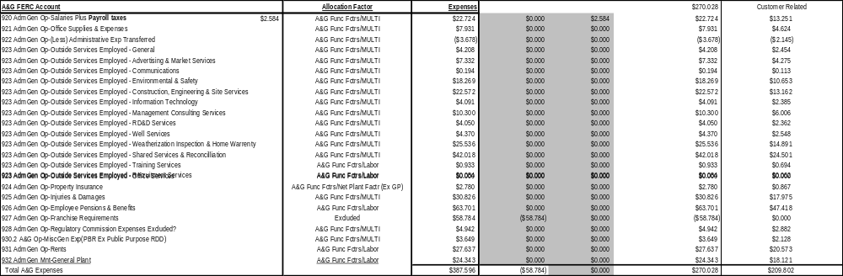
QUESTION PZS3-15:

Table 19 on page 42 shows labor expenses classification for purposes of payroll tax functionalization. SoCalGas states that FERC Account 408 shows recorded payroll taxes of $36.8 million in 2006. Please cite the reference page in FERC Form 2 where this amount of recorded payroll taxes can be verified. Gas supply salaries appear to be included in Table 19. Please explain why gas supply should be included in the labor expense classification.

RESPONSE PZS3-15:

Labor-related Taxes are shown in FERC Form 2 p. 263a. Gas Supply-related salaries and associated taxes were calculated in order to exclude them from cost allocation.

QUESTION PZS3-16:

On page 42 at Lines 21-22, SoCalGas states that “Distribution plant is recorded in FERC Accounts 374 through 387 and totaled $1,867 million in Rate base in 2006 as shown in Table 4 above.” Table 4 shows that Account 388 is also part of the distribution plant. Please confirm whether this is correct. Please explain how the weighted average rate base as of 12/31/06 for the distribution plant in the amount of $1,867 million was calculated.

RESPONSE PZS3-16:

FERC Account 388 Asset Retirement Costs are not included in the cost allocation process because they are not part of Rate Base. The calculation of Rate Base was made by Plant Accounting using standard CPUC-approved Rate Base calculations taking into account Rate Base reductions from plant in service such as deferred taxes, accumulated depreciation reserves, customer advances and gain on sale revenues and other various reductions. These calculations are shown in Table 6 of Mr. Emmrich’s direct testimony.
QUESTION PZS3-17:

Table 20 on page 43 shows the classification of distribution plant expenses into customer-related ($242 million), high pressure-related (27.6 million) and medium pressure-related ($173 million). Please identify all the allocators used by SoCalGas to classify these distribution expenses as such. Please explain why distribution plant expenses are mainly customer-related rather than demand-related costs. Please provide the excel spreadsheets and workpapers that verify the classification shown in Table 20. If previously included in SoCalGas workpapers provided to DRA, please cite reference.

RESPONSE PZS3-17:

Please see the “Net Plant Factor” tab in the EC Model. There are $871 million (cell F56) or 42% in customer-related distribution plant expenses and $1,051 million in demand-related costs or 58%. Customer-related expenses are mainly services, meters and regulators while demand-related expenses are mainly medium and high pressure distribution mains. That allocation is directly related to the cost to provide customer- or demand-related services.
QUESTION PZS3-18:

Table 21 on page 43 shows the details of the allocation of distribution depreciation expense into the customer-related classification by account. Please cite reference to FERC Form 2 where the amounts listed in the 3rd column in Table 21 in the total amount of $170.6 million can be verified.

RESPONSE PZS3-18:

The Distribution depreciation expenses were provided by Plant Accounting as shown in WP-31. These are the final numbers for 2006 that tie directly into the calculation of rate base by functional category. There is a reference to FERC Form 2 page 219 for total depreciation taken during 2006 at $266.4 million and on page 336 showing the breakdown of the depreciation costs by functional category. As the data on FERC Form 2 page 336 shows, Distribution Plant depreciation costs totaled $169.639 million while in Table 21 Distribution depreciation is shown to total $170.60 million. Please note that in Table 21 FERC Account 387.2-NGV Fueling Stations depreciation of $0.96 million is noted as “excluded” and therefore $170.6 million minus $0.96 million of NGV Fueling Stations depreciation equals the FERC Form 2 total of $169.6 million. The NGV depreciation is treated separately from distribution costs because it is being treated as a normal rate class in this BCAP while previously NGV rates were calculated below the line.
QUESTION PZS3-19:

Tables 22 and 23, on pages 44-45, show footage breakdown of service lines and distribution mains as of 1/1/2002. Please explain why SoCalGas selected to use the data as of the beginning of 2002. Has the current footage of service lines and distribution mains remained fairly the same as those in 2002? Has there been any change in rules regarding service line lengths or distribution mains since 2002 that may result in a different percentage than those in shown in these tables? If more updated information is available, please provide them.

RESPONSE PZS3-19:

The footage breakdown is the latest available data. In order to make this calculation, months of work using paper maps was required to calculate the footage in 2002. Since SoCalGas has over 30,000 miles of distribution pipe and a customer growth rate of only about 1% annually, this data is still reasonable for allocation purposes. Therefore, the footage percent (%) allocation between distribution mains and services has not changed significantly since 2002.
QUESTION PZS3-20:

On page 46 at Lines 8-11, SoCalGas states “In the ECS, gauge-related costs, based on a $21.53 million net book value, were allocated to customer classes based on the number of meters above standard pressure. The number of above standard pressure meters, by customer class, are shown in Table 24 below.” Please cite reference to FERC Form 2 where the stated amount of $21.53 million can be verified from the recorded amounts. Please describe the data on number of meters reviewed by SoCalGas that results in the distribution shown in Table 24 (i.e., number of meters as of what date if they were historical data, or if forecast-based, then period covered by the estimated number of meters, etc), including how the number of meters were allocated to the different customer classes.

RESPONSE PZS3-20:

The reason for separating out gauge-related costs was to assure that residential and small C&I customers would not be allocated the higher O&M costs of more expensive gauges that are needed to meter larger customers. There is no reference in the FERC Form 2 to verify this cost. These costs are derived from Plant Accounting data that tracks costs by meter size and customer class. Please check WP-30 for the calculation of above standard pressure meters.
QUESTION PZS3-21:

On page 47 at Lines 5-6, SoCalGas states “The total cost to operate, maintain and rate of return and depreciation costs of company-owned NGV stations was $3 million as shown in Table 25 below.” Table 25 shows the detailed cost allocation of NGV class. The compression adder per therm of $0.867 is also shown in Table 25. Further, on page 48 at Lines 6-7, SoCalGas states that the distribution, transmission, customer services, and storage expenses were allocated based on throughput.

- Please cite reference of FERC Form 2 where the stated amount of $3 million can be verified from recorded amounts.
- Please explain how the compression adder per therm of $0.867 was used in the cost allocation of NGV class.
- Please explain how the expenses were allocated based on throughput and identify the basis for using this throughput.
- Please provide excel spreadsheets to verify the calculations shown on Table 25 and cite reference to SoCalGas workpapers that support Table 25 if they were previously provided to DRA.

RESPONSE PZS3-21:

- There is no FERC Form 2 data specifically related to NGV stations. The data was specifically provided by Plant Accounting. Please see the footnote in WP-31 that shows the breakout of NGV capital-related costs.
- The compression adder costs are part of the total costs allocated to the NGV class’ rates and the revenues derived from providing public access compression service is recorded as Miscellaneous Revenues for rate making purposes. Miscellaneous revenues are subtracted from the total authorized base margin in order to calculate rates by customer class.
- The total costs for transportation of gas to the NGV class including company use and compressed service were divided by total forecasted throughput by the NGV class. Similarly the total cost to provide compressed service was broken out and divided by the forecast of company use and NGV compression costs which includes the capital and O&M costs of Company-owned NGV compression stations. The public access NGV compression stations costs are a subset of the total Company-owned compression stations because only some of the Company-owned stations provide for public access. The throughput forecast was provided by the NGV group in the Customer Service and Information Department. The forecast is in Mr. Emmrich’s Demand Forecast work papers at page 227.
- Please see WP-1 “NGV Allocators tab.
QUESTION PZS3-22:

On page 48 at Lines 13-16, SoCalGas states “Recorded book values of general plant and intangibles in service totaled $144 million. The functionalization of $67 million General Plant capital-related costs are shown in Table 26 below.” Also, SoCalGas states that the general plant costs were classified based on the Labor factor allocation percentages.

- Please provide reference to FERC Form 2 accounts where the total recorded amount of $144 million and the $67 million can be verified.
- Please explain why the Labor factor allocation percentages would be the appropriate allocation for general plant costs.

RESPONSE PZS3-22:

- The book value of General Plant was provided by Plant Accounting and is shown in WP-31 and is directly related to the calculation of Rate Base by functional category. There is no direct reference in the FERC Form 2 data to that number. The General Plant in service is shown in the FERC Form 2 on page 209, line 124 and the total depreciation is shown on page 219, line 29. The calculation of the $144 million of weighted average rate base associated with General Plant is shown in Table 4 of Mr. Emmrich’s direct testimony on page 27 as prepared by Plant Accounting.
- General plant capital costs are related to office buildings and other associated labor-related facilities and therefore are related to the number of people working in headquarters facilities and the facilities in each functional service category. Therefore using the Labor factor is most appropriate to allocate these costs.
QUESTION PZS3-23:

On page 49, SoCalGas states that it used the forecasted Cold-Year Coincident Peak Month to allocate high pressure distribution load costs and the 1-in-35 year peak day for medium pressure distribution load costs. Likewise, SoCalGas states that it used Cold-Year Throughput to allocate Backbone transmission load costs and cold-year peak month to allocate local transmission costs. SoCalGas states that these cost allocation methods are consistent with past Commission decisions.

- Please provide the set of forecasts used by SoCalGas as described.
- Please identify the specific Commission decisions where the above were adopted.

RESPONSE PZS3-23:

- The forecasts are provided in Mr. Emmrich’s demand forecast testimony on page 6, Table 3 shows Cold Temperature Year throughput; and, on page 13, Table 8 shows Peak Day demand and Table 9 shows Peak Month demand.
- The Commission decision was the LRMC decision, D.92-12-058.
QUESTION PZS3-24:

On page 49, at Lines 11-13, SoCalGas states that “Underground storage costs were allocated to the core as proposed by the Sempra Energy Companies and Southern California (SCE) Settlement as filed in the Omnibus Application (A.06-08-026).” In D.07-12-019, the Commission denied in part and approved in part the Omnibus application A.06-08-026.

- Please explain why the SoCalGas underground storage costs allocation should be considered consistent with the most recent Commission decision that denied that settlement proposal on core storage.
- Please provide a revised showing on underground storage costs that implements the Commission decision in D.07-12-019.
- Please provide all workpapers that support the SoCalGas revised showing in item (b).

RESPONSE PZS3-24:

(a) The Commission did not permanently allocate underground storage costs in D.07-12-019. Rather it allocated costs based on the information available to it at that time, particularly Mr. Emmrich’s June 2005 testimony in R.04-01-025 (see D.07-12-019, mimeo., at 23-24). A revised look at the allocation of storage costs based upon new information is both reasonable and appropriate in this BCAP. The allocation of storage costs among customer classes is always an issue in the BCAP and that necessarily includes the allocation of the capacity itself. Since this is always a BCAP issue, the Omnibus decision would have had to specifically exclude this from the BCAP to keep it out of the BCAP and the decision did not do that. In addition, as Mr. Emmrich’s testimony states, there are several changed circumstances from the Gas OIR core demand forecast used by DRA to justify the 79 BCF of core storage inventory; such as: a lower core demand forecast; higher gas prices; warmer weather; slower customer growth; higher Btu content of purchased gas; and, increased energy efficiency savings. Since the BCAP is the place where the demand forecasts are updated for ratemaking and cost allocation purposes, a change in the core demand forecast necessarily suggests a change in the core storage inventory allocation. Thus, the 79 Bcf core storage inventory can and should be re-examined in the BCAP.
(b) The following is the revised Storage Allocation using the Commission adopted allocation in the Omnibus decision, D.07-12-019.
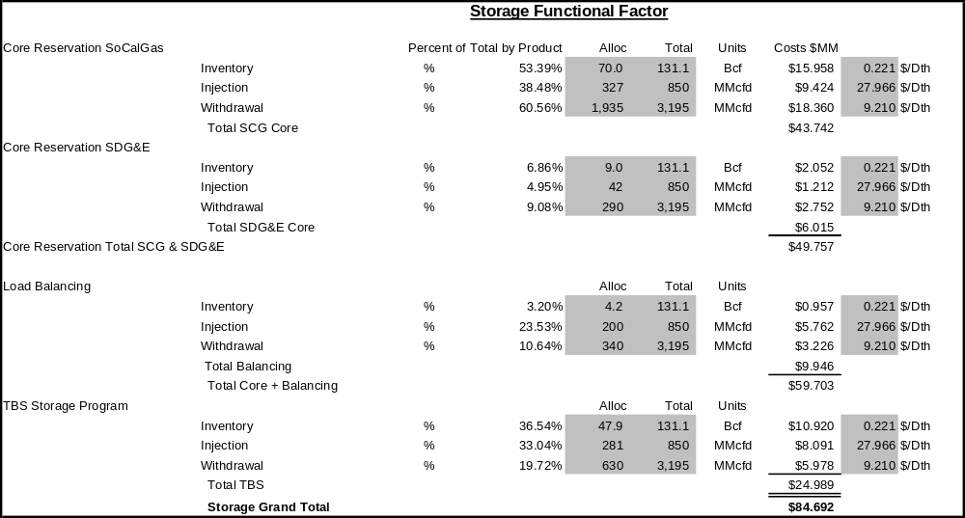

( c ) The work papers are shown in the Revised for DRA EC Model “Storage Func Fctr” tab.
QUESTION PZS3-25:

Based on SoCalGas response to PZS1-4, please provide documents that verify to DRA the supposed contacts made by SoCalGas with the NRRI and the response provided by NRRI, the contact with AGA and their response verifying the inquiry to member utilities, and contacts by SoCalGas with the regulatory agencies of states that used marginal costs for allocation purposes in the past and their responses.

RESPONSE PZS3-25:

NRRI
Last fall Dr. Schmidt contacted Ken Costello at NRRI by telephone regarding the marginal cost allocation methodology. Mr. Costello is NRRI’s natural gas rate and policy expert. He indicated that he was unaware of any states (other than California) that used marginal cost methods for natural gas cost allocation. Mr. Costello can be reached at: kcostello@nrri.org.

Ken Costello
National Regulatory Research Institute
tel. 614-292-2831
fax. 614-292-7196

AGA
The AGA rate committee chairperson was unaware of any states (other than California) that rely on marginal cost methods for cost allocation. At SDG&E’s request, AGA sent out the following email inquiry to its members on October 31, 2007. All responses were negative.

From: Batte, Kelly [mailto:kbatte@aga.org]
Sent: Wednesday, October 31, 2007 9:26 AM
To: AGA Members
Subject: Marginal Cost Allocation SOS - San Diego Gas & Electric

RATE ISSUES S.O.S. 08-2007

October 30, 2007

Subject: Marginal Cost Allocation

Marginal costs are used to allocate San Diego Gas & Electric’s (SDG&E’s) revenue requirement. Unit marginal cost for customer, distribution, transmission, and components are first calculated using California Public Utilities Commission approved methods, and then multiplied times the appropriate marginal demand measure in order to derive marginal cost revenues by customer class. Allocators are developed using marginal demand measures and are then applied to total revenue requirement. For example, using this methodology leads to transmission costs being allocated using cold year coincident peak month values, distribution costs being allocated using cold year peak day values, and customer costs being allocated using the number of forecasted total customers.

Specifically, SDE&G would like to know if your utility uses a marginal cost based method to allocate your revenue requirement? If yes, how long has your utility used marginal instead of other methods of allocating revenue requirement such as embedded costs?

PLEASE RESPOND TO THE PERSON LISTED ABOVE. In addition to the SDG&E company contact, please send a copy of any written response to:

Cynthia J. Marple
Director, Rates and Regulatory Affairs
American Gas Association
Phone: (202) 824-7228
Fax: (202) 824-7086
E-Mail: cmarple@aga.org

Participants should review the AGA Antitrust Guidelines (www.aga.org/antitrust) prior to any discussions of this information and no information shall be disseminated or discussed that violates those guidelines. To steer clear of trouble, do not exchange company-specific, competitively sensitive information, i.e., prices, costs, terms and conditions of sale capacity, business strategies or future plans. Participants should not make disparaging comments and generally not make recommendations for or against any of the products or services of particular manufacturers or service providers.

Inquiry as to continued use of MC by States
SDG&E’s contact at Christensen Associates Energy Consulting, LLC replied to SDG&E’s inquiry as follows:

-----Original Message-----
From: Mike O'Sheasy [mailto:mtosheasy@CAEnergy.com]
Sent: Thursday, December 13, 2007 10:48 AM
To: Schmidt, Mike (Reg Aff)
Subject: RE: Marginal Cost in Cost Allocation

Hi Mike! I've been on the road and therefore haven't been able to respond promptly to your question below. The only other utility that I'm aware of using marginal cost as an allocator of embedded cost is Public Service of New Mexico (PNM) (I believe it's required by Commission order). I can put you in touch with them if it'd be helpful.

Mike, my firm does a lot of work in computing marginal cost. We're actually doing so for a Caribbean country right now to allocate embedded cost for a rate filing as well as to help influence the rate design. Please let me know if there's anything that we can do to help.

Sincerely,

Mike

Michael T. O'Sheasy
Christensen Associates Energy Consulting, LLC
(w) 770-993-2336
(f) 770-993-5419

________________________________

From: Schmidt, Mike (Reg Aff) [mailto:MSchmidt@semprautilities.com]
Sent: Tue 12/11/2007 4:53 PM
To: Mike O'Sheasy
Subject: Marginal Cost in Cost Allocation

Marginal costs are used to allocate San Diego Gas & Electric's (SDG&E's) revenue requirement for natural gas service. Unit marginal cost for customer, distribution, transmission, and components are first calculated using California Public Utilities Commission approved methods, and then multiplied times the appropriate marginal demand measure in order to derive marginal cost revenues by customer class. Allocators are developed using marginal demand measures and are then applied to total revenue requirement. For example, using this methodology leads to transmission costs being allocated using cold year coincident peak month values, distribution costs being allocated using cold year peak day values, and customer costs being allocated using the number of forecasted total customers.

Specifically, SDE&G would like to know if you are aware of any other states/utilities that use a marginal cost based method to allocate the revenue requirement?

Mike Schmidt
Regulatory Strategy Manager
SDG&E
CP 32-D
(858) 650-4098

QUESTION PZS3-26:

Based on your response to PZS1-14, do you confirm that the SoCalGas testimony using the LRMC methodology will allocate less base margin costs to SoCalGas’ core customers compared to those made under embedded cost method? If this not the case, please explain.

RESPONSE PZS3-26:

Yes, that is confirmed.

QUESTION PZS3-27:

Assuming that the embedded cost methodology was approved by the Commission as requested by SoCalGas, please describe the following:
- The amount by which a typical winter bill for a residential customer using 40 therms will increase under the embedded cost method compared to one that uses the LRMC methodology in each year of the BCAP period 2009, 2010, and 2011.
- The impact on each of the other customer classes based on their typical average winter usage in each year of the BCAP period 2009, 2010, and 2011.
- Please provide the corresponding spreadsheet calculations for purposes of your responses to both (a) and (b) and state any assumptions.

RESPONSE PZS3-27:

- The average winter bill for a residential customer using 40 therms under current, EC and LRMC rates is shown below. The typical winter bill will increase by 6 cents using the EC methodology and decrease by 62 cents using LRMC compared to the current rate. The rate is the same for each year of the BCAP.
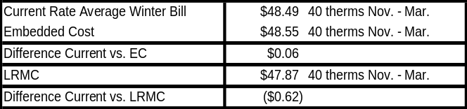
(b) The following are the typical winter bills for core C&I, Gas AC, Gas Engine, Non Core C&I and EG rates based on current, EC and LRMC rates. The rate is the same for each year of the BCAP.
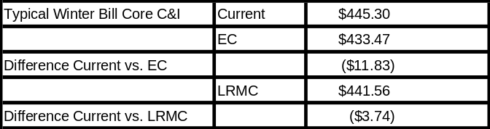

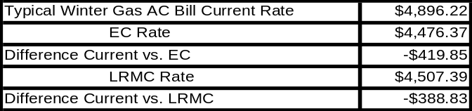

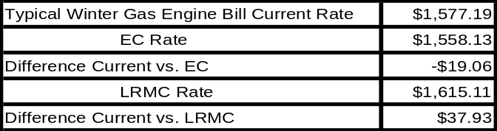

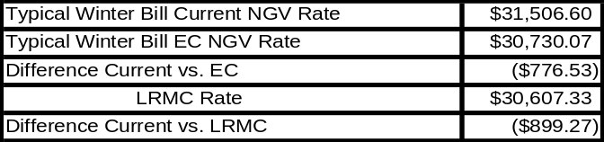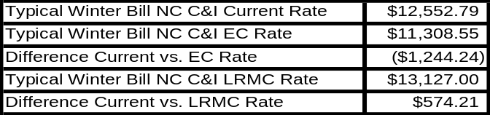
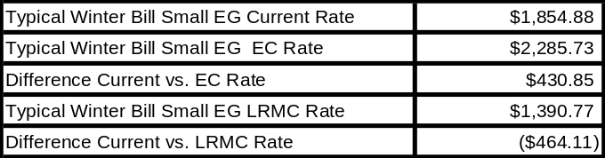

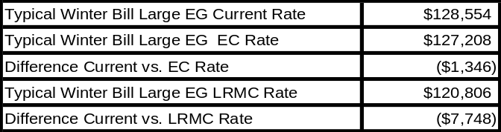

(c) The work papers for the Residential and Non-residential bills’ analysis are attached below.

