QUESTION 1:

TMR4 – Q.1 In response to DRA Data Request No. DRA-TMR1, Question 16, SoCalGas provided a spreadsheet showing the price elasticities for the commercial noncore and industrial noncore market segments. It is DRA’s understanding that these price elasticities were derived from models similar to those described in response to Question 4 of DRA Data Request No. DRA-TMR1. For the industrial noncore and commercial noncore market segments please provide the employment and price data that were used to generate the price elasticities.

RESPONSE 1:

The data file used to generate the price elasticities is attached in the following .zip file. The same information is also provided in the following excel files.

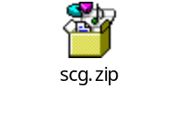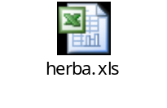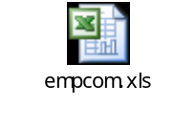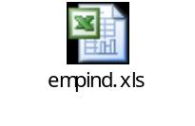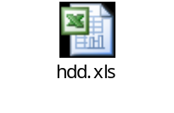
The SAS programming code to read the data and run the estimation of the price elasticities is attached.

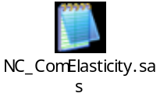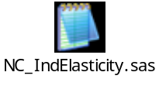

The output is also attached.


