QUESTION PZS1-1:

Subject: Feb.4, 2008 SoCalGas Direct Testimony of Herbert S. Emmrich (Embedded Cost)

On page 3 at Lines 8 -10, SoCalGas states: “Core reliability storage costs were allocated directly in core transportation rates and storage balancing costs were allocated across all customer classes based on average year throughput forecasts in transportation rates.”

- Please identify, in dollars, how much of core reliability storage costs were allocated directly in core transportation rates.
- Please identify, in dollars, how much of storage balancing costs were allocated across all customer classes.
- Please provide the page numbers to the portions of your testimony and workpapers which support your responses to (a) and (b).

RESPONSE PZS1-1:

(a) $39,125,000 in core reliability storage costs were allocated to SoCalGas' core
customers.
(b) $12,381,000 in storage balancing costs, including fuel costs for injection related to load balancing, was allocated across all customer classes.
(c) See the work papers to testimony of Mr.Lenart for embedded cost, worksheet tab #6 "Cost Alloc" starting on page 26.

The storage costs allocated to all customers and the TBS program, excluding fuel costs, are also shown in Mr. Emmrich’s testimony in Table 27 on page 50.

Table 27
Allocation of Storage Costs
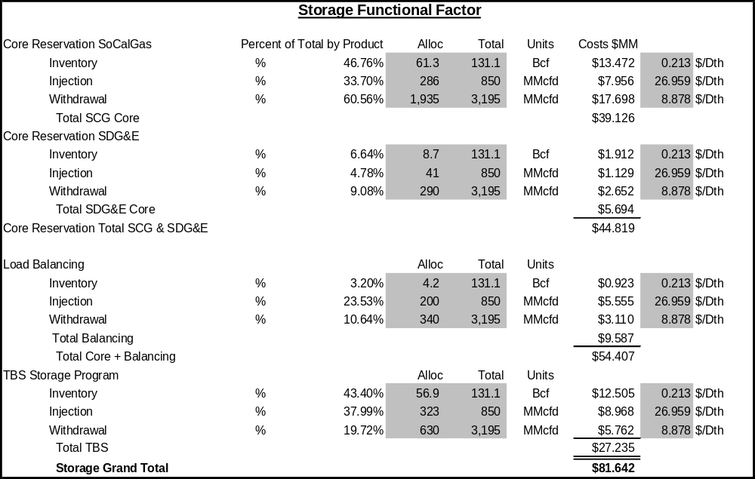

QUESTION PZS1-2:

On page 5 at Lines 19-22, SoCalGas states: “Unfortunately, the Commission has deviated from this economic efficiency principle and has instead implemented LRMC-based rates that have distorted the cost signals…” Please provide all documents, with specific page references, that show the distortion of cost signals referred to in the statement.

RESPONSE PZS1-2:

Since all rates based on the Commission-adopted hybrid LRMC cost allocation methodology have deviated from the economically-efficient cost allocation principles of basing customer costs on the cost of adding one new customer holding demand constant and basing demand-related costs on serving one additional therm holding customers constant, all cost allocations based on the Commission-approved LRMC allocation method have provided customers with distorted price signals. The use of the NCO method vs. the rental method of allocating customer costs is a prime example of providing customers distorted cost signals as indicated by Ms. Smith in her direct testimony. Therefore, all rates adopted since 1992 in D.92-12-058 have provided customers with distorted cost signals. All documents related to BCAPs since 1992 are available in Commission filings. All rates shown in the final BCAP decisions since 1992 therefore have provided distorted price signals to customers.

QUESTION PZS1-3:

On page 7 at Line 1, SoCalGas refers to utility resource plans.

- Please explain whether these utility resource plans can be considered the utility’s least cost resource plans for the planning period for transmission, distribution, and storage.
- Please explain whether the utility prepares least cost resource plans for transmission, distribution and storage regardless of whether it employs an LRMC cost allocation or an embedded cost allocation approach.

RESPONSE PZS1-3:
- The transmission resource plan represents the least cost means to provide the incremental intrastate capacity required to meet the long-term demand forecast over the plan period. The resource plan for distribution represents a reasonable estimate of the costs necessary to expand the distribution system over the plan period. The storage resource plan represents a best-guess estimate of the costs to expand storage capacities assuming sufficient long-term contract demand in the unbundled storage program exists to warrant such expansions. The per-unit cost of these storage expansions depends upon size of the expansion, which is unpredictable.
- Resource plans are only required for LRMC cost allocation and are not needed under an embedded cost methodology. Under an embedded cost methodology, the Utility will no longer have a need to prepare a "resource plan" per se, but will plan and maintain its system to meet the CPUC-mandated design criteria and market-based demand for its products.

QUESTION PZS1-4:

On page 7 at Lines 11-13, SoCalGas states: “Today, nearly all gas distribution utilities and pipelines in North America utilize, and their regulators endorse, embedded costing principles….” (a) Please provide a list of the utilities referred to in the statement.
(b) Please provide all documents, with specific page references, showing that the regulators referred to in the statement endorse embedded costing principles.

RESPONSE PZS1-4:

- SoCalGas first contacted the gas group at the National Regulatory Research Institute (NRRI) at Ohio State University and was told that NRRI was unaware of any state that relies on marginal cost for cost allocation. SoCalGas also contacted the American Gas Association’s (AGA) Rates and Regulatory Policy Group to inquire as to any states that use marginal cost in the allocation of base margin. AGA has a membership in excess of 700 organizations that includes almost all gas distribution and transmission companies in the USA. The AGA membership list is restricted to AGA members. Besides California, the AGA was unaware that any states relied on marginal cost methods for the allocation of costs of service. As a check, the AGA sent out an inquiry to all its member utilities. All of the responders indicated that their utilities do not use marginal costs for this purpose. Next SoCalGas contacted the regulatory agencies of states that used marginal costs for allocation purposes in the past. Again the responses were negative. Finally, SoCalGas asked one of its consultants that is familiar with national practices in utility ratemaking. The consultant indicated that only New Mexico uses marginal cost methods for cost allocation purposes. Based on these inquiries, SoCalGas has concluded that California and New Mexico remain as the only states to rely on marginal costs for allocation purposes for gas utilities.
- Since only one state besides California could be identified that still uses marginal cost for cost allocation and ratemaking for gas utilities, we must assume that regulators in all states, except California and New Mexico, endorse embedded cost allocation principles for allocating gas utility costs. In addition, FERC and the NEB of Canada also use embedded cost allocation for ratemaking purposes for gas pipeline services. We have no specific documents to quote.

QUESTION PZS1-5:

On page 7 at Lines 17-20, SoCalGas states: “In fact, for those states in the U.S. where gas marginal cost studies were conducted in the past (other than in California). Many of the regulators in those states have now abandoned marginal cost concepts altogether.”

- Please provide a list of the utilities referenced in the statement.

- Please provide all documents, with specific page references, showing that the regulators referred to in the statement have now abandoned marginal cost concepts.

RESPONSE PZS1-5:

(a) As stated in response to PZS1-4, SoCalGas first contacted the gas group at the National Regulatory Research Institute (NRRI) at Ohio State University and was told that NRRI was unaware of any state that relies on marginal cost for cost allocation. SoCalGas also contacted the American Gas Association’s (AGA) Rates and Regulatory Policy Group to inquire as to any states that use marginal cost in the allocation of base margin. Besides California, the AGA was unaware that any states relied on marginal cost methods for the allocation of costs of service. As a check the AGA sent out an inquiry to all its member utilities. All of the responders indicated that their utilities do not use marginal costs for this purpose. Next SoCalGas contacted the regulatory agencies of states that used marginal costs for allocation purposes in the past. Again the responses were negative. Finally, SoCalGas asked one of its consultants that is familiar with national practices in utility ratemaking. The consultant indicated that only New Mexico uses marginal cost methods for cost allocation purposes. Based on these inquiries, SoCalGas has concluded that California and New Mexico remain as the only states to rely on marginal costs for allocation purposes. We conclude therefore that all other states, in addition to FERC and the NEB, use embedded costs for ratemaking. The 700 plus membership list of AGA is restricted by AGA but generally includes almost all gas utilities and gas transmission companies in the USA.
(b) We have no specific documents or references to cite. However, since Russell Feingold could identify only five states that used LRMC and since Dr. Schmidt was able to identify only one state, other than California, that still uses LRMC, New Mexico, and since FERC- and NEB-regulated gas pipelines use embedded costs to set rates, logically, they must have abandoned LRMC in favor of embedded cost principles otherwise they would still be using LRMC-based ratemaking.

QUESTION PZS1-6:

On page 7 at Lines 21-23, SoCalGas refers to an industry-wide review conducted by Russell Feingold on behalf of SoCalGas. Please provide DRA a copy of the referenced review.

RESPONSE PZS1-6:

The study is attached below.


QUESTION PZS1-7:

On page 7 at Lines 25-27, SoCalGas refers to a late 2007 updated review conducted by Dr. Schmidt that found only five states remain where some type of marginal cost study is still conducted. Please provide DRA with a copy of the referenced review.

RESPONSE PZS1-7:

a) As stated in response to PZS1-4 above, Russell Feingold identified 5 states that used LRMC cost allocation in setting rates. In order to verify if these states have continued to use LRMC, Dr. Schmidt first contacted the gas group at the National Regulatory Research Institute (NRRI) at Ohio State University and was told that NRRI was unaware of any state that relies on marginal cost for cost allocation. SoCalGas also contacted the American Gas Association’s (AGA) Rates and Regulatory Policy Group to inquire as to any states that use marginal cost in the allocation of base margin. Besides California, the AGA was unaware that any states relied on marginal cost methods for the allocation of costs of service. As a check the AGA sent out an inquiry to all its member utilities. All of the responders indicated that their utilities do not use marginal costs for this purpose. Next SoCalGas contacted the regulatory agencies of states that used marginal costs for allocation purposes in the past. Again the responses were negative. Finally, SoCalGas asked one of its consultants that is familiar with national practices in utility ratemaking. The consultant indicated that only New Mexico uses marginal cost methods for cost allocation purposes. Based on these inquiries, SoCalGas has concluded that California remains the only state to rely on marginal costs for allocation purposes. We conclude therefore that all other states, FERC and the NEB use embedded costs for ratemaking. The 700 plus membership list of AGA is restricted by AGA but generally includes almost all gas utilities and gas transmission companies in the USA.

QUESTION PZS1-8:

On page 8 at Lines 2-3, SoCalGas states: “First, as the cost of gas decreased over time, there was less interest and concern over the need to provide gas customers with some type of price signal based on marginal cost to influence their gas consumption habits.” Please describe the time period, in months and years, during which the events referred to in the statement occurred.

RESPONSE PZS1-8:

Gas prices decreased in real dollar terms or were fairly flat from 1994 to 1999. The table below shows the price history of core flowing supply WACOG costs from 1994 to 2007.

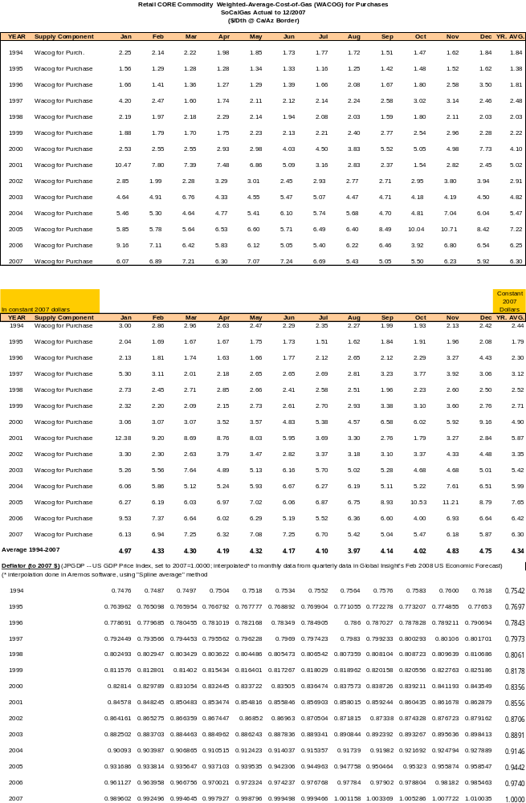

QUESTION PZS1-9:

On page 8 at Lines 7-10, SoCalGas states: “Finally, in states where both types of cost studies were conducted, the regulators recognized that the results of the marginal cost studies were similar directionally to the results already obtained under the embedded cost allocation studies.” Please provide DRA a copy of the results of the marginal cost studies referred to in the statement, with specific page references showing that the marginal cost studies were similar directionally to the results already obtained under the embedded cost allocation studies.

RESPONSE PZS1-9:

The statement refers to the study by Russ Feingold that has been provided in response to PZS1-6.

QUESTION PZS1-10:

On page 8 at Lines 10-12, SoCalGas states: “Therefore, they chose to rely solely upon the embedded cost allocation studies for purposes of setting gas rates, and eliminated the need to conduct marginal cost studies.” Please provide the basis for this statement.

RESPONSE PZS1-10:

The basis for this statement is the Russ Feingold study provided in PZS1-6.

QUESTION PZS1-11:

On page 10 starting at Line 13-21, SoCalGas states: “To develop future marginal costs, the marginal cost estimation process necessarily relies upon utility plans and single-scenario forecasts …”

- In SoCalGas’ last BCAP, were costs allocated on the basis of marginal costs?
- Did the utility develop utility plans and forecasts to estimate those marginal costs?
- Please identify which projects in those resource plans were actually implemented and describe how much of the utility’s resource plans actually materialized in terms of costs being incurred.

RESPONSE PZS1-11:

(a) In SoCalGas’ last BCAP, costs were allocated on the basis of the Commission-approved marginal costs approach which is not a true reflection of marginal costs but a hybrid approach using some aspects of LRMC, embedded costs and social ratemaking.
(b) Yes, the utility developed 15-year transmission and storage resource plans 10-year historical and 5-year forecast distribution regression analyses to forecast and estimate those marginal costs. For Transmission and Storage, we develop 15-year resource plans to calculate the LRMC for each function. In these long-term resource plans, we project the facilities needed to meet demand growth over the 15-year planning period. We aren't however looking at actual forecasted budgeted spending. These T&S resource plans for the BCAP are different from our plans used for budgeting purposes. Since, these BCAP Transmission or Storage long-term resource plans are highly speculative, they end up being one of the more contentious aspects of the LRMC study. The marginal costs adopted in the 1999 BCAP are attached below.

( c ) Distribution - In general, distribution resource plans were actually implemented, that is about 68,000 new customers per year were hooked up during the 2001 to 2007 period at an average cost of $1,123. The attached Excel spreadsheet and table below show the detail of distribution expenditures for new business.

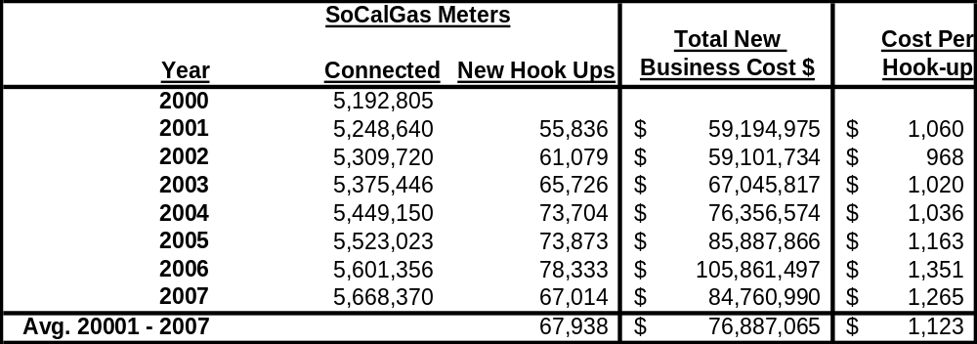

Transmission - The following lists the transmission projects identified in the SoCalGas 1999 BCAP application that have been completed and their associated costs.
Line 6900 Phase 2 & 3: $22.2 million
Although not identified in the 1999 BCAP application, SoCalGas expanded the receipt capacity of its transmission system in 2001 and 2002. These improvements added 375 MMcfd of additional receipt capacity for interstate and local supplies at a cost of approximately $61 million.
Storage - SoCalGas also provided exemplary storage expansions in the 1999 BCAP application for ratemaking purposes. While the expansions identified in that application did not materialize, SoCalGas has created 25 BCF of additional inventory capacity since the 1999 BCAP. Please refer to the prepared direct testimony of Steve Watson in A.08-02-001.

QUESTION PZS1-12:

On page 10 at Lines 22-23, SoCalGas states: “The average costs derived from this ECS diverge less from proper marginal costs than under the Commission-adopted LRMC methodology.” Please provide the basis for this statement.

RESPONSE PZS1-12:

The statement is based on the fact that using the ECS a small 2.6% true-up factor was needed to fully recover the revenue requirement while a 20% scale down of LRMC costs was made to align LRMC-based cost allocation with the revenue requirement. In equilibrium, LRMC equal average costs, and, since the ECS’s results are only 2.6% lower than the revenue requirement, which by definition equates to average cost, and using the Commission-approved LRMC methodology results in a 20% scale down to meet the revenue requirement, the ECS approach is more closely aligned with true marginal costs.

QUESTION PZS1-13:

On page 11 at Lines 17-19, SoCalGas states: “Because marginal costs are estimates, they must be created, requiring a complex process that is based upon numerous assumptions and analyses.” Please provide a list of the typical assumptions and analyses that would be required as part of the complex process referenced in the statement.

RESPONSE PZS1-13:

The Commission-approved LRMC methodology requires single scenario estimates of future demand and capital and O&M costs to provide service to new customers or to meet additional forecasted demand requirements. These single scenario approaches are deterministic in nature rather than probabilistic. The level of demand and cost forecasts 15 years into the future have only a 50% probability of occurring. The use of single point estimates of future gas price levels also have only a 50% probability of occurring and therefore demand forecasts are also problematical. There is constant debate over what costs are base costs vs. what costs are marginal costs 15 years out in the future. It is not theoretically correct or practical to use forecasts of demand and costs 15 years into the future to set current rates. In a fully competitive market, which we assume the Commission is attempting to replicate with the use of LRMC, prices are set at current marginal costs not estimated marginal costs 15 years out in the future.

QUESTION PZS1-14:

On page 23, starting at Line 13, SoCalGas describes the proposed embedded cost-based allocation of base margin for each of SoCalGas’ customer classes. When compared to the results for SoCalGas under the LRMC method as described in Ms. Allison Smith’s testimony and shown in Table 11 of said testimony, please explain which approach would result in a greater cost burden for SoCalGas core customers in 2009 through 2011.

RESPONSE PZS1-14:

The Embedded Cost methodology will allocate $1,424.4 million or 90.5% of base margin costs to SoCalGas' core customers. The LRMC methodology will allocate $1,379.5 million or 87.7% of base margin costs to SoCalGas' core customers. The total difference therefore is $44.9 million or 2.8% of base margin. These percentages are applicable throughout the BCAP period. This is the allocation of base margin costs, before integration of transmission system costs, and before separating out charges for Firm Access Rights (i.e.; FAR costs are included in the base margin costs but recovered separately as FAR charges).

