QUESTION 1:

Please explain why there are no local transmission costs allocated to Long Beach in Mr. Lenart’s workpapers (see “Cost Alloc” worksheet, cell P11).

RESPONSE 1:

Worksheet “Cost Alloc” cell P11 contains the results of the embedded cost study from the testimony of Mr. Emmrich. Please refer to response to Long Beach Data request 1-15.

QUESTION 2:

Please explain why local transmission costs were subsequently allocated to Long Beach in the workpapers (see “Cost Alloc” worksheet, cell P22, in the amount of $1,175,000).

RESPONSE 2:

Worksheet “Cost Alloc” cell P22 contains the local transmission costs allocated to customer classes on an integrated system basis. Under system integration, local transmission system costs are allocated to customer classes based on Cold Year Peak Month demand.

QUESTION 3:

Please explain why it is appropriate to allocate any local transmission costs to Long Beach, in light of Mr. Emmrich’s embedded cost analysis, which allocates no local transmission costs to the Long Beach.

RESPONSE 3:

While the allocation of integrated transmission system costs uses the system total local transmission costs that was determined on an embedded cost basis, the integrated costs are allocated on Cold Year Peak Month basis to all customer classes. Please refer to response to Long Beach Data request 1-15.

QUESTION 4:

Please explain why the backbone transmission costs of $91,885,000 (see “Cost Alloc” worksheet, cell X10), which are subsequently removed in Line 19, are less than the backbone transmission costs that are added back in on Line 21 (see “Cost Alloc” worksheet, cell X21, $98,196,000).

RESPONSE 4:

The pre-system integrated costs developed on an embedded cost basis per the testimony of Mr. Emmrich are $91,885,000. These costs are combined with SDG&E’s backbone transmission costs to obtain the fully integrated costs of $112,550,000. The integrated costs are allocated based on cold year throughput. Customers located in SoCalGas’ service area, represented as a % of total cold year throughput on the integrated backbone transmission system, applied to the total integrated costs, results in $98,196,000 allocated to SoCalGas.

QUESTION 5:

Please explain why the local transmission costs of $75,179,000 (see “Cost Alloc” worksheet, cell X11), which are subsequently removed in Line 20, are less than the local transmission costs that are added back in on Line 22 (see “Cost Alloc” worksheet, cell X22, $80,012,000).

RESPONSE 5:

The pre-system integrated costs developed on an embedded cost basis per the testimony of Mr. Emmrich are $75,179,000. These costs are combined with SDG&E’s local transmission costs to obtain the fully integrated costs of $92,086,000. The integrated costs are allocated based on cold year peak month demand. Customers located in SoCalGas’ service area, represented as a % of total cold year peak month demand on the integrated local transmission system, applied to the total integrated costs, results in $80,012,000 allocated to SoCalGas.

QUESTION 6:

Please explain why backbone transmission costs were removed for SDG&E (see “Cost Alloc” worksheet, cell Q19), but then not added back in with system integration (see “Cost Alloc” worksheet, cell Q21).

RESPONSE 6:

Integrated transmission system costs are allocated directly to SDG&E’s customer classes, as opposed to being allocated to SDG&E as a wholesale charge. Please refer to the workpapers of Mr.Bonnett - worksheet “Cost Alloc” row 20.

QUESTION 7:

Please explain whether it is correct to interpret the numbers in the “SI & FAR” worksheet to mean that in the absence of system integration, SDG&E would have been allocated $11,835,000 (cell P36) and $20,664,000 (cell W37) for backbone transmission, but under system integration, SDG&E would be charged only a total of $14,353,000 (cell W56). If this is not a correct interpretation, please provide a detailed explanation of the backbone transmission costs that were allocated to SDG&E without system integration and after system integration.

RESPONSE 7:

No. In order to evaluate the full impact of system integration (D.06-04-033) on SDG&E, the Sempra-wide rates must also be taken into account. Sempra-wide rates are rates that are averaged (in the case of Sempra-wide NGV and EG-distribution rates) and combined (in the case of the TLS rate). Due to system integration (SI), the adjustments made for Sempra-wide rates without SI result in lesser decreases to SDGE. Also, the wholesale charge from SoCalGas to SDG&E is much smaller due to the integrated transmission costs being directly allocated to SDG&E rather than being charged to SDG&E through the wholesale rate.

The Table below shows the full impact on SDG&E due to system integration. ($000’s)

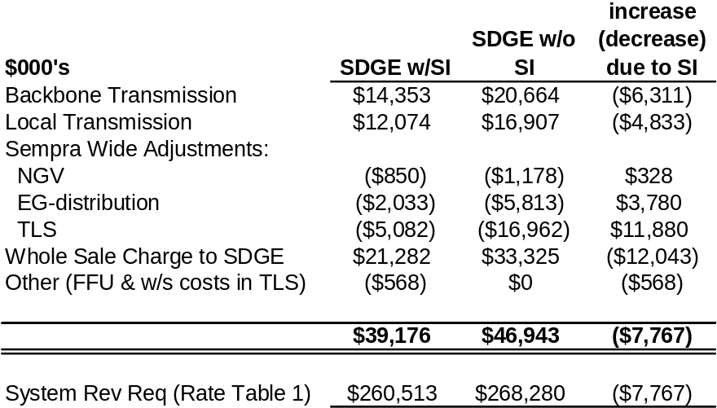

QUESTION 8:

Please explain whether it is correct to interpret the numbers in the “SI & FAR” worksheet to mean that in the absence of system integration, SDG&E would have paid $16,907,000 for local transmission (see cell W9), but under system integration, SDG&E would be charged only $12,074,000. If this is not a correct interpretation, please provide a detailed explanation of the local transmission costs that were allocated to SDG&E without system integration and after system integration.

RESPONSE 8:

See response to1.7.

QUESTION 9:

In Mr. Lenart’s workpapers, “Alloc Factors,” Lines 12 through 28, data were provided on a variety of allocators.

  - Notes on these lines refer to Ken Paris’ analysis of 2006 throughput data contained in an e-mail dated 9-25-07. Please provide this analysis and the e-mail noted in this reference (see, for example, “Alloc Factors” worksheet, cell B11).

  - Notes on these lines also refer to Marjorie Schmidt-Pines’ analysis of 2006 throughput data contained in an e-mail dated 10-8-07 (see, for example, “Alloc Factors” worksheet, cell I11). Please provide this analysis and the e-mail noted in this reference.

  - Notes on these lines also refer to Sharon Pope’s analysis of 2009 throughput data contained in an e-mail dated 10-9-07 (see, for example, “Alloc Factors” worksheet, cell K11). Please provide this analysis and the e-mail noted in this reference.

  - Please provide the analysis underlying the NonCore C&I numbers (see “Alloc Factors” worksheet, Column H, Lines 12-28).

RESPONSE 9:

a. Attached is a copy of Mr. Paris’ e-mail (w/attachment file) of 9/25/2007.



b . The cell note you have referenced in Mr. Lenart’s Excel file refers to preliminary analyses that were subsequently replaced by final values however, due to an oversight, the cell note remained. Please see the response to 1.27. Note that the referenced numeric data in Mr. Lenarts’ Excel file for the Noncore C&I data is the same as the corresponding data provided in the primary Excel file with data (and supporting “linked” files) for Mr. Emmrich’s SoCalGas gas demand forecast work papers: pages, EmmrichSCGDF-3 through EmmrichSCGDF-55.
c. See Response 9b.

d. Please see response 1. 27. Note that the referenced numeric data in Mr. Lenart’s Excel file for the Noncore C&I data is the same as the corresponding data provided in the primary Excel file with data (and supporting “linked” files) for Mr. Emmrich’s SoCalGas gas demand forecast work papers: pages, EmmrichSCGDF-3 through EmmrichSCGDF-55.

QUESTION 10 (WITHDRAWN):

In the worksheet entitled “TLS Rate,” the Applicants have assumed that Long Beach reserves 24,446 Dth/day and purchases 8,750.5 Mdth/year under the SFV rate and 2,958.8 Mdth/year under the volumetric rate.

- Please describe how the Applicants developed these estimates.
- Please provide historical usage, by day, for the past five years for Long Beach.

- Please provide the amount that Long Beach has paid for transportation for each of the past five years and the associated volume purchased.

- If Long Beach has less than a 98% load factor at the 24,446 Dth/day reservation level (e.g., 80% load factor at this reservation), will it pay more than assumed in the “TLS Rate” sheet? If so, please explain. If not, please explain why not.

- Is it possible that SoCalGas would collect substantially more in revenues from Long Beach under the proposed TLS rate structure than the embedded costs that were directly assigned as a result of SoCalGas’ embedded costs analysis? If not, why not? If so, does SoCalGas believe that this result is consistent with its efforts to “establish a linkage between a utility’s customers and the particular costs incurred by the utility in serving those customers” (Emmrich, Embedded Cost Study, p. 4)?

RESPONSE 10:

This Data Request was withdrawn by requester.

QUESTION 11:

In the worksheet entitled “TLS Rate,” the Applicants have made a number of assumptions regarding the capacity reserved and Mdth/year (see Columns F-I, Lines 78-107).

- Please explain how these figures (e.g., Mdth/yr, Capacity Reserved Dth/day) were developed.

- Please provide the workpapers and all supporting documents and assumptions for these estimates.

- Please indicate what capacity factors were assumed for each of the customer classes under the Reservation Plus Usage Rate (i.e., given reservation requests, how much of the reserved amounts were customers assumed to use 1) each day and, 2) on an annual basis).

RESPONSE 11:

Please refer to data request #2 from SCGC, numbers 2.5.2 and 2.5.3.

QUESTION 12 (WITHDRAWN):

Using 2006 data, please perform a bill analysis showing the total charges under the proposed TLS rate structure to Long Beach if it should choose a daily reservation amount equal to 25%, 50%, 75% and 100% of maximum peak demand and a reservation amount equal to its 2006 minimum daily load. Please indicate whether you have included the FAR charges. Please provide all data supporting this analysis.

RESPONSE 12:

This data request was withdrawn by requester.

QUESTION 13:

On page 13, Mr. Lenart proposes that “the base margin portion of the ITBA and NFCA regulatory accounts should be excluded from the usage rate applied to Option #1.”

- Please explain how SoCalGas would determine and separate the “base margin” from the “non-base margin” within the NFCA and ITBA.

- Please explain what would happen if SoCalGas overcollected its revenue requirements allocated to TLS because customers reserved greater capacity than forecast.

- Would this excess revenue be refunded to customers through the ITBA and NFCA under SoCalGas proposal? If so, where would it be found in rates if not in the usage charge? If not, why not?

RESPONSE 13:

a. Authorized Transportation revenues are separated into the required components (e.g., a revenue component for NFCA amortization). These components are then expressed as a rate per therm. This rate is applied to the difference between adopted throughput volumes and actual volumes delivered in order to arrive at an over or under collection in dollar amounts.

Historically, the components SoCalGas separates and maintains are amortizations for regulatory accounts and various other operating costs. Effective with the 1/1/2008 implementation of system integration, SoCalGas segregated transmission costs based on this cost component methodology for recording in the ITBA. Now, due to this BCAP proposal, SoCalGas will begin to separately maintain the remaining base margin items in a similar manner.

b. The reservation rate and volumetric rate are comprised solely of base margin costs (the usage rate which is applied to both TLS options is comprised of non margin costs). If during the initial open season customers reserve greater capacity than forecast, this would potentially result in a decrease in the volumetric rate option of the TLS rate. This potential decrease would be the result of the volumetric rate being arrived at as:
the total base margin costs allocated to TLS customers
less the reservation revenue associated with the customers electing the reservation charge options
divided by the forecasted demand under the volumetric rate.

c. No, because there would be no excess revenue. The volumetric option of the TLS rate would be reduced accordingly before any deliveries are made. After the initial open season and the volumetric rate has been finalized, any increases or decreases in deliveries under the volumetric TLS option causing an over or under revenue collection will be handled through the usage rate.

QUESTION 14:

On p. 4, Mr. Lenart indicates that SoCalGas is proposing to modify “the allocation of the Noncore Fixed Cost Account and the Core Fixed Cost Account to reflect different allocation methods for the base margin and non-base margin portions of these accounts. SoCalGas is proposing to allocate base margin portion on the basis of Equal Percent Marginal Cost, and the non-base margin portions will continue to be allocated on an Equal Cents-Per-Therm (ECPT) basis. This proposal will not be implemented until the second year of the BCAP period.”

- Please explain how SoCalGas previously allocated base margin and non-base margin items of the Noncore Fixed Cost Account and the Core Fixed Costs Account and why SoCalGas believes that such a change is appropriate.

- Please provide the EPMC and ECTP allocators for 1) all of the customer classes currently in effect (e.g., including each of the wholesale customers separately) and 2) all of the proposed customer classes (e.g., including the new, proposed TLS, etc.). Please provide all workpapers supporting these calculations.

RESPONSE 14:

a. The Noncore Fixed Cost Account is currently allocated using the Equal cents Per Therm (ECPT) method for noncore classes excluding EOR class. There is no distinction made between base margin and non-base margin items within the NFCA.

The Core Fixed Cost Account is currently allocated using ECPT method for core classes. There is no distinction made between base margin and non-base margin items within the CFCA.

For an explanation on why SoCalGas believes that such a change is appropriate, please refer to the testimony of Mr. Lenart, page 8, Line 12-21.

b.

QUESTION 15:

Please explain why no local transmission costs are allocated to Long Beach in the embedded costs study (see workpapers Emmrich SCGC-5). Please provide the rationale and any workpapers supporting this decision.

RESPONSE 15:

Long Beach is served off of the SCG backbone and local transmission system and some off of the SCG distribution system. The allocation of Long Beach transmission costs will be corrected to reflect this fact in an upcoming update filing based on 2007 actual costs.

QUESTION 16:

Please explain why Mr. Emmrich used “cold-year coincident peak month demand by class” to allocate high-pressure distribution related costs for SoCalGas (p. 22), but Mr. Schmidt used “cold year peak day demand by class” to allocate high-pressure distribution related costs for SDG&E. Why is it appropriate to have two different allocators?

RESPONSE 16:

Different allocators for high pressure distribution costs were used based on the reasons stated in the Long Run Marginal Cost (LRMC) policy decisions, D.93-05-071 and D.92-12-058. D.93-05-071 (last page) established a cold year peak day allocator for distribution costs. D.92-12-058 concluded that SoCalGas could use cold-year coincident peak month to allocate high-pressure distribution costs.

In D.92-12-058, SoCalGas proposed disaggregating its distribution system into high-pressure and medium-pressure components. The CPUC found merit in this proposal and thought it made sense to apply the same cost allocation methodology to SoCalGas’ high-pressure lines as was applied to local transmission lines, which was cold-year coincident peak month.

D.92-12-058, p. 23, states:

“…We find merit, though, in SoCal’s alternate proposal as discussed in Exhibit No. MC-17, at pp. 19-21 to disaggregate its distribution system into high-pressure and medium-pressure components.

SoCal’s high-pressure distribution “supply” lines serve a function similar to PG&E’s local transmission lines. For example, both are used to serve those portions of the UEG load not served off the backbone transmission system. It may be that SoCal and PG&E are simply using different criteria for the classification of lines as distribution or transmission. To the extent that identified pipeline infrastructure is similarly characterized between the LDCs, it makes sense to apply a similar cost allocation methodology.”

QUESTION 17:

Please explain whether there is a difference between the “cold-year peak month demand by class” (p. 22) allocator used by SoCalGas to allocate local transmission-related costs and the “cold-year coincident peak month demand by class” (p. 8) used by Mr. Schmidt in his embedded cost analysis for SDG&E. If so, please explain this difference and why it is appropriate to have two different allocators?

RESPONSE 17:

There is no difference between cold-year peak month and cold-year coincident peak month.

QUESTION 18:

For each of the regulatory accounts discussed in your testimony, please indicate the manner in which these costs are currently allocated to customers and whether SoCalGas is proposing any changes in this BCAP to the manner in which these costs are allocated to customers. If there are any changes, please explain the basis for each of the proposed changes.

RESPONSE 18:

The attached excel file indicates how each regulatory account, as discussed in the testimony of Mr. Ahmed, is currently allocated to customers (i.e., what is currently in rates effective January 1, 2008) and the proposed allocation in the BCAP.

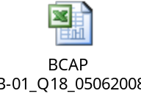

There are changes in the allocation method of two existing regulatory accounts, the Core Fixed Cost Account (CFCA) and Noncore Fixed Cost Account (NFCA). These changes are discussed in the testimony of Mr. Lenart on page 8, lines 8 through 23.

QUESTION 19:

Mr. Ahmed indicates that his responsibilities include “SoCalGas’ regulatory balancing accounts, tracking and memorandum accounts…” (p. 1). The following questions pertain to non-core transportation revenues.

- Please explain how under- and over-collections of non-core transportation revenues are currently allocated to customers.

- Please explain which balancing account currently tracks these differences and how these balances are currently allocated to customers. For example, are these costs tracked for all non-core customers as a whole, or are they separately tracked for individual customers or for groups of customers?

- Are over- and under-collections collected or refunded on an equal cents per therm basis or is this done in some other manner? If these costs are not allocated on an equal cents per therm basis, please explain the basis for the allocations.
- Please explain whether the Applicants are proposing any changes to the manner in which these under- and over-collections are tracked and allocated.

RESPONSE 19:

a. Noncore transportation revenues are balanced with the related authorized and actual non-gas costs in regulatory accounts. The resulting under- or over-collected balance in the regulatory account is allocated to customers based on the allocation method authorized for the specific regulatory account.
- As discussed in the testimony of Mr. Ahmed on pages 5 and 7-10, noncore transportation revenues and the related authorized and actual non-gas costs are balanced in the Enhanced Oil Recovery Account (EORA), Noncore Fixed Cost Account (NFCA), and the Integrated Transmission Balancing Account (ITBA). Revenues and costs are not recorded in the NFCA and ITBA by individual customer class but in total; the EORA records revenues and costs specifically for the EOR customer class. Refer to the response to 1.18 for the current allocation method for these accounts.

- Refer to the response to question 18 for the current allocation method for each regulatory account.

e. Refer to the response to question 18 for proposed changes to the allocation method for these regulatory accounts and the testimony of Mr. Ahmed on pages 7-10.

QUESTION 20:

On p. 6, Mr. Schwecke states that “Interstate pipelines competing with the Utilities recover their fixed costs through a Straight Fixed Variable rate design that recovers all fixed costs over the capacity reserved on that interstate pipeline.”

- Please provide a list of the pipelines that are competing with the Utilities.

- Please provide the rates for each of these pipelines.

- Please indicate whether each of these pipelines has any throughput risk and, if so, how much.

RESPONSE 20:

a. SoCalGas continues to compete with Kern River GT, Mojave Pipeline Company, and recently North Baja Pipeline. However, any interstate pipeline could propose to run an extension of their line or a new line to compete with the Utilities.

b. The existing rates for all the interstate pipelines serving southern California are available online from each respective company’s web site.

c. Please see response to SCGC Data Request 8, Question 8.1.1.

QUESTION 21:

On p. 9, Mr. Schwecke states: “The Utilities propose here to redesign the rates of their transmission-level noncore customers. This group of customers includes a majority of those whose high usage and experience managing energy needs makes them the traditional candidates to commit to the construction of an interstate pipeline into the Utilities’ service territories.”

- Given that SoCalGas has conducted an embedded cost study and that an embedded cost study aims to “achieve a reasonable representation of the true costs of serving a specific customer classes” (Emmerich, p. 17), why do the Applicants not then keep the embedded costs within each customer class separate so as to ensure that the costs are most appropriately allocated to those customers who incur them?

- Since SoCalGas has asserted that its embedded cost study represents, as close as possible, the costs of providing service to Long Beach, why does SoCalGas not propose to maintain a separate rate schedule for Long Beach?

- The embedded cost study allocated different per-unit embedded costs to each of the transmission-level customers. Why then does SoCalGas propose to combine transmission-level customers into one rate class under the TLS tariff? Please explain how this proposal is consistent with the objective of the embedded cost analysis (i.e., to appropriately assign costs to customer classes).

- Would the price signals sent to a customer be more clear if the customer had its own rate schedule or if many customers received service under a particular rate schedule? Please explain your answer. If price signals would be more clear with individual rate schedules, what is the justification for SoCalGas’ proposal to cancel Long Beach’s rate schedule and to place Long Beach under an aggregated TLS rate schedule?

- Please indicate whether the new TLS rate structure encourages energy efficiency and promotes greenhouse gas reductions and, if so, how. Please quantify the energy efficiency and other benefits anticipated by the proposed TLS rate.

RESPONSE 21:

a. The costs required to serve noncore transmission level service customers are not kept individually because then there would be a separate TLS rate for every customer comprising the TLS class. In order to achieve a single TLS rate, the costs required to serve all TLS customers are combined.

b. Long Beach will not need a separate rate schedule because Long Beach has been classified as a member of the new TLS class.

c. SoCalGas proposes to combine transmission-level customers into one rate class under the TLS tariff in order to have a single TLS rate that meets the needs of this unique class. This proposal is consistent with the objective of the embedded cost analysis because the costs are assigned to the new customer class, i.e. the TLS class.

d. The price signals are most clear when they respond to the issue being addressed. The issue being addressed is that there are a group of customers whose high usage and experience managing energy needs makes them the traditional candidates to commit to the construction of an interstate pipeline into the Utilities’ service territories.

e. When compared to the existing all-volumetric rate structure, the proposed TLS rate structure is neutral as to the discouragement of energy efficiency or increasing of greenhouse gas emissions.

QUESTION 22:

On p. 32, Mr. Schwecke provides a list of the lines that are “backbone pipelines” and “local pipelines.”

- Please indicate what criteria are used to designate a pipeline as backbone or local. Please provide all documentation that supports the use of these criteria.

- Please indicate whether these criteria have changed over the past five years. If so, please explain how and why.

- Please explain how it is determined whether a customer takes service from a backbone pipeline or a local pipeline.

- Please identify the pipeline from which Long Beach takes its service and whether this pipeline is considered a backbone pipeline or a local pipeline. Please provide all documentation that supports this designation.

- Please provide a map that shows the location of all SoCalGas pipelines with the corresponding backbone and local transmission pipeline numbers shown on the map.

RESPONSE 22:

  - Transmission pipelines in the SoCalGas and SDG&E system are classified as either backbone or local transmission pipelines depending upon the function they primarily serve. Backbone transmission pipelines transport gas supplies from the interstate pipelines and from California producers to the local transmission pipeline system or to the storage fields. Local transmission pipelines transport the supplies from the backbone transmission system or from the storage fields to end-use customers.
  - These criteria for classifying transmission pipelines have not changed over the past five years.
  - A customer’s interconnection with the SoCalGas or SDG&E system determines whether the customer takes service from a backbone transmission, local transmission, or distribution pipeline.
  - Long Beach takes service from several pipelines in the Los Angeles Basin:
Line 512 (local transmission)
Line 775 (local transmission)
Line 1211 (local transmission)
Supply Line 37-52B (distribution)
Per the meet-and-confer on April 29, 2008, the attached map of the SoCalGas and SDG&E system highlights areas that generally consist of the local transmission pipelines listed in Mr. Schwecke’s Prepared Direct Testimony.


QUESTION 23:

On p. 34, Mr. Schwecke states that “Specifically, 35% of the Utilities’ 1-in 10 year peak day end-use demand is served directly off of the backbone transmission system, without going through any local transmission lines as classified in Table 2 above.”

- Please indicate whether Long Beach is one of these customers that take service off of the backbone transmission system without going through any local transmission lines.

- Please indicate whether you believe it is appropriate to allocate the local transmission costs to these customers who take service directly off the backbone. If so, please explain why this might be appropriate.

RESPONSE 23:

  - Long Beach does not take service directly from a backbone transmission pipeline.
  - Yes, it is appropriate. Please refer to the Prepared Direct Testimony of Mr. Schwecke at page 34.

QUESTION 24:

Mr. Watson states that SoCalGas intends to meet and confer with wholesale core customers and DRA to implement core parity.
- Please explain how SoCalGas defines “core parity” for wholesale core customers and state the basis for SoCalGas’ views in this regard.
- Does SoCalGas believe that its current storage contract with Long Beach reflects parity with SoCalGas’ core customers? Does SoCalGas believe that the inventory, injection and withdrawal capacities reserved for Long Beach under this contract reflect parity with SoCalGas’ core customers?
- Does SoCalGas believe that its current storage contract with Long Beach reflects parity with the core customers of SoCalGas and SDG&E under their proposed combined SoCalGas/SDG&E core portfolio? Does SoCalGas believe that the inventory, injection and withdrawal capacities reserved for Long Beach under this contract reflect parity with core customers of SoCalGas and SDG&E under their proposed combined SoCalGas/SDG&E core portfolio?
- Please explain how the inventory, injection and withdrawal capacities reserved for Long Beach in its current contract with SoCalGas were determined. Please explain and provide copies of any demand forecast used by SoCalGas to determine Long Beach’s core storage requirements. Please also provide a list of the key assumptions made by SoCalGas in determining Long Beach’s core storage requirements under its current storage contract and provide calculations showing how these capacities were derived.

RESPONSE 24:

a. The last Section of Mr. Watson’s Phase 1 Testimony discusses “core parity”. Mr. Watson’s Omnibus testimony (A.06-08-026) discusses this topic in more detail.

b & c. In the near-term, the Omnibus Decision directed that no unbundled storage sales be made until “wholesale core customers have had an opportunity to make their desired reservations in the same proportion as the combined core portfolio.” (p.101) SoCalGas estimated Long Beach annual core load to be 1.35% of the combined core load of SoCalGas and SDG&E. The decision provided Long Beach the opportunity to purchase 1.35% of the quantities provided to the combined core in the Omnibus Decision (79 Bcf, 369 MMcfd injection, and 2225 MMcfd of withdrawal). Although the Omnibus Decision did not require it, SoCalGas sold these quantities at the same fully-scaled LRMC rate paid by the combined core for storage in 2008. Assuming that Long Beach follows the same flowing supply and storage purchasing strategy for its core that is followed by the combined core, this allocation should provide the same level of reliability at the same price as the combined core. This asset allocation is identical to the increase Mr. Watson suggested for a larger combined core portfolio in his Rebuttal Testimony in the Omnibus proceeding. One advantage of the combined portfolio approach suggested by Mr. Watson is that the use of these cost-based assets would remain under CPUC jurisdiction.

Long Beach accepted this package on January 18th rather than compete in the unbundled storage program to buy some different package at the then-prevailing market price. It is up to the Commission in this BCAP to determine whether this is an appropriate long-term practice.

d. The spreadsheet below, which was included in the January 15th offer package to Long Beach, explains the calculation. No alternative calculation was suggested by Long Beach.

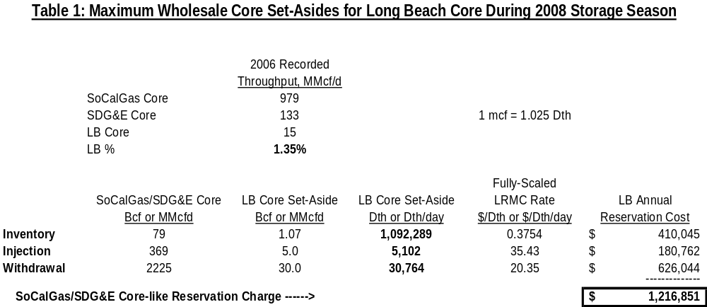

QUESTION 25:

Mr. Watson proposes that the current 10% monthly balancing tolerance be reduced to 5% (p. 4).
- (WITHDRAWN) How much tolerance did Long Beach use in each month, from 2000 through 2007? How much would Long Beach have been required to pay in each of these years if the monthly balancing tolerance had been 5%? Please provide all data underlying this analysis.
- Does Watson’s statement that “noncore customers do not frequently use more than a five percent monthly tolerance” refer to noncore customers in the aggregate or to individual noncore customers? Please provide all data underlying this analysis.
- For each month from 2000 through 2007, what percent of noncore customers used between 5% and 10% of balancing tolerance? What would the additional costs to these customers have been had the balancing tolerance been 5%? Please provide all data underlying this analysis.

RESPONSE 25:

a. WITHDRAWN

b. Noncore customers in aggregate. This is an appropriate perspective because if the aggregate level is below the tolerance level, noncore customers who are out of tolerance should be able to trade with noncore customers who are within tolerance.

Long Beach’s data illustrates this point. Long Beach never incurred a penalty for being outside of the 10 percent monthly balancing tolerance over this period. Even though it had many months where its month-end imbalance was greater than 10%, it used imbalance trading to get within the ten percent tolerance level over those months. Had the balancing tolerance over the period been 5%, rather than 10%, Long Beach could easily avoid imbalance penalties though additional imbalance trading. In addition, Long Beach could do a better scheduling job to match monthly supplies with monthly burns in order to reduce the need for imbalance trading. Even absent such imbalance trading, customers can purchase/sell storage inventory to bring themselves in balance. For a further discussion, please see SCGC 3.1 and 3.4.

c. See SCGC 3.1.

QUESTION 26:

Please provide all spreadsheet-based workpapers for SoCalGas’ demand forecast in Excel worksheets with all links intact.

RESPONSE 26:

The accompanying Excel files, with link references where applicable, are grouped by SoCalGas demand forecast category. Those files without links contain data imported into Excel from non-Excel sources.

Service Area Economy:
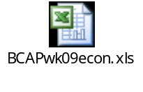
Natural Gas Prices:
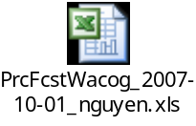

Customers:
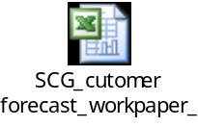

Residential:


Core Commercial:
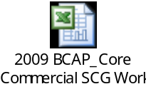

Core Industrial:
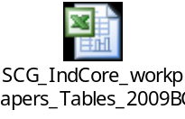

Small Cogeneration:
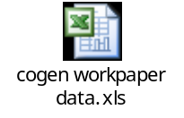
Natural Gas Vehicles (NGV):
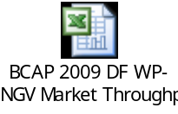

Noncore Commercial:
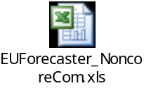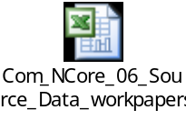

Noncore Industrial:
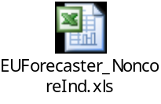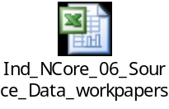

Enhanced Oil Recovery (EOR):
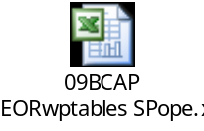

QUESTION 27:

Please provide the source (with date) of all data used in compiling forecasts for transmission-level average year throughput, cold year throughput, cold year peak month throughput, and peak day throughput for the following customer categories: Core, C&I, EG, other Noncore Retail, Long Beach, SDG&E, Southwest Gas, Vernon, and Mexicali. Please provide all workpapers used in developing these forecasts.

RESPONSE 27:

Forecast sources were various SoCalGas internal models. The following files include models and workpapers for these sources.

Consolidated Demand and Peak Calculations, with Various Linked Files
(use WinZip or similar program to extract the various Excel files from this single ZIP file).


Non-Core Retail Commercial & Industrial
Attached is a file containing the noncore G30 demand forecast which combines the industrial refinery load and regular noncore C&I load. Also attached is the noncore C&I demand forecast with supporting model for forecasting cold, peak day, peak month, etc. Both models were finalized on November 1, 2007.
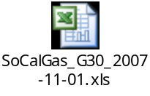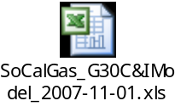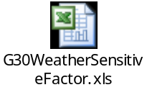

Electric Generation (EG)
The forecast was made in Fall, 2007, with data recorded through October 2007.
SoCalGas’ source of its EG forecast was the “Market Analytics – Zonal Analysis Module”. This model is powered by PROSYM -- the industry's leading chronological simulation engine that is used by over 130 customers worldwide for over two decades. The PROSYM simulation engine optimizes unit commitment and economic dispatch to meet the load for an interconnected electric system, considering the reserve requirements and other aspects of the electric system. PROSYM uses Lagrangian relaxation coupled with an exhaustive search for marginal units. Market Analytics includes multi-area unit commitment functionality and supports cost or bid based dispatch as well as ancillary services price forecasting simultaneously optimized with energy. The highly flexible user interface enables users to determine the granularity of the market to be analyzed – from 10 minute to four hourly time steps - from single control areas to entire continents.

Enhanced Oil Recovery (EOR)
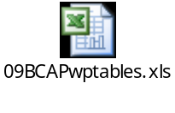

Wholesale and Mexicali-Ecogas
The 2006 California Gas Report 2006 (http://www.socalgas.com/regulatory/cgr.shtml) was used in compiling BCAP forecasts for City of Long Beach, Southwest Gas and Mexicali. These forecasts were provided by those respective customers. The workpapers for Long Beach, SDG&E, Southwest Gas, Vernon, and Mexicali are shown in the Demand Forecast Workpapers Herb Emmrich, (SoCalGas BCAP Workpapers Volume 2 of 4), page 325, available online at: http://socalgas.com/regulatory/bcap2008/docs/wp_emmrichDemand1.pdf

QUESTION 28:

Please provide the transmission-level average year throughput, cold year throughput, cold year peak month throughput, and peak day throughput separated out by local and backbone pipeline for the following customer categories: Core, C&I, EG, other Noncore Retail, Long Beach, SDG&E, Southwest Gas, Vernon, and Mexicali. Please provide all workpapers used in developing these figures. If the sum of the local and backbone pipeline throughputs for any of these customer categories does not equal the transmission-level throughput figures shown in Mr. Lenart’s workpapers (Alloc Factors tab), please explain why.

RESPONSE 28:

SoCalGas does not identify or record throughput by customer class that differentiates between local and backbone transmission level service.

QUESTION 29:

Please explain why local transmission costs are allocated based on cold year coincident peak month throughput and backbone transmission costs are allocated based on cold year throughput. (See Cost Alloc sheet in wp_smith 9.xls.)

RESPONSE 29:

As discussed (starting on p. 14) in the testimony of Ms. Smith, SoCalGas proposes to move to a different allocation for local transmission costs.

QUESTION 30:

It appears from wp_smith 9.xls that local transmission costs are allocated by multiplying a customer’s total cold year coincident peak month throughput by the per unit long-run marginal cost for local transmission.

  - Is this correct? If not, please explain how local transmission costs are allocated. If so, please explain why it is reasonable to allocate local transmission costs based on total (i.e., local and backbone) throughput rather than based on local throughput.

  - Is it reasonable to allocate local transmission charges to customers that do not use the local transmission system? If so, please explain why.

RESPONSE 30:

a. Yes

b. All customers use the local transmission system, even those that are directly connected to a backbone transmission pipeline since the function of a backbone transmission pipeline does not include service directly to end-use customers. For this reason, SoCalGas and SDG&E have allocated a certain percentage of the backbone transmission system costs to the local transmission system. Please refer to Mr. Schwecke's prepared direct testimony at page 34 for further details.

QUESTION 31:

Please confirm that the workpapers for Table 8 and Table 9 are in the file wp_smith 7.xls. If this is incorrect, please identify the file or files containing workpapers for these tables.

RESPONSE 31:

Yes, Tables 8 and 9 of Ms. Smith’s testimony summarize the results of the study presented as WP#7.

QUESTION 32:

Please explain why the M&S Loader for SoCalGas local transmission in wp_smith 7.xls is $0.0002/dth and the M&S Loader for SoCalGas local transmission in Table 9 is $0.0003/dth.

RESPONSE 32:

Table 9 should be $0.0002/dth.

QUESTION 33:

Please provide brief descriptions of each workpaper (e.g., wp_smith1: Levelized annual capital costs and RECC factors).

RESPONSE 33:

WP# 1 Economic Assumptions
Includes RECC factors, Inflation

WP# 2 A&G Loader

WP# 3 General Plant Loader

WP# 4 M&S Loader

WP# 5 Customer-related marginal unit costs

WP# 6 Distribution marginal unit costs

WP# 7 Transmission marginal unit costs

WP# 8 Storage marginal unit costs

WP# 9 Base Margin Allocation

WP #10 Core Brokerage Fee

QUESTION 34:

Please provide a table of contents for each spreadsheet that contains more than ten worksheets. See, for example, the tables of contents for Mr. Lenart’s workpapers.

RESPONSE 34:

Only two files contain more than 10 sheets WP#5 and WP#6. WP#6 already contains a description of all tabs as the first page of the worksheet. Although the tab names in WP#5 are already descriptive, a TOC for WP#5 is provided below.

Worksheet Tab | Purpose
Number of Customers | customer count data by class
Residential Segmentation | data for intraclass allocation for Residential segment
G10 Segmentation | data for intraclass allocation for Core C/I segment
G30 Segmentation | data for intraclass allocation for Noncore C/I segment
Escalation Factors | data to escalate costs to 2009$
Investment Meters, REGs | data reflecting meter and house regulatory cost by customer class
Investment Service Lines | data reflecting service line cost by customer class
DG Cost | data reflecting costs for distributed generation customers
Big Gems | data reflecting costs of Big GEMS by customer class
Exclusive Use Facilities | data reflecting exclusive use costs by customer class
O&M Customer Services | data reflecting O&M costs related to Customer Services activities by customer class
O&M Customer Accounts | data reflecting O&M costs related to Customer Accounts activities by customer class
O&M Meters, Regulators, MSAs | data reflecting O&M costs related to Meter, Regulators and MSA by customer class
O&M Service Lines | data reflecting O&M costs related to Service Lines by customer class
A&G-Payrol, GP Loading Factors | A&G and General Plant loading factors
M&S Add-on | M&S loader allocated by customer class
Customer_Cost_LRMC! | Calculation of Customer-related marginal unit cost by customer class
Meter, Regs Replacement | data used for NCO calculation
EU Replace factors | data used for NCO calculation
NCO method | Calculation of Customer-related marginal unit cost under the NCO method by customer class
Summary! | Summary of customer-related marginal unit cost by customer class

