Subject: Direct Testimony of R. Thomas Beach:

QUESTION 1:

Please provide a complete set of workpapers for the above referenced testimony served on December 23, 2008. Workpapers should be in the form of working Excel spreadsheets with complete formulas and relevant data. If the workpapers are derived from the workpapers of a SDG&E/SoCalGas witness, please identify the version of the workpapers and all changes made to the original workpapers to reflect your proposal. The identification of changes should include the workpaper name, all cells changed and an explanation for the change.

RESPONSE 1: Attached is a complete set of workpapers for Mr. Beach’s testimony. Please note that the Word document includes a brief summary of the spreadsheets included in the workpapers; this summary and the title of the spreadsheets indicate the derivation of these workpapers from SCG/SDG&E workpapers. All six of these spreadsheets are linked to each other.

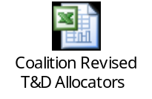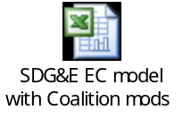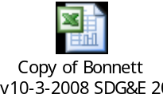

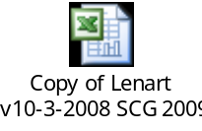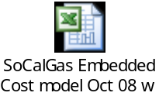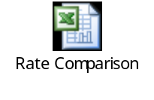
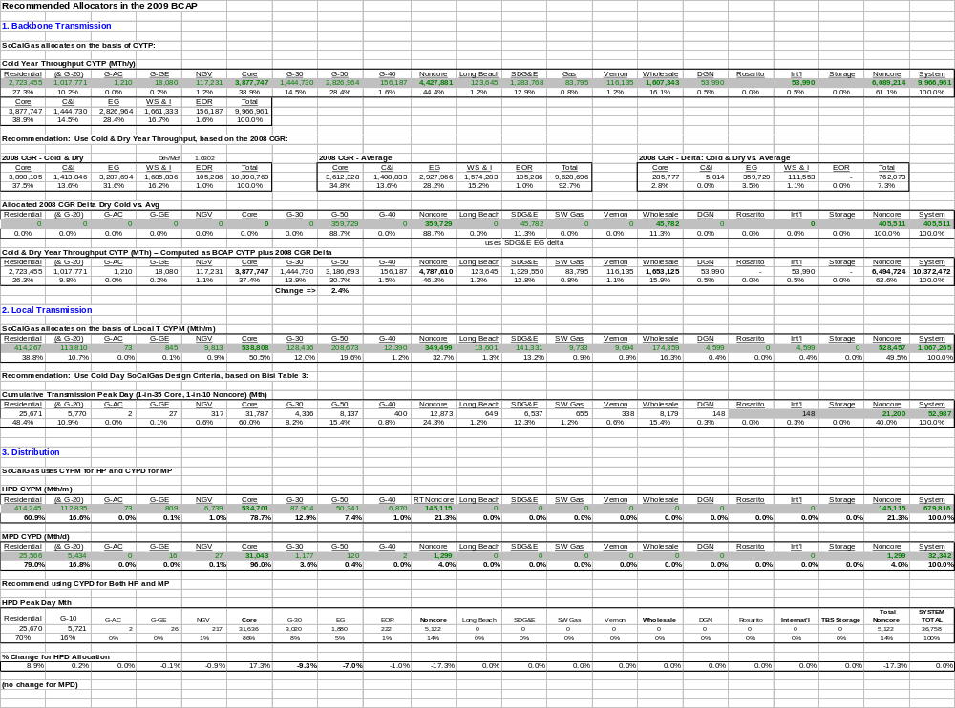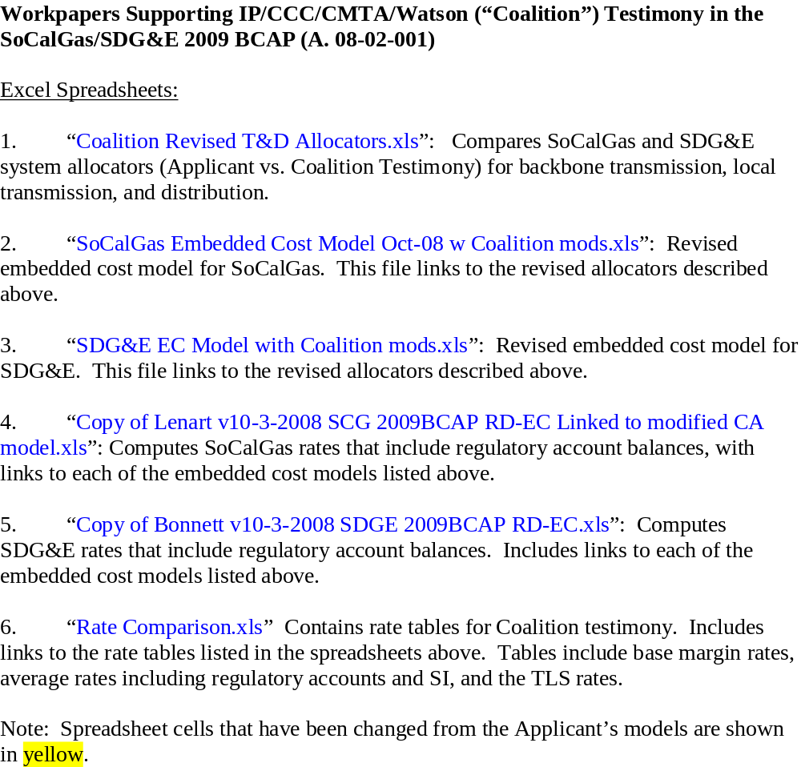

QUESTION 2:

Please provide electronic copies of all ongoing data requests and responses from other parties in this proceeding.

RESPONSE 2: To date, IP / CCC / CMTA / Watson have received only an informal request for Mr. Beach’s workpapers from the Southern California Generation Coalition.

