QUESTION TURN-TCAP-PSEP-03-01:

On pages 6-7 of the Sempra Utilities’ 8/26/11 PSEP filing, the Sempra utilities state: “Further records research reduced the number of miles in Category 4 to 385 miles (322 miles for SoCalGas and 64 miles for SDG&E).” Please provide any documents provided to the CPUC that document and explain this reduction in the number of Category 4 miles.

RESPONSE TURN-TCAP-PSEP-03-01:

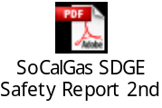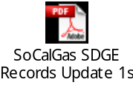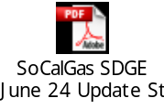

Three updates to the April 15, 2011 Report of SoCalGas and SDG&E on Actions Taken in Response to the National Transportation Safety Board Recommendations were provided to the CPUC between April 15, 2011 and August 26, 2011, the date we filed our proposed PSEP. These updates are attached and explain the reduction in the number of Category 4 miles. One was provided on April 26, 2011, one on May 9, 2011, and one on June 24, 2011.

QUESTION TURN-TCAP-PSEP-03-02:

Please provide the complete response to DRA DAO-16-6.

RESPONSE TURN-TCAP-PSEP-03-02:

DRA-DAO-16-6 is confidential, but will be provided to TURN upon execution of a non-disclosure agreement with SoCalGas and SDG&E.

