Application No: A.04-12-004
Exhibit No.:
Witness: Stephen A. Watson

In the Matter of the Application of San Diego Gas & Electric Company (U 902 G) and Southern California Gas Company (U 904 G) for Authority to Integrate Their Gas Transmission Rates, Establish Firm Access Rights, and Provide Off-System Gas Transportation Services. | )  )  )  )  )  )  )  ) | A.04-12-004  (Filed December 2, 2004)
PREPARED DIRECT TESTIMONY
OF STEPHEN A. WATSON
SAN DIEGO GAS & ELECTRIC COMPANY
AND
SOUTHERN CALIFORNIA GAS COMPANY

BEFORE THE PUBLIC UTILITIES COMMISSION
OF THE STATE OF CALIFORNIA
May 5, 2006

TABLE OF CONTENTS
Page

A. WITNESS QUALIFICATIONS 1
B. PURPOSE OF TESTIMONY 1
C. FIRM ACCESS RIGHTS 1
1. The Importance of Establishing Firm Access Rights 1
2. Path-based versus postage stamp fees for firm rights 9
3. Proposed Allocation of Firm Capacity 9
a. Step 1 - Set-Aside Options for Three Years 10
b. Step 2 - Preferential Open Season Bidding by Noncore Customers for Three Years 11
c. Step 3 - Long-Term Open Season for Remaining and New Receipt Capacity 12

4. Capacity Allocations After Initial Awards 15
5. Regulatory Process 15
6. Interruptible Forward-Haul Service 16
D. OFF-SYSTEM SERVICES TO PG&E 16
1. Interruptible Off-System, Backhaul Service/ 16
2. Firm Off-System at Either Wheeler Ridge or Kramer Junction 17
3. Regulatory Process for Off-System Services 17
E. MARKET MONITORING 18

PREPARED DIRECT TESTIMONY
OF STEPHEN A. WATSON

A. WITNESS QUALIFICATIONS
My name is Steve Watson. I am employed by SDG&E and SoCalGas as the Capacity Products Staff Manager. My business address is 555 West Fifth Street, Los Angeles, California, 90013-1011.
I received a Bachelor’s degree from the University of California, Davis, in History and International Relations and a Master’s Degree in Public Policy from the University of California, Berkeley. I have been employed by SoCalGas since 1986. I have worked in Gas Supply, Customer Services, the Strategic Planning and Transmission Capacity Planning Departments. I am currently the Capacity Products Staff Manager, responsible for staff support to the line managers in the development of new transmission services, interstate commitments, supplier interconnects, and storage services. Before joining SoCalGas I worked as a natural gas analyst at the Department of Energy.
I have previously testified before this Commission.

B. PURPOSE OF TESTIMONY
The purpose of my testimony is to generally describe the proposal of SDG&E and SoCalGas to establish a system of firm access rights. The implementation details of this proposal and supporting tariffs are being sponsored by Mr. Schwecke. I will also describe how SDG&E and SoCalGas propose to provide off-system transportation services to Pacific Gas and Electric Company (PG&E).

C. FIRM ACCESS RIGHTS

1. The Importance of Establishing Firm Access Rights
A proper system of firm, tradable access rights will permit developers of interstate pipeline and LNG projects to know that their gas supplies will be able to enter the SDG&E and SoCalGas system on a firm basis. SDG&E and SoCalGas therefore request that the Commission adopt the system of firm, tradable access rights presented below as soon as possible.
An integrated SDG&E and SoCalGas transmission system has the capability to take 3,875 MMcf/d of intrastate and interstate supplies from various receipt points and redeliver those supplies to storage fields and/or end-users. This is a firm, 365 day a year capability. This capability is 50% greater than SoCalGas’ annual average load during 2003, which was slightly less than 2,600 MMcf/d. Nevertheless, the total supplies that theoretically could reach SDG&E and SoCalGas on a given day are 5.7 Bcf/d based on the Federal Energy Regulatory Commission (FERC) Certificated Capacity or SoCalGas estimated physical capacity of upstream pipelines. This “mismatch” between potential upstream supply delivery and existing intrastate transmission redelivery capability may well increase as new supply projects are developed.

Table 1

Pipeline | Upstream Capacity
El Paso @ Blythe | 1,410
El Paso @ Topock | 540
Transwestern @ Needles | 1,150
PG&E @ Kern River | 650*
Southern Trails @ Needles | 80
Kern/Mojave @ Wheeler | 885
Kern @ Kramer | 500
Occidental @ Wheeler | 150
California | 310
Total | 5675
*Estimate of physical capacity
This mismatch can create uncertainty for suppliers and their customers about whether the full supply from a particular source will be delivered. Under current rules, this mismatch makes it difficult to create a firm connection between a supplier and its southern California end-use customer that is reliable every day of the year.
If a particular single interstate pipeline has contracted capacity with its shippers for volumes that exceed the physical take-away of a specific SoCalGas receipt point (e.g., Kern River Pipeline Company (Kern River) at Wheeler Ridge), it is the upstream pipeline shippers’ contractual rights that define whose gas flows on that day. SDG&E and SoCalGas believe that this Commission would rather have California end-users, or their agents, control which supplies enter the SDG&E and SoCalGas system under this circumstance.
Furthermore, as detailed in this Application, many of SoCalGas’ receipt points with particular suppliers interact with other receipt points with other suppliers in certain Transmission Zones. An example of this in the Wheeler Ridge Zone is SoCalGas’ connection with Kern River and Mojave Pipeline Company (Mojave) at Wheeler Ridge, SoCalGas’ connection with Pacific Gas and Electric Company (PG&E) at Kern River Station, and SoCalGas’ connection with Occidental Petroleum (Occidental) at Gosford. Another example would be SoCalGas’ connection with Transwestern Pipeline Company (Transwestern) at North Needles, SoCalGas’ connection with El Paso Natural Gas Company (El Paso) at Topock, and SoCalGas’ connection with Kern River at Kramer Junction in the Northern Transmission Zone. Whenever the combined receipts from these multiple suppliers exceed the take-away capacity of the particular zone -- 1,435 MMcf/d of potential upstream receipts versus 765 MMcf/d of take-away capacity in the case of Wheeler Ridge and 2,150 MMcf/d of potential upstream receipts versus 1,590 MMcf/d of take-away capacity in the case of the Northern Transmission Zone -- then SoCalGas is forced to pro-rate allocations to the respective upstream suppliers./
Pro-rationing frustrates both suppliers and end-users, creates confusion in the marketplace, and does not necessarily allow the lowest-cost gas to get to end-use markets. Pro-rationing on the El Paso system during the last decade has led to contentious and time-consuming efforts at the FERC to institute a system of rational, firm rights on that pipeline which will obviate the need for pro-rationing. The CPUC has supported these efforts at the FERC.
Not only is there currently pro-rationing within both of these zones, the pro-rationing schemes have other drawbacks. As illustrated in Mr. Schwecke’s discussion of the current allocation system for the Northern Transmission Zone, there is an outdated preference for El Paso and Transwestern supplies over those from other suppliers interacting in that zone. In addition, as explained by Mr. Schwecke, the pro-rationing priorities for Wheeler Ridge are based on gas flows from suppliers in total from a prior period. This prevents customers from switching from one supplier/receipt point to another on a day-to-day basis to take advantage of daily price movements. It also means that a particular shipper might get cut if other shippers reduced deliveries during the prior period, even if the particular shipper has had constant deliveries.
Even after pro-rationing the various upstream suppliers in a Transmission Zone, if the allocations provide for less receipt point capacity than the contracted upstream pipelines’ delivery rights, it is the interstate pipelines’ upstream rights, not CPUC-established priorities, which determine whose gas flows into the SDG&E and SoCalGas system.
Under a system of firm access rights, it will be the holders of firm access rights who will determine which supply flows from each supplier on each day within each zone. Holding the firm receipt point rights that flow through the Wheeler Ridge Zone, for example, will give that customer the ability to determine the choice of supply daily. Along with the increased choice of supply will come increased certainty of flow. Firm receipt point rights will assure the customer that 100% of its designated gas flow will flow 100% of the time. Finally, firm access rights move the control of the SoCalGas receipt points from the FERC-regulated interstate pipelines to the utilities in California and their customers.
An alternative way to eliminate the supply uncertainty associated with the status quo would be to expand the take-away capacity of SoCalGas’ backbone transmission system to match or even exceed the peak, simultaneous delivery capacity of all upstream pipelines through additional investment in the SDG&E and SoCalGas backbone transmission system. But the cost of expanding SoCalGas’ receipt point take-away capability in this manner to 5 Bcf/d would be extremely expensive (greater than $857 million according to Mr. Bisi’s December 2005 testimony in R.04-01-025), and is, in SoCalGas’ opinion, unnecessary to do at ratepayer expense. SoCalGas already has total transmission delivery capacity that exceeds total end-use demand to a significant degree (a “slack capacity factor”)./
A better solution, one that does not require unnecessary capital investment in the backbone transmission system, is to create a system of firm tradable access rights on the intrastate transmission system. If SDG&E and SoCalGas establish ownership rights for the existing 3,875 MMcf/d of backbone transmission take-away capacity, the owners of those rights will be able to establish a firm, reliable connection between a particular supply source and the customer’s burnertip. The owners of such receipt point rights could then switch suppliers within a transmission zone on a daily basis depending on the price benefits of that supply. New customers or suppliers who value the receipt point rights more highly than others could bid or trade for those rights through the secondary market to ensure firm deliveries to the SoCalGas citygate. Prices in this secondary market would encourage low-cost suppliers to expand their access to California and could help shape/guide utility and shipper investment decisions.
PG&E has had a system of firm tradable backbone rights since 1998. Now is the time to establish a system of firm, tradable access rights on the southern California gas system.
The Comprehensive Settlement Agreement (CSA) of April 2000 tried to establish just such a system. That system, however, was never implemented and has now become outdated. Relative to the CSA framework, the firm access rights proposal recommended by SDG&E and SoCalGas in this Application should be preferable to customers because:

- The set-asides for core customers better match SoCalGas’ current El Paso and Transwestern service agreements and allow for future core supply diversity approved by the Commission in D. 04-09-022.

- There is a substantially lower reservation charge, and the resulting revenues are credited back to end-users. The credit back to end-users will exceed the reservation charge if the 3875 MMcfd of backbone capacity is fully subscribed and/or if 1 Bcfd or more of new receipt capacity is constructed.

- The broader and more flexible definition of access rights by transmission zone will allow customers greater ability to exert downward price pressure on competing gas supplies.

- It avoids changes to current storage and balancing rules. These changes were controversial and diminished customer support for the transmission-related aspects of the CSA.

Relative to the CSA framework, this proposal should be preferable to new gas suppliers because:

- It puts new gas supplies on a level playing field with existing supplies.

- It permits the economic expansion of the transmission system and the establishment of new receipt points.

- It allows new suppliers and/or their customers to obtain long-term access to the SDG&E and SoCalGas system so that their large capital investments can be justified.
Relative to the status quo, the proposal set forth below should be preferable to both suppliers and end-users because it will eliminate unpredictable pro-rationing that can and does occur in the Northern and Wheeler Ridge Transmission Zones. Absent the establishment of firm access rights, the development of the LNG supplies at both the Otay Mesa and North Baja Pipeline receipt points will lead to pro-rationing in the Southern Zone.
///
///
///
///
///
///
///
///
///
///

Table 2 – Current Available Firm Receipt Point Capacity and Zones
Name | Receipt Capacity (MMcf/d) | Transmission Zone  (MMcf/d)
Transwestern @ North Needles/ | 800 | Northern
Questar @ North Needles | 120 | Northern
El Paso @ Topock/ | 540* | Northern
TW @ Topock | 190 | Northern
Kern River @ Kramer | 500 | Northern
Subtotal of Supply | {2150}
Northern Zone Capacity |  | 1,590
El Paso @ Blythe | 1,210* | Southern
Subtotal of Current Supply | {1210}
Southern Zone Capacity |  | 1,210
Coastal System (Producers) | 150 | California
L85 System (Producers) | 160 | California
Subtotal of Supply | {310}
California Capacity/ |  | 310
Kern/Mojave @ Wheeler | 765 | Wheeler
PG&E @ Kern River Station/ | 520 | Wheeler
Oxy @ Gosford | 150 | Wheeler
Subtotal of Supply | {1435}
Wheeler Zone Capacity |  | 765
Total Receipt Points  (Total Non-CA Points) | 4,795  (5,105)
Total Backbone Capacity |  | 3,875
* Receipt capacity at Topock and Blythe will occasionally be reduced at times due to temperature and low sendout conditions, respectively. SoCalGas estimates the frequency of these conditions at these two receipt points to be approximately 3% of the time.
As Mr. Schwecke describes in more detail in his testimony, SDG&E and SoCalGas propose that firm rights holders choose their particular receipt point rights within a zone and that they have primary firm rights at that point. We also propose that they have alternate firm rights within that same zone without having to pay any additional fees. For example, if a party acquires firm rights at Kern/Mojave at Wheeler Ridge, they could also nominate on a firm basis at PG&E (Kern River Station) or Occidential at Gosford if primary rights holders were not nominating the full receipt point capacity at those receipt points. Nominations using alternate firm rights might still be pro-rated, but the likelihood and degree of pro-rationing is lessened by limiting alternate firm rights to receipt point holders in the same zone rather than allowing alternate firm rights outside of zones. For example, if 382 MMcf/d of primary firm rights were initially awarded at Kern/Mojave and PG&E each in the Wheeler Ridge Zone, allowing these primary rights to switch suppliers on an alternate firm basis would result in little, if any prorationing of those requests./ Allowing all 3,875 MMcf/d of firm rights holders, however, to have alternate firm rights anywhere on the system would continue current pro-rationing problems because alternate firm rights in excess of zone capacity limitations would need to be pro-rated./
This approach to the definition of firm rights is also generally analogous to that taken by PG&E in its Gas Accord. Customers with firm Baja path rights, for example, can choose among Kern River supplies at Daggett, and Transwestern or El Paso supplies at Topock, on a daily basis. But they cannot use these Baja path rights on an “alternate firm” basis to access Canadian supplies on the Redwood path. They must instead make interruptible purchases of Canadian supplies, space permitting, on the Redwood path.
We believe our proposal for alternate firm rights within transmission zones balances the need for firm rights certainty against supply choice flexibility. Within the Wheeler Ridge Transmission Zone, there would be the flexibility to choose among Canadian, San Juan, Rockies, and California supplies. Within the Northern Transmission Zone, there would be the flexibility to choose among San Juan, Rockies, and Permian supplies. And within the Southern Transmission Zone, there would be the flexibility to choose among San Juan, Permian, and potential LNG supplies.

2. Path-based versus postage stamp fees for firm rights
The Scoping Memo asks about the merits of path-based fees for firm rights (such as exist on the PG&E system) versus postage stamp (system-wide average) fees for firm rights such as are being proposed by SDG&E and SoCalGas. Differentiated, path-based fees have merit if the following conditions apply:
- There is an unbundling of the transmission system costs from rates.
- The embedded costs of the various paths can be easily identified.
- The costs of those paths vary significantly.
None of these conditions apply to the SDG&E and SoCalGas system. First, SDG&E and SoCalGas are not proposing to unbundle transmission costs from end-user rates. Second, PG&E’s Lines 300 and Lines 400 resemble interstate pipelines with two well-defined main paths where gas flows in one direction (toward the San Francisco Bay Area load center). The proper assignment of costs to those two paths is relatively straightforward. SoCalGas, on the other hand, has many more receipt points than does PG&E. Its transmission system is more of a network with bi-directional flows—the direction of flow depending upon the operation of the pipeline. For example, Lines 225/335 between Quigley & Adelanto are sometimes used to flow EP/TW supplies into storage during the summer and then to flow Wheeler Ridge supplies in a west-east direction to help support high loads on the east end of the SDG&E and SoCalGas system during the winter. This makes the proper cost assignment of facilities problematic. Finally, when the Gas Accord structure was originally established, there was a 10 cent/dth difference in the full contract rates of the Baja and Redwood on-system paths. SoCalGas’ average backbone transmission rate, as established in the CSA, was only 7.2 cents/dth in total. Parties to the CSA recognized there was little incremental benefit in trying to ascertain any small difference in the cost of the SoCalGas transmission system by particular paths.

3. Proposed Allocation of Firm Capacity
Most customers will need to make some adjustments in the capacity they are awarded through the open season process via trading in the secondary market. That is the very purpose of establishing well-defined ownership rights; owners need to be able to buy and sell the capacity to meet their ever-changing needs and market valuations. Nevertheless, our initial allocation procedures are suggested with the following priorities. First, preferential access to existing capacity will be provided to California producers and end-use customers up to their current usage of capacity. Second, any remaining existing capacity and/or new capacity will be provided to those shippers willing to sign long-term contracts that recover (1) the system-wide firm access reservation fee as established by the CPUC over time (SDG&E and SoCalGas are proposing 5 cents/dth/d) and (2) the full costs of any necessary expansion facilities. The procedures outlined below follow these priorities.

a. Step 1 - Set-Aside Options for Three Years
This step would apply to existing or any rolled-in expansion capacity like that identified above in Table 2. Based on conversations with customers, three years is about the maximum length of commitment end-use customers feel comfortable making. Furthermore, customer load profiles can change considerably over a three year period.

1. A set-aside option would be provided to California Producers up to their individual peak monthly average production level over the prior 12 months with a daily reservation charge of five cents/dth/d./ This set-aside would also apply to any SoCalGas “native gas” production.

2. A set-aside equal to the annual average commitments exceeding 18 months during the 3-year period would be established for the SoCalGas Gas Acquisition Group and the SDG&E Gas Acquisition Group with a daily five cent/dth/day reservation charge. These set-asides would be established based on actual commitments in place 3 months before the open season. For illustrative purposes, those set-asides would be equal to those in the table below based on today’s core commitments.

MMcfd

 | Ehrenberg | Topock | N. Needles | Wheeler Ridge
SCG | 470 | 280 | 200 | -
SDG&E | 10 |  |  | 50

- The core load of wholesale customers and core aggregators would have the option of matching upstream commitments similar to those described above or of bidding like other noncore customers in Steps 2 and/or 3 as described below.

- Customers holding CPUC-approved long-term contracts that specify one or more particular receipt point(s) would be entitled to a set-aside option to elect those receipt points pursuant to the terms of the contract. Currently, four customers have contracts that specify one or more receipt points of 80 MMcf/d in the Wheeler Ridge Zone.

- This step would be repeated every three years.

b. Step 2 - Preferential Open Season Bidding by Noncore Customers for Three Years
As with the set-asides, this open season process would only allocate existing or rolled-in expansion capacity. Noncore customers could bid for the remaining receipt point capacity listed in Table 2 subject to a 75% limitation discussed below. Their preferential bidding rights would be limited by their historical consumption levels. Customers could bid on a baseload basis only up to their annual average usage established during the most recent twelve-month period (Base Period). If applicable, core customers could also have bidding rights equal to the difference between their annual average usage and their matching upstream set-asides in Step 1. Customers could bid on a monthly basis, but would be limited by their actual monthly profile in the Base Period. A second limitation would be that total customer bids (including Step 1 set-asides) could not exceed 75% at any individual receipt point./ Other aspects of this process would be:

1. Term of the bid would be three years.

2. A five cent/dth daily reservation charge. We believe that 5 cents/dth/d is the minimum level of daily reservation charge that is needed to discourage speculation in and the hoarding of capacity. Customers who own capacity but who do not need it should have a strong financial incentive to sell the capacity, which, in turn, will help create liquidity in the secondary market.

3. Bids with monthly profiles based on the Base Period are permitted at existing receipt points, subject to the 75% limitation by month at each receipt point. But preference is given to base-load bids because bids that vary by month create gaps in firm access rights. Obviously, an annual base-load bid has higher value than a seasonal or monthly bid. This preference for base-load bids was used by PG&E in its Gas Accord Open Season and was endorsed by the Commission in its review of the CSA implementation tariffs in D.04-04-015.

4. If the bids at a receipt point exceed the capacity limit of 75%, the awards are pro-rated.

5. Remaining bid volumes may then be re-bid in a subsequent round of this step at another receipt point with available capacity.

6. This step would be repeated every three years.
The details of this open season process are discussed by Mr. Schwecke.

c. Step 3 - Long-Term Open Season for Remaining and New Receipt Capacity
After the needs of customers have been met with existing receipt capacity, a 15-year open season would be held for remaining and new receipt point capacity. Any creditworthy party could participate in this open season. Long-term bids are required in order to justify potential expansions and capital investments.
For new receipt points, the open season bids would be submitted at 5 cents/dth/d (the proposed system-wide firm access reservation fee)/ plus any new facility costs, which would be converted to cents/dth/day amortized over 15 years using the utilities’ cost structure. SDG&E and SoCalGas would attempt to expand the receipt point in question to meet all open season bids without prorationing. If necessary, however, prorationing would be used. The facility costs used in this incremental surcharge would be those necessary to add to the system’s current
3875 MMcfd of capacity; that is, the new receipt capacity would not diminish the take-away capacity of any other transmission zone or receipt point within the same zone./
Consistent with the recent System Integration Decision, a limited exception to the definition of receipt point costs in the long-term bidding for Step 3 would apply to the new Otay Mesa and North Baja receipt points. To the extent that end-users did not fully nominate existing Southern Zone receipt capacity, shippers at these new receipt points could submit 15-year bids for facility costs (unique to each receipt point) using the “displacement” of potential El Paso supplies at Ehrenberg on the Southern System. Center Road Station and Salt Works Station levelized costs, on the other hand, would be calculated using expansion costs./ Those suppliers would essentially be creating new transmission zones that add to the total capacity of the system without adversely impacting the take-away capacity of any other zone. For the first 800 MMcf/d or so of receipts at Center Road or Salt Works, there is little distinction between the “displacement” and “expansion” cost curves./ But these curves are significantly different for the Otay Mesa and North Baja receipt points./ If any initial long-term bid at Otay Mesa or North Baja were prorated due the full subscription of the 1210 MMcfd Southern System, those parties could resubmit their prorated volumes at bid prices that would include the higher costs of expanding the Southern System in conjunction with their particular receipt point.
Long-term bidders interested in capacity at existing receipt points, on the other hand, could submit volume bids at two price levels: (1) the system-wide firm access reservation fee established by the Commission (SDG&E and SoCalGas propose initially 5 cents/dth/d), and (2) 5 cents/dth/d plus the levelized cost of expanding that particular receipt point (assuming some credible interest has been expressed beforehand in such an expansion) spread over both remaining and expansion volumes at that receipt point. SDG&E and SoCalGas would charge the lower 5 cents/dth/d if all the bids at that receipt point can be accommodated without expanding facilities. If expansion is required to meet most of the open season bids at the higher price level, then SDG&E and SoCalGas will charge the higher price with expansion costs embedded in the charge./ Since an open season, not an auction, process is being used, some prorationing may be necessary even with the expansion of existing receipt point facilities./
Although binding open season bids would be based upon the best estimate of SDG&E and SoCalGas of expansion facility costs at the time of the open season, the contracts would establish the final “levelized expansion surcharge” using final, actual facility construction costs./
Winning open season bidders would receive the following:

1. 15-year bids with uniform annual rights throughout the period.

2. Capacity rights for the term of their commitment treated the same as other rights in their respective zone./

3. If bidders in this Step secure capacity that later is accorded rolled-in ratemaking treatment, they would be permitted to relinquish the capacity before the end of their contract term (and be relieved of the associated reservation charges). This relinquishment would be timed to correspond to the preferential allocation of “rolled-in” capacity to customers in succeeding Steps 1 and 2 open seasons.
Long-term shipper subscriptions for existing capacity will serve to reduce end-users’ net transportation rate. Nevertheless, in order to preserve end-users’ preferential access to existing capacity in Steps 1 and 2 three years later, SDG&E and SoCalGas propose that total existing receipt capacity subscribed to under long-term contracts be limited to 900 MMcfd, or 25% of
non-California capacity./ Prorationing would be used to meet this limit, if necessary, but preference would be provided to long-term shippers paying the “levelized expansion cost surcharge.”/

4. Capacity Allocations After Initial Awards
As described in further detail by Mr. Schwecke, SDG&E and SoCalGas will allow customers at any time to re-contract their initially-awarded firm capacity to any other receipt point for which there is space available. SDG&E and SoCalGas will also sell additional firm capacity, to the extent it is available, to any creditworthy party for up the tariffed reservation charge for a minimum term of one month and a maximum term of the remaining duration of the three year cycle.

5. Regulatory Process
SDG&E and SoCalGas believe that many of the expansions and new supply receipts described earlier should be considered for rolled-in rate treatment. At this point in time, however, SDG&E and SoCalGas and most potential new suppliers believe it is more important to get the facilities built and to establish a system of firm access rights than it is determine rolled-in versus incremental rate treatment. This framework allows infrastructure to be developed quickly and reasonably on an incremental cost basis but, at the same time, makes provision for potential rolled-in treatment of those facilities at a later point in time—after the merits of the facilities are well-demonstrated and understood.
Nevertheless, SDG&E and SoCalGas will, upon construction of the facilities, ask for expedited consideration of Advice Letters it would file. Upon completion of construction and as service is about to commence, rates will need to be quickly finalized, with Commission approval, via Advice Letter. SDG&E and SoCalGas are not proposing to obtain Commission approval prior to expansion of incremental receipt point facilities except where required by regulations or where a Certificate of Public Convenience and Necessity (CPCN) is required.

6. Interruptible Forward-Haul Service
Any un-awarded or unused firm capacity will be offered by the utility on a daily, interruptible volumetric rate up to the tariffed reservation charge. A 75/25 ratepayer/shareholder incentive/sharing mechanism with a $5 million/year cap on the shareholder portion will be established for interruptible revenues to provide the utility with a financial incentive to ensure that the maximum amount of interruptible capacity is offered and to ensure that firm capacity cannot be profitably withheld from the secondary market.

D. OFF-SYSTEM SERVICES TO PG&E
For off-system services to PG&E, the charges will be as shown in Ms. Smith’s testimony./
Off-system option services are described below.

1. Interruptible Off-System, Backhaul Service/
The utility may sell interruptible backhaul services from the citygate to any PG&E receipt point on its system. This gas could, in turn, then be delivered off-system by PG&E. This service will be interruptible, since it depends upon there being sufficient forward-haul deliveries at the utility receipt point.
Interruptible off-system service will help to ensure that long-term shippers don’t use only the minimal, take-or-pay off-system services and keep the remaining off-system capacity idle. Off-system service to PG&E will provide additional market outlets for new potential supplies coming to California, which, in turn, will increase the likely development of these new supplies. This service, by definition, will not jeopardize on-system reliability since it is interruptible. Moreover, such services would provide additional revenues, and therefore lower transportation rates, to utility customers.
SDG&E and SoCalGas propose to use the same incentive mechanism described for other interruptible services. An incentive mechanism will ensure that the utilities devote sufficient resources to the development of this new service.

2. Firm Off-System at Either Wheeler Ridge or Kramer Junction
SDG&E and SoCalGas are proposing to conduct an open season for firm backhaul service to PG&E that would require new facilities at either the Adelanto/Kramer Junction/ area or Kern River Station. This service would be sold to shippers willing to commit to long-term contracts with significant use-or-pay provisions priced at the utilities’ rolled-in system average transmission rates./ If the demand for facilities exceeds the availability of these facilities, SDG&E and SoCalGas propose to keep increasing the use-or-pay commitment associated with the facilities (up to 100%), in order to equate demand with supply.
Interruptible off-system services utilizing these facilities would be offered on a daily basis if the long-term contract rights were not being utilized./ The same incentive mechanism that applies to other interruptible service would apply to this daily service. The price cap on this daily, lower-priority interruptible service would be the same as described by Ms. Smith.

3. Regulatory Process for Off-System Services
SDG&E and SoCalGas propose that they would begin to offer the interruptible off-system service to PG&E immediately. The service will produce an immediate incremental benefit to ratepayers with absolutely no offsetting costs. SDG&E and SoCalGas would hold open seasons for firm off-system service to PG&E at Kern River Station and/or Kramer Junction.
If customer or shipper interest is expressed in either of these new, firm, facility-based off-system services, SDG&E and SoCalGas would then submit the project to the Commission for approval and to determine rolled-in or incremental pricing via an expedited application. The expedited application would contain the detailed estimated costs to be reflected in transmission rates.

E. MARKET MONITORING
SDG&E and SoCalGas are not proposing either: (1) receipt point capacity ownership limits or (2) price caps in secondary markets. We believe that excess capacity, secondary market trading opportunities, and interruptible service opportunities make such measures unnecessary. However, in order to assist the Commission in addressing any market power concerns it may have, SDG&E and SoCalGas will provide quarterly reports to the Commission and post market information on the SoCalGas EBB. Mr. Schwecke describes this information in detail. The Commission may impose price caps or ownership limits at some latter point if it deems that the markets are not functioning in a sufficiently competitive manner.
This concludes my testimony.
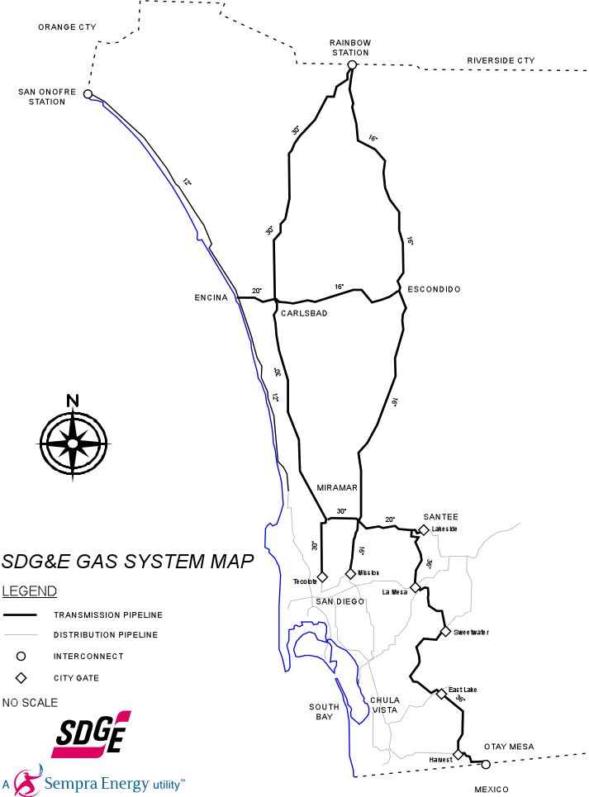
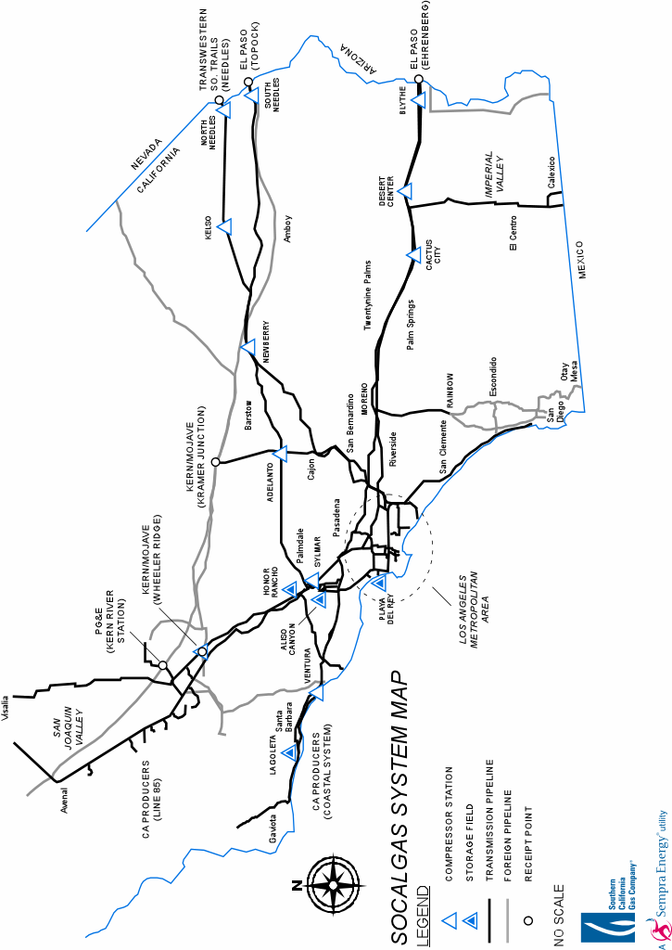

/ See Table 2 for a comparison of upstream receipts and intrastate take-away capacity in these two zones.
/ As will be clear later in my testimony, SDG&E and SoCalGas support expanding take-away capacity if the full costs of such expansion is paid for by interested shippers who, in return, would receive firm rights for said capacity.
/ Transwestern and Southern Trails at N. Needles cannot exceed 800 MMcf/d.
/ El Paso & TW at Topock cannot exceed 540 MMcf/d.
/ Excludes 20 MMcf/d of “other” producers who deliver directly into distribution, not backbone, system.
/ PG&E and Occidental Supplies cannot exceed 520 MMcf/d in total.
/ In this case, all 382 MMcf/d of firm primary rights at PG&E could switch to Kern/Mojave and 40% of the Kern/Mojave (138 MMcf/d) could switch to PG&E at Kern River Station on an alternate firm basis without prorationing.
/ It is for this reason that we propose that significant new LNG at L.A. Harbor or Center Road should not have alternate firm rights anywhere else on the system. Each of these LNG projects is larger than the Wheeler Ridge Zone. The first 600-800 MMcf/d of receipts from these potential new supplies will actually increase total take-away capacity on the SoCalGas/SDG&E system. If these projects proceed, they will be their own new Zones.
/ Wheeler Ridge is an access point for interstate supplies. Although Occidental has a traditional producer access agreement on the Line 85 system, its separate agreement for the Gosford connection, which interconnects to Wheeler Ridge and the Line 225 system, is more like those SoCalGas has with interstate pipelines. Occidental is treated like an interstate supplier for purposes of its interconnection at Wheeler Ridge. Any unsubscribed Line 85/San Joaquin capacity would be reallocated to Wheeler Ridge under Step 2.
/ This percentage is approximately equal to estimated 2004 consumption divided by 3,565 MMcf/d of non-California backbone take-away capacity. The preference accorded to end-users in this open season process is greater than that accorded in the CSA, which established a 50% receipt point limitation.
/ The Commission may re-evaluate this fee over time and change it. We recommend that the fee charged to all long-term shippers, however, should be the same charged to end-users through the 3-year open seasons.
/ This discussion is focused on Step 3 bidding for long-term firm rights and access by LNG developers. New interstate pipelines in the future can still connect to an existing zone at a new receipt point, which would not impose any downstream costs for SDG&E and SoCalGas ratepayers since the pipelines bear the interconnect cost, and have their receipt point become immediately eligible for nomination on an alternate firm and/or interruptible basis by shippers and subscription by end-users in succeeding open seasons.
/ See the December 1, 2005, testimony of David Bisi in R.04-01-025, Section G, for a discussion of the difference between expansion and displacement costs.
/ Ibid., Table 6, shows that the capital costs of expanding both Center Road and Salt Works can be considerably higher than the sum of the individual expansion costs. If there are successful open season bids that pay for the expansion cost for each individual receipt point, then there would be a second, incremental surcharge for both receipt points that would take this joint, common expansion cost and allocate it proportional to the final awards at those two receipt points.
/ One disadvantage Otay and North Baja shippers may have in the use of lower displacement capacity costs within an existing zone is that they will be subject to prorationing in Step 3.
/ In order to minimize the amount of expansion capacity that is actually required to meet the 15-year open season bids, SDG&E and SoCalGas would first ask all existing capacity rights holders if they are willing to turn-back their awarded capacity at 5 cents/dth/day.
/ SDG&E and SoCalGas do not propose to analyze a multitude of potential expansion volumes and construct supply curves for various levels. Instead, it will have a well-analyzed cost estimate for one, reasonable expansion volume and base the open season on that one expansion volume. If there is significant prorationing, SoCalGas will consider a second open season at a later date for a further expansion.
/ The final levelized cost surcharge might also have to be adjusted if open season bid volumes were slightly below total expansion volumes.
/ LNG coming through North Baja Pipeline or Otay Mesa will be a part of the Southern Zone. LNG supplies at the new receipt point of Center Road or Salt Works would constitute their own, new transmission zones.
/ This eventuality will only occur if many noncore customers choose not to exercise their option in Step 2 in the expectation of being served by shippers at the citygate over the initial 3 year period. The 25% limit is only an aggregate limit, not a limit at particular receipt points that may have most of their capacity remaining after Step 2.
/ This preference allows SDG&E and SoCalGas to fully recover expansion costs without having to adjust the open season bidders’ rate.
/ These charges for off-system service presume that a shipper has already paid the forward haul charge to deliver these supplies to the utilities’ citygate.
/ This type of service is already permitted to PG&E under its Gas Accord.
/ Although the Kramer Hub would be able to deliver off-system into pipelines other than PG&E, initial service from that Hub would be limited to PG&E until the Commission authorized off-system service to out-of-state pipelines. The service would only be firm up to the minimum level of combined on-system deliveries from the Wheeler Ridge & the North Desert Transmission Zone.
/ In other words, the use-or-pay commitment would guarantee sufficient additional throughput that rolling-in the cost of the facilities would lower the systemwide transmission rate. If there is insufficient demand to lower the systemwide rate from rolling-in the facilities costs, the service would be offered at an incremental rate per the testimony of Allison Smith.
/ The long-term contract holder could bump other, lower-priority “interruptible” volumes during the nomination cycles.

