QUESTION 27.1:

- Please calculate the GT-PS Peaking Service rate for each class of customer listed in the tariff assuming SoCalGas’ LRMC allocation as presented by Ms. Smith in direct testimony. The calculation should be provided with a complete set of workpapers in working Excel format (including all formulas and links to relevant spreadsheets) and explicitly tied to the class allocations presented in Ms. Smith’s complete LRMC Rental cost allocation spreadsheet associated with the December 5, 2008 revised testimony. If the workpapers for this GT-PS derivation are linked to any spreadsheet that has not previously been provided to SCGC, please provide a copy of that spreadsheet in response to this request.

RESPONSE 27.1:

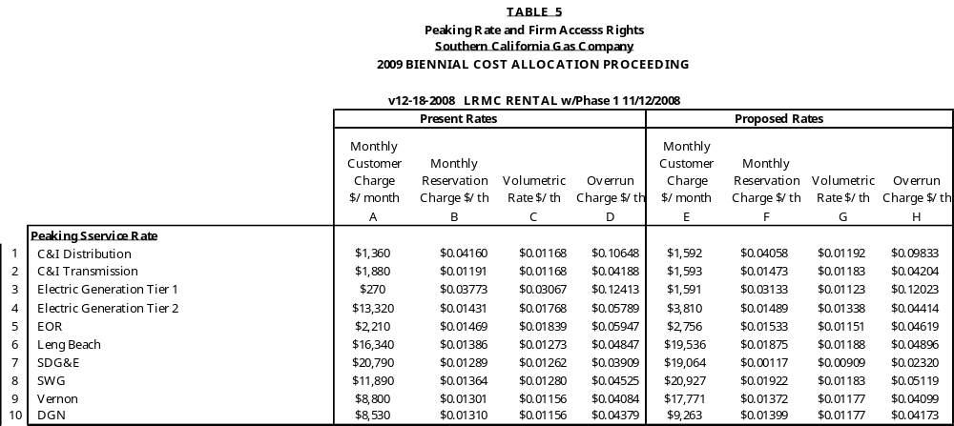

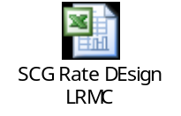

QUESTION 27.2:

- Please calculate the GT-PS Peaking Service rate for each class of customer listed in the tariff assuming SoCalGas’ proposed EC allocation as presented by Mr. Emmrich in direct testimony. The calculation should be provided with a complete set of workpapers in working Excel format (including all formulas and links to relevant spreadsheets) and explicitly tied to the class allocations presented in Mr. Emmrich’s EC cost allocation spreadsheet associated with the December 5, 2008 revised testimony. If the workpapers for this GT-PS derivation are linked to any spreadsheet that has not previously been provided to SCGC, please provide a copy of that spreadsheet in response to this request.

RESPONSE 27.2:

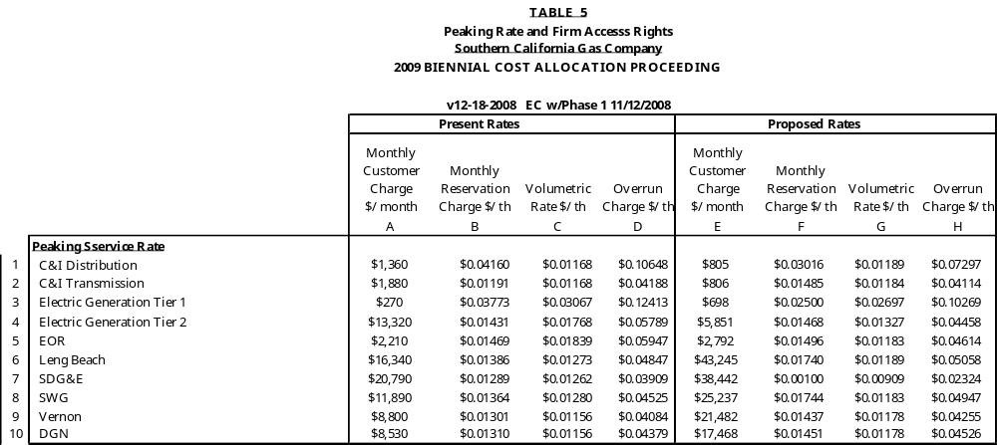



QUESTION 27.3:

- Please assume current system balancing procedures and explain each response:
  - Is the 4.2 Bcf of balancing inventory (as adopted in the Phase 1 settlement) used for providing 10% monthly imbalance tolerance?
  - Is this 4.2 Bcf of balancing inventory used for any other purpose?
  - Is the 200 MMcfd injection capacity used to perform daily balancing?
  - Is this 200 MMcfd injection capacity used for any other purpose?
  - Is the 340 MMcfd withdrawal capacity used to perform daily balancing?
  - Is this 340 MMcfd withdrawal capacity used for any other purpose?
  - In performing its daily balancing of the system, is the System Operator limited to the amount of load balancing assets (4.2 Bcf inventory, 200 MMcfd injection, and 340 MMcfd withdrawal)?
  - If the answer to the previous question is “no,” please explain what limitations on pipeline or storage assets that the System Operator faces in performing its daily balancing of the system.
  - Please provide the criteria that the System Operator uses to determine that a (high) OFO is required on any particular day.
  - Does SoCalGas/SDG&E match on a daily basis the amount of gas delivered for each noncore customer with the amount of gas burned by that customer plus injected/withdrawn from storage on behalf of that customer?
  - If the answer to the previous question is “yes” for only a portion of noncore customers, please specify which customers or customer classes correspond to the “yes” response.

RESPONSE 27.3.1:

Yes.

RESPONSE 27.3.2:

Like all other storage assets, the inventory may be used by the Hub for a short period of time if it is unused for balancing. It can also be used for hourly balancing.

RESPONSE 27.3.3:

Yes.

RESPONSE 27.3.4:

The injection may be sold on an interruptible (lower priority than balancing) basis. It can also be used for hourly balancing.

RESPONSE 27.3.5:

Yes.

RESPONSE 27.3.6:

Under SoCalGas’ proposal, the withdrawal may be sold on an interruptible (lower priority than balancing) basis.

RESPONSE 27.3.7:

No.

RESPONSE 27.3.8:

On the high (injection) side, the Operator is limited by total injection capacity. On the low (withdrawal, winter) side, the operator is limited by total withdrawal capability and the system storage inventory level-based balancing regimes established in Rule 30 G for winter balancing.

RESPONSE 27.3.9:

As described on the Envoy EBB, “An OFO is declared when SoCalGas determines that the expected total transportation delivery quantities for a specific gas flow day exceeds its total forecasted system capacity (including storage) on that flow day.: Forecasted system capacity is the sum of the forecasted sendout (i.e., the demand forecast), the injection capacity, and off-system nominations.

RESPONSE 27.3.10:

The meaning of this question is unclear. If it means “does SoCalGas match every individual noncore customers’ deliveries to burn during OFOs and during the winter to the balancing requirements described in Rule 30”, then the answer is no. SoCalGas has a “Contracted Marketer” program that allows for combining of individual customers for balancing purposes, in those cases, SoCalGas matches deliveries to burn at this aggregated Contracted Marketers level and not down to the individual customer level.

RESPONSE 27.3.11:

See response 27.3.10.

QUESTION 27.4:

- Please provide a comparison of daily core deliveries with daily core burn and daily core firm injection/withdrawal for the years 2005-2008.

RESPONSE 27.4:

SoCalGas considers these data confidential.

QUESTION 27.5:

- Please update the response to SCGC-08, Question 8.9 to reflect the EC allocation presented in the December 5, 2008 revised testimony of Mr. Emmrich.

RESPONSE 27.5:



QUESTION 27.6:

- Please update the response to SCGC-08, Question 8.9 to reflect the LRMC rental allocation presented in the December 5, 2008 revised testimony of Ms. Smith.

RESPONSE 27.6:

