Industrial Furnace Energy Efficiency
Review and Acceptance

Information Submitted: |  |  | - Industrial Furnace Energy Efficiency Workpaper  - Furnace Efficiency Calculator, Version 1.0, April 2006
Submitted by: |  |  | Energy and Environmental Analysis, Inc.
Date: |  |  | April 3, 2006
Program Affected:
 |  | Express Efficiency |  |  |  | Energy Efficiency Grant Program (EEGP)
 |  | Process Equipment Replacement (PER) |  |  |  | Custom Process Improvement (CPI)
 |  | Efficient Equipment Replacement (EER) |  |  |  | Residential
 | X | Local Business Energy Efficiency Program (LBEEP)
 |  | Other (please describe)

The undersigned individuals have reviewed the information cited above, and accept this information for determining energy consumption and/or energy savings related to energy efficiency measures.

Tom DeCarlo, PE
Commercial & Industrial Program Manager |  | Signature
Southern California Gas Company
 |  | Approval Date
Eric Kirchoff, PE
Energy Efficiency Engineering Supervisor |  | Signature
Southern California Gas Company
 |  | Approval Date
Arvind C. Thekdi, PhD
President |  | Signature
E3M, Inc.
 |  | Approval Date


B-REP-06-599-13

Industrial Furnace Energy Efficiency

April 2006

Prepared for:

Prepared by:

Energy and Environmental Analysis, Inc.

www.eea-inc.com
Headquarters | West Coast Office
1655 N. Fort Myer Drive, Suite 600 | 12011 NE First Street, Suite 210
Arlington, Virginia 22209 | Bellevue, Washington 98005
Tel: (703) 528-1900 | Tel: (425) 688-0141
Fax: (703) 528-5106 | Fax: (425) 688-0180

Executive Summary
This workpaper describes six calculators that will allow the Southern California Gas Company (The Gas Company) account executives and other staff to estimate annual gas savings for industrial customers applying for incentive funds for heat recovery under the Business Energy Efficiency Programs (BEEP). These calculators are as follows:
- Oxygen Enrichment
- Moisture Reduction
- Wall Losses
- Aluminum Charge Preheat
- Steel Charge Preheat.
- Furnace Fixture Replacement
Industrial process heating consumes a significant amount of natural gas in California and throughout the United States. While the efficiency of many industrial heating systems such as furnaces, ovens, and kilns have been improved over time, there are still significant opportunities remaining for improving the efficiency of these systems.
TABLE OF CONTENTS
Page
Executive Summary i
1. Overview 1
2. Annual Gas Use 3
3. Gas Savings Calculations 3
3.1 Oxygen Enrichment 4
3.2 Moisture Reduction 8
3.3 Wall Losses 11
3.4 Aluminum Charge Preheat Energy Savings Calculator 13
3.5 Steel Charge Preheat 17
3.6 Fixture Weight Reduction 20
Appendix A Furnace Available Heat Calculation A-1
Appendix B Wall Heat Loss Calculations B-1
Appendix C: Assumed Gas Composition C-1

LIST OF TABLES
Page
Table 1. Oxygen Enrichment Calculator 6
Table 2. Moisture Reduction Calculation 9
Table 3. Furnace Wall Loss Savings Calculator Input/Output Table 12
Table 4. Aluminum Preheat Calculator 15
Table 5. Steel Charge Preheat Calculator 18
Table 6. Fixture Weight Reduction 21
Table 7. Specific Heat of Materials Used in Fixture Loss Reduction Calculator 23
Table 8. Assumed Gas Composition 1

LIST OF FIGURES
Page
Figure 1. Sankey Energy Diagram for Generic Process Heater 2
Figure 2. Oxygen Enriched Burner Schematic 4
Figure 3. High Efficiency Centrifuge Mechanical Dewatering Press 8
Figure 4. Furnace Wall Losses 11
Figure 5. Aluminum Stack Melter 14
Figure 6. Steel Charge preheat in Steel Reheat Furnace Achieved by Extending the Heating Zone 17
Figure 7. Advanced Lightweight Carbon Fiber Reinforced Carbon Furnace Fixture 20
Figure 8. Available Heat for Stoichiometric Natural Gas Combustion as a Function of Flue Gas Temperature 2
Figure 9. Heat Content of Air as Function of Temperature 3
Figure 10. Simplified Diagram of Heat Loss from External Surface of Process Heater 1

1. Overview
This workpaper describes six calculators that will allow the Southern California Gas Company (The Gas Company) account executives and other staff to estimate annual gas savings for industrial customers applying for incentive funds for heat recovery under the Business Energy Efficiency Programs (BEEP). These calculators are as follows:
- Oxygen Enrichment
- Moisture Reduction
- Wall Losses
- Aluminum Charge Preheat
- Steel Charge Preheat.
- Furnace Fixture Replacement
Industrial process heating consumes a significant amount of natural gas in California and throughout the United States. While the efficiency of many industrial heating systems such as furnaces, ovens, and kilns have been improved over time, there are still significant opportunities remaining for improving the efficiency of these systems. To illustrate the opportunities for energy savings, consider the Sankey diagram shown in Figure 1. As indicated, the heat that goes into an industrial process typically leaves the process as follows:
- Flue gas
  - Moist component accounts for heat required to vaporize water produced during combustion)
  - Dry component accounts for heat carried away by hot flue gases (after water has been vaporized)
- Wall losses
- Opening losses
- Conveyor losses (includes fixtures in batch or continuous furnaces)
- Heat storage (batch operations only)
- Heat to load (useful heat)
Source: North American Combustion Handbook, 3rd Edition, Vol 1, 1986
Figure 1. Sankey Energy Diagram for Generic Process Heater
Referring to Figure 1, any heat that leaves the process heater, other than the useful heat to the load, represents lost energy that reduces overall efficiency. This workpaper specifically addresses energy efficiency improvements that can be accomplished through the following energy efficiency measures:
- Increasing the oxygen content of combustion air by using oxygen or enriched air combustion – reduces flue loss by reducing the volume and associated heat contained in the hot nitrogen in the flue. The higher the percentage of oxygen that there is in the combustion “air” the lower will be the volume of nitrogen that gets heated and exhausted by the process.
- Reducing wall heat losses – By reducing the temperature of external furnace walls through the use of better insulating materials and elimination of gaps and hot spots, the heat lost through the walls can be reduced.
- Preheating the load (either aluminum or steel) using flue gas energy – Charge preheating captures some of the waste heat in the flue gas and transfers it to the incoming product stream.
- Replacing furnaces fixtures (e.g., kiln furniture) with lower thermal mass materials – reduces the conveyor and fixture losses.
- Reducing the moisture of the load prior to processing – A significant amount of heat is required to remove product moisture within a process heater. Reducing the moisture content of the feedstock before it enters the furnace can significantly reduce the heat required to process the feedstock to its final output conditions.
Because the input energy must match the sum of all of the output energy streams – useful or wasteful – reducing any of the losses described above will reduce the input energy requirements according to specific relationships of temperature, mass-flow, heat capacities (air, combustion products, feedstock, fixtures), and heat transfer. These relationships are imbedded into the six savings calculators described in this workpaper to facilitate the consistent and correct energy savings estimation under BEEP and other efficiency incentive programs currently being implemented.
The calculators require a limited number of inputs
- Annual Fuel Use – The estimated consumption of natural gas by the baseline process heater (furnace, oven, kiln, etc.) In a recent 12-month period (therms/year).
- Flue Gas Temperature – The temperature of the flue gases exiting the process before and after implementation of the efficiency measure.
- Oxygen Concentration in Flue Gas – The percentage of oxygen in the flue gas measured on a dry basis. (This value is assumed to remain constant before and after implementation of efficiency measure.)
- Combustion Air Temperature – The temperature of the combustion air before and after implementation of the efficiency measure.
- Furnace Product and Fixture Thermal Characteristics – For charge preheating and moisture reduction, the charge temperature, and /or moisture content must be known.
- Ambient or Starting Conditions for Fuel, Air, and Secondary Products – the starting temperature for combustion air, furnace charge products must be specified.

2. Annual Gas Use
The baseline annual fuel use by an individual process heater within a facility is rarely measured directly because, typically, there is no sub-metering of individual equipment, just the main gas meter for the facility as a whole. To provide a standardized estimate of the baseline annual fuel use, The Gas Company has developed an Excel based Load Balance Tool. The tool allows the user to identify and characterize the gas-using equipment within the facility. The tool then allocates the metered facility consumption among the equipment identified within the facility. The assumptions and equations used in the Load Balance Tool are documented in its workpaper.

3. Gas Savings Calculations
The natural gas consumption and savings calculations are in the Excel based Furnace Savings Workbook. There are six calculators in this workbook:
- Oxygen Enrichment
- Moisture Reduction
- Wall Losses
- Aluminum Charge Preheat
- Steel Charge Preheat.
- Furnace Fixture Replacement

3.1 Oxygen Enrichment
When natural gas is burned, oxygen in the combustion air chemically combines with hydrogen and carbon in the fuel to form water and carbon dioxide, releasing heat in the process. Air is composed of approximately 21% oxygen, 78% nitrogen, and 1% various other gases. During air-fuel combustion, the chemically inert nitrogen dilutes the reactive oxygen and carries away some of the energy in the hot combustion exhaust gas. An increase in oxygen in the combustion air can reduce the energy loss in the exhaust gases and increase heating system efficiency. Oxygen enriched combustion is primarily used in the glass melting industry, but has application as well to metals melting and heating, pulp and paper, chemicals processing, and petroleum refining.. Figure 2 shows a schematic representation of an oxygen enriched burner.
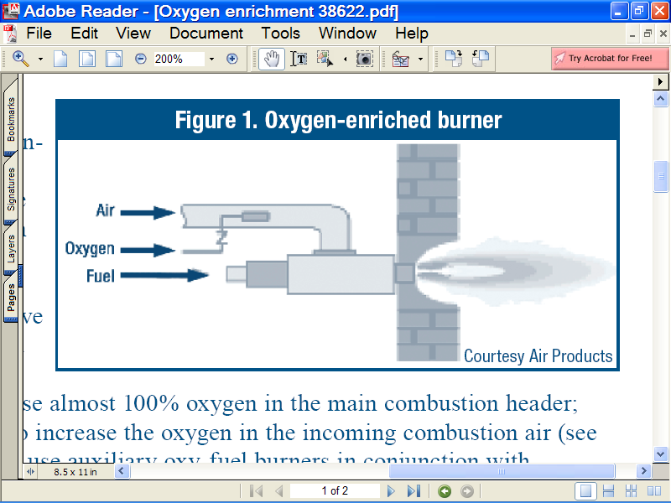
Figure 2. Oxygen Enriched Burner Schematic
The inputs and the results for the Oxygen Enrichment Calculator are shown in a one-page table, Table 1. User inputs are in blue on the white fields, the gray fields represent intermediate calculations, the final annual gas savings value is shown at the bottom of the table in the dark blue field.
Table 1. Oxygen Enrichment Calculator
The calculator requires only three inputs to characterize the duty cycle and annual gas consumption, and two inputs to describe the before and after furnace (process) operation. The calculations determine the fuel use, flue gas, and preheat air energy to define before and after available heat to the process. The unit savings are then applied to the annual consumption to determine the annual gas savings.
Equipment Load and Annual Use Calculation – Information from this section is to be taken from the Load Balance Tool. Customer supplied information that varies from the Load Balance Tool requires approval.
- Input: Equipment rating or connected load (MBtuh) is provided by the customer (for screening purposes) this information may be available for customers using the MAS database.
- Input: Equipment usage rate (hours/year) -- to be taken from the Load Balance Tool
- Input: Equipment load factor in use (percent ) – to be taken from the Load Balance Tool
- Calc: Equivalent full load hours = (Line 2) x (Line 3).
- Calc.: Annual gas consumption = (Line 4) x (Line 1) x MBtu/therm conversion
Furnace Conditions and Oxygen Ratio
- Oxygen in combustion air % -- The concentration of oxygen in standard air is approximately 21%. This is used as the starting value for this calculator. The percentage of oxygen in the enriched air stream is entered in the last column.
- Input: Flue gas temperature – a customer supplied input.
- Calc.: Available Heat to the Process (percent) – This equals the total heat of combustion minus the sensible and latent heat contained in the flue gases. In this calculator the effect of excess air is ignored. (The justification and documentation of this calculation are provided in Appendix A.)
Gas Savings Rate and Annual Gas Savings
- Calc.: Gas Savings Percent – the difference of baseline gas use (5) and new gas use (10) divided by baseline gas use. (5).
- Calc.: (5) old gas use x (8) old available heat / (8) new available heat
- Calc.: Annual Gas Savings due to efficiency measure – this is the primary output of the calculation based on baseline gas use minus gas use after implementation of the efficiency measure.
Annual Gas Cost Savings (Optional Calculation)
- Input: gas rate ($/therm) – Customer gas rate—avoided commodity and delivery rate.
- Calc.: (12) gas rate x (11) gas savings.
In the example shown above in Table 1, a 5,000 MBtuh furnace available 8760 hours/year with a 68.5% load factor consumes 300,030 therms/year using air for combustion. Oxygen enrichment to 45% air is the proposed efficiency measure. Flue gas temperature is 2000 °F; this is assumed to be a condition of the furnace that remains unchanged. The reduction in the volume of nitrogen in the flue gas results in the available heat to the furnace increasing from 45.0% to 65.4%. This change will result in a 31% energy savings, for the same production, or 93,527 therms/year. The customer will save $88,851 per year in gas costs based on an average gas rate of $0.95/therm.

3.2 Moisture Reduction
The separation of water from a feedstock or product is a common, often energy-intensive, function in many industrial manufacturing processes. Thermal dewatering in the furnace requires about 1,000 Btu/lb of water that needs to be removed. If the furnace feedstock can be dewatered mechanically or by some other means such as air drying, then the quantity of energy needed within the furnace or oven can be reduced significantly. Dewatering applications are found in a variety of industries including pulp and paper, food processing, agriculture, chemicals, and mining. Figure 3 shows a schematic of a high efficiency mechanical dewatering press.

Figure 3. High Efficiency Centrifuge Mechanical Dewatering Press
Table 2 shows the moisture reduction calculation. The calculator measures the energy savings due to lowering the moisture percentage of the feedstock entering the process based on the capacity and duty cycle of the process, and the furnace operating conditions. The calculator assumes that the moisture removed is free water, i.e., not chemically bound to the feedstock as in calcining, and that the final product moisture requirements are below the input conditions.
Table 2. Moisture Reduction Calculation
The calculation steps corresponding to the line numbers on the table are described below.
Equipment Load and Annual Use Calculation – Information from this section is to be taken from the Load Balance Tool. Customer supplied information that varies from the Load Balance Tool requires approval. Lines 1-5 are the same for all calculations in this workbook, so are omitted from the discussion here.
Furnace Conditions
- Input: Flue gas temperature – a customer supplied input – the same for both before and after efficiency measure. The higher the flue gas temperature is the higher will be the energy savings from an equivalent volume of water removal.
- Input: Oxygen percent in the flue gas (% dry basis) – a customer supplied input.
- Calc.: Excess air is a function of Oxygen in the exhaust (Line 7). This is function is a polynomial curve fit to the output of a combustion equilibrium model.
- Input: Combustion air temperature – typically higher than ambient temperature due to pick of heat from the blower motor.
- Calc.: Available Heat to the Process (percent) – This equals the total heat of combustion minus the sensible and latent heat contained in the flue gases. In this calculator the effect of excess air is ignored. (The justification and documentation of this calculation are provided in Appendix A.)
Charge Material Weight and Moisture Conditions
- Input: Total weight (lbs/hour) – total weight of the charge input to the process, assumed to be the same before and after moisture removal.
- Input: Moisture content (%) – the basis for the energy savings for the process.
- Calc.: Water content (lbs/hr) – Total weight (11) times (12) moisture percent
- Input: Temperature at furnace entrance – The input temperature of the product entering the furnace. Drier product may be hotter depending on moisture removal process used.
Gas Savings Rate and Annual Gas Savings
- Calc.: Gas Savings Percent – Calc.: Gas savings (17) / Initial Gas use (5)
- Calc.: New gas use (therms/year) – Calc.: Initial Gas Use (5) - Gas savings (17)
- Calc.: Annual Gas Savings due to efficiency measure – The difference in the heat required to heat and vaporize the water in the feedstock divided by the furnace available heat. This is the primary output of the calculation tool.
Annual Gas Cost Savings (Optional Calculation)
- Input: gas rate ($/therm) – Customer gas rate—avoided commodity and delivery rate.
- Calc.: (18) gas rate x (17) gas savings.
The calculation shown in Table 2 shows the natural gas savings where the incoming feedstock moisture is reduced from 30% to 20% before entering the process. The equipment has a 2,000 MBtuh connected load and its duty cycle is equal to 4,000 EFLH. The process has a 600 °F flue gas temperature and a measured 3% O₂ (dry basis) in the flue gas. The available heat to the furnace is 78.4%. The full load product input is 5,000 lbs/hour. Reducing the moisture percentage as shown reduces the moisture that must be removed thermally by the furnace by 500 lbs/hr. This change results in a 44% energy savings or 34,870 therms/year with a gas cost savings to the customer of t $33,126.

3.3 Wall Losses
Heat is lost through the furnace walls during production. These losses are caused by the conduction of heat through the walls, roof, and floor of the heating device, as shown in Figure 4. Once that heat reaches the outer skin of the furnace and radiates to the surrounding area or is carried away by air currents, it must be replaced by an equal amount taken from the combustion gases. This process continues as long as the furnace is at an elevated temperature.
Figure 4. Furnace Wall Losses
Table 3 shows the one-page input/output table for the wall losses savings calculator. .The basis for the calculations are described Appendix B Wall Heat Loss Calculations.

Table 3. Furnace Wall Loss Savings Calculator Input/Output Table
The calculation steps corresponding to the line numbers on the table are described below.
Equipment Load and Annual Use Calculation – Information from this section is to be taken from the Load Balance Tool. Customer supplied information that varies from the Load Balance Tool requires approval. Lines 1-5 are the same for all calculations in this workbook.
Furnace Conditions
- Input: Flue gas temperature – a customer supplied input – the same for both before and after efficiency measure.
- Input: Oxygen percent in the flue gas (% dry basis) – a customer supplied input.
- Calc.: Excess air is a function of Oxygen in the exhaust (Line 7). This is function is a polynomial curve fit to the output of a combustion equilibrium model.
- Input: Ambient air temperature – part of the calculation of heat loss from the wall.
- Input: Combustion air temperature – typically higher than ambient temperature due to pick of heat from the blower motor.
Furnace Wall Area and Temperature
- Input: Surface area of the furnace (sq.ft.) – Based on the length, height, and width of the furnace.
- Input: Wall surface temperature – the reduction in temperature from the baseline to the efficiency case is the basis for the savings.
- Calc.: Heat loss (Btu/sq.ft.) – Estimated heat loss per square foot based on the difference between the furnace surface temperature and ambient conditions (see Appendix B)
Gas Savings Rate and Annual Gas Savings
- Calc.: Gas Savings Percent – Calc.: Gas savings (16) / Initial Gas use (5)
- Calc.: New gas use (therms/year) – Calc.: Initial Gas Use (5) - Gas savings (16)
- Calc.: Annual Gas Savings due to efficiency measure – Heat loss difference x surface area x EFLH (see Appendix C)
Annual Gas Cost Savings (Optional Calculation)
- Input: gas rate ($/therm) – Customer gas rate—avoided commodity and delivery rate.
- Calc.: (17) gas rate x (16) gas savings.
In the example shown above in Table 3, the furnace insulation is to be rebuilt so that average wall temperature during operation will drop from 250 to 145 °F. Given the furnace capacity and duty cycle shown, the annual savings are 39,954 therms representing an 8% savings.

3.4 Aluminum Charge Preheat Energy Savings Calculator
Where permitted by system configuration, preheating the product charge can also be a feasible efficiency improvement. Much like combustion air preheating, this form of energy transfer to an upstream mass can reduce fuel use. Aluminum melters can use stack charging of scrap or preheating chambers for ingots and sows. In these systems, aluminum scrap is charged through an inclined grate at the top of the furnace that serves as the stack for exhausting flue gases. This configuration allows the charge to be preheated thereby reducing capturing additional energy from the high temperature flue gases required for the melt zone. These furnaces are capable of melting aluminum for as little as 1,000 Btu/lb.
The aluminum preheat calculator defines the energy savings attributable to the increase in aluminum charge temperature. The calculator is shown in Table 4.
Thermal Product Solutions
Figure 5. Aluminum Stack Melter
The calculation steps corresponding to the line numbers on the table are described below.
Equipment Load and Annual Use Calculation – Information from this section is to be taken from the Load Balance Tool. Customer supplied information that varies from the Load Balance Tool requires approval. Lines 1-5 are the same for all calculations in this workbook.
- Input: Annual production (tons/year) – customer supplied input on tons of molten aluminum produced by the furnace.
- Calc.: Energy use (Btu/lb Aluminum) – annual energy consumption (5) divided by annual production (6) with unit conversion from therms to Btus and tons to lbs.
Furnace Conditions
- Input: Flue gas temperature – a customer supplied input – the same for both before and after efficiency measure.
- Input: Combustion air temperature – typically higher than ambient temperature due to pick of heat from the blower motor.
- Input: Oxygen percent in the flue gas (% dry basis) – a customer supplied input.
- Calc.: Excess air is a function of Oxygen in the exhaust (Line 10). This is function is a polynomial curve fit to the output of a combustion equilibrium model.
- Calc.: Available Heat to the Furnace (percent) – This equals the total heat of combustion minus the sensible and latent heat contained in the flue gases. In this calculator the effect of excess air is ignored. (The justification and documentation of this calculation are provided in Appendix A.)

Table 4. Aluminum Preheat Calculator

Aluminum Input and Output Conditions
- Input: Charge initial temperature – Baseline temperature of the aluminum charged to the melter, a customer supplied input.
- Input: Charge preheat temperature – The suggested charge preheat for the efficiency measure, a customer supplied input.
- Input: Final molten aluminum temperature (F) – the temperature of the molten aluminum leaving the furnace, a customer supplied input.
- Calc.: Heat required for the aluminum (Btu/lb) – this calculation includes the heat required to raise the aluminum to melt temperature, the heat required for the phase change from solid to liquid, and the heat required to raise the molten aluminum to its final temperature. This calculation requires the specific heat of solid aluminum from ambient to melting temperature, approximately 1225º F, the heat of fusion, and the specific heat of molten aluminum from 1225º F to its final temperature.
- Calc.: Heat in other losses (Btu/lb) – this calculated value is the difference between the available heat to the furnace and the heat contained in the final product. These losses include losses from the walls, openings, conveyors and fixtures, and heat stored in the furnace. It is assumed for this calculation that these other losses remain the same, a reasonable assumption if the charge preheat is used to decrease energy use rather than to increase the throughput of the furnace.
- Calc.: Total net heat to the furnace (Btu/lb) – this calculated value equals the sum of the heat required for the product and the other losses, or as previously defined the available heat to the furnace.
- Calc.: Gross heat to required (Btu/lb) – net heat required (18) divided by available heat % (12) / 100.
Gas Savings Rate and Annual Gas Savings
- Calc.: Gas Savings Percent – Calc.: The difference between baseline and efficiency measure gross heats (line 19) / baseline gross heat (19)
- Calc.: New gas use (therms/year) – Calc.: (1 – gas savings % (20)) x baseline gas use (5)
- Calc.: Annual Gas Savings due to efficiency measure – Baseline gas use (5) minus new gas use (20).
Annual Gas Cost Savings (Optional Calculation)
- Input: gas rate ($/therm) – Customer gas rate—avoided commodity and delivery rate.
- Calc.: Gas savings (22) x Gas rate (23).
The savings calculation shown above in Table 4 is based on a 14,000 MBtuh furnace with a duty cycle equal to 8,000 EFLH. The furnace produces 40,000 tons/year of molten aluminum with an average energy use of 1400 Btu/lb. The furnace operates with 15.65% excess air (calculated from 3% oxygen in the exhaust on a dry basis) and has a flue gas temperature (before any charge preheating) of 1450 °F. The resulting available heat to the furnace is 54.55%. By raising the charge temperature from 100-700 °F, the average energy required is reduced to 1136 Btu/lb, an 18.9% savings in energy consumption. Annual energy savings of 211,493 therms translate to a $200,918 reduction in gas costs to the customer.

3.5 Steel Charge Preheat
Steel charge preheating is conceptually similar to aluminum preheating only the steel application involves steel reheat rather than melting. Figure 6 shows how charge preheat can be achieved directly by extending the heating zone in a continuous steel reheat furnace. The steel charge heating calculator is shown in Table 5. The only conceptual differences between this calculator and the aluminum preheat calculator is that there is no melting in the steel furnace; therefore, only the specific heats of the solid material need to be considered and the steel calculator also includes combustion air preheat that is upstream of the product heating.
Figure 6. Steel Charge preheat in Steel Reheat Furnace Achieved by Extending the Heating Zone
Table 5. Steel Charge Preheat Calculator
The calculation steps corresponding to the line numbers on the table are described below.
Equipment Load and Annual Use Calculation – Information from this section is to be taken from the Load Balance Tool. Customer supplied information that varies from the Load Balance Tool requires approval. Lines 1-5 are the same for all calculations in this workbook.
- Input: Annual production (tons/year) – customer supplied input on tons of heated steel produced by the furnace.
- Calc.: Energy use (Btu/lb steel) – annual energy consumption (5) divided by annual production (6) with unit conversion from therms to Btus and tons to lbs.
Furnace Conditions
- Input: Flue gas temperature – a customer supplied input – the same for both before and after efficiency measure.
- Input: Combustion air temperature – may include combustion air preheat.
- Input: Oxygen percent in the flue gas (% dry basis) – a customer supplied input.
- Calc.: Excess air is a function of Oxygen in the exhaust (Line 10). This is function is a polynomial curve fit to the output of a combustion equilibrium model.
- Calc.: Available Heat to the Furnace (percent) – This equals the total heat of combustion minus the sensible and latent heat contained in the flue gases. In this calculator the effect of excess air is ignored. (The justification and documentation of this calculation are provided in Appendix A.)
Steel Input and Output Conditions
- Input: Charge initial temperature – customer supplied input concerning the temperature of the steel charged to the furnace.
- Input: Charge preheat temperature – This input describes the preheat to be achieved by the energy efficiency measure and is the basis for the savings. (Note: should be less than 1400º F.)
- Input: Final steel temperature (F) – the temperature of the steel product leaving the furnace, a customer supplied input. (Note: should be greater than 1700º F.)
- Calc.: Heat required for the steel (Btu/lb) – this calculation includes the heat required to raise the steel to its final temperature. This calculation requires the mean specific heat of steel from initial charge temperature to its final exit temperature.
- Calc.: Heat in other losses (Btu/lb) – this calculated value is the difference between the available heat to the furnace and the heat contained in the final product. These losses include losses from the walls, openings, conveyors and fixtures, and heat stored in the furnace. It is assumed for this calculation that these other losses remain the same; a reasonable assumption if the charge preheat is used to decrease energy use rather than to increase the throughput of the furnace.
- Calc.: Total net heat to the furnace (Btu/lb) – this calculated value equals the sum of the heat required for the product and the other losses, or as previously defined the available heat to the furnace.
- Calc.: Gross heat to required (Btu/lb) – net heat required (18) divided by available heat % (12) / 100.
Gas Savings Rate and Annual Gas Savings
- Calc.: Gas Savings Percent – Calc.: The difference between baseline and efficiency measure gross heats (line 19) / baseline gross heat (19)
- Calc.: New gas use (therms/year) – Calc.: (1 – gas savings % (20)) x baseline gas use (5)
- Calc.: Annual Gas Savings due to efficiency measure – Baseline gas use (5) minus new gas use (20).
Annual Gas Cost Savings (Optional Calculation)
- Input: gas rate ($/therm) – Customer gas rate—avoided commodity and delivery rate.
- Calc.: Gas savings (22) x Gas rate (23).
The example calculation shown in Table 5 shows the energy savings attributable to increasing the temperature of the steel charged to the furnace from 80 to 700 °F, resulting in a 19.3%

3.6 Fixture Weight Reduction
The product being heated in many furnaces must be carried or supported by conveyors, fixtures, trays, etc. This material must be heated to the same temperature as the product and will exit the furnace carrying that heat away with it. Reducing the heat lost through fixtures requires a reduction in the heat capacity (mass times mean specific heat) of these systems and materials. Figure 7 shows an innovative extremely lightweight carbon fiber furnace fixture that could replace a much heavier metal fixture.
The furnace fixture heat loss reduction calculator is shown in Table 6. The energy savings are determined by the type of fixture material and its associated mean specific heat, accessed by means of a drop-down menu and look-up table, the reduction in the heat leaving the furnace, the furnace conditions, and the duty cycle.
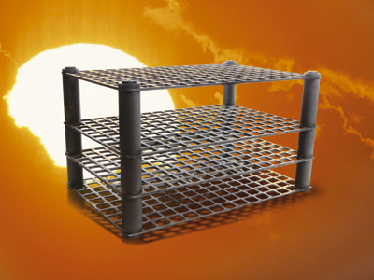
Source: Schunk Graphite Technology, LLC
Figure 7. Advanced Lightweight Carbon Fiber Reinforced Carbon Furnace Fixture
Table 6. Fixture Weight Reduction
The calculation steps corresponding to the line numbers on the table are described below.
Equipment Load and Annual Use Calculation – Information from this section is to be taken from the Load Balance Tool. Customer supplied information that varies from the Load Balance Tool requires approval. Lines 1-5 are the same for all calculations in this workbook.
Furnace Conditions
- Input: Flue gas temperature – a customer supplied input – the same for both before and after efficiency measure.
- Input: Oxygen percent in the flue gas (% dry basis) – a customer supplied input.
- Calc.: Excess air is a function of Oxygen in the exhaust (Line 7). This is function is a polynomial curve fit to the output of a combustion equilibrium model.
- Input: Combustion air temperature – typically higher than ambient temperature due to pick of heat from the blower motor.
- Calc.: Available Heat to the Process (percent) – This equals the total heat of combustion minus the sensible and latent heat contained in the flue gases. In this calculator the effect of excess air is ignored. (The justification and documentation of this calculation are provided in Appendix A.)
Charge in Fixture Material and/orWeight
- Input: Initial temperature (F) – the temperature of the fixture entering the furnace, a customer input.
- Input: Final temperature (F) – the temperature of the fixture leaving the furnace, a customer input.
- Input: Total fixture weight (lbs) – The weight of the fixtures for both the baseline and the energy efficiency measure cases, a customer input.
- Input: Material used for the fixture/furniture – the calculator has a drop down list of materials. The user selects from this list for both the baseline and the efficiency measure cases.
- Calc.: mean specific heat of the fixture material – once the fixture material is selected (14) the specific heat for that material between the entrance (11) and exit temperatures (12) is entered into the calculator automatically by means of a look-up table, shown in Table 7.

Gas Savings Rate and Annual Gas Savings
- Calc.: Gas Savings Percent – Calc.: Gas savings (18) / Initial Gas use (5)
- Calc.: New gas use (therms/year) – Calc.: Initial Gas Use (5) - Gas savings (18)
- Calc.: Annual Gas Savings due to efficiency measure – EFLH x (exit temp - initial temp) x (Weight₁ x Cp₁ -Weight₂ x CP₂)/Available heat to furnace, with units corrected to therms/year from Btu/year
Annual Gas Cost Savings (Optional Calculation)
- Input: gas rate ($/therm) – Customer gas rate—avoided commodity and delivery rate.
- Calc.: (19) gas rate x (18) gas savings.
Table 7. Specific Heat of Materials Used in Fixture Loss Reduction Calculator
Material | Specific Heat Btu/(lb. F.) | Notes
Carbon- graphite | 0.21 to 0.46 | from 200 F. to 1200 F.
Carbon Steel | 0.13 to 0.166 | from 200 F to 2200 F.
Cast Iron/Iron | 0.117
Ceramics | 0.23
Copper | 0.1
Glass | 0.13 to 0.2 | from 60 F. to 1200 F.
Inconel | 0.12
Magnesium | 0.27
Nickel (Nickel alloys) | 0.134
Platinum | 0.036
Quartz | 0.23
Silicon carbide | 0.23
Silicone | 0.176
Stainless steel | 0.14 to 0.24 | from 400 F. to 1200 F.
Stone | 0.2
Titanium | 0.14
Tungsten | 0.034
Zinc | 0.12
Source: Compiled by Arvind Thekdi from various sources including North American Combustion Handbook.
Note: Linear interpolation used to get value of specific heat at a required temperature where a range of values is given.
The savings calculation shown in Table 6 illustrates the savings that can be achieved by reducing total fixture weight from 3,000 lbs to 1,000 lbs including a change from carbon steel to stainless steel. Given the capacity and duty cycle of the furnace and the available heat of 61.58%, annual gas savings of 26,051 therms are possible (an 11% savings over baseline energy consumption) with customer gas cost savings of $24,749.

Appendix A Furnace Available Heat Calculation
The calculation of the value of heat recovery for preheating combustion air is based on the heating value of the fuel, the quantity of heat leaving the process in the flue gases, and the amount of heat that can be put back into the process by preheating the combustion air. This general relationship is described in the equation below:
To calculate a numerical result for this general equation, one needs to know both the composition of the fuel (in order to determine the stoichiometric air to fuel ratio and the heating value) and also the amount of excess air that is in the flue gas. Of course, the flue gas temperature and the desired combustion air preheat must also be input. The problem is solved using fitted equations to the results of a general equilibrium combustion model. There are three equations that go into the determination of Available Heat to the Process Percent: These equations estimate the following:
- Available heat to the process for stoichiometric air to fuel ratio based on an assumed natural gas composition (Appendix C.)
=95 - 0.025 x t₂ (see variable definitions above)
- Minus a correction factor for the heat contained in the excess air that is also “going up the flue”
=-(-2 + 0.02 x t₂)*(Excess Air%/100) alternatively
= .02 x (t₂ -100) x Excess Air%/100 (where .02 Btu/scf is the average specific heat of air and 100 is the assumed base combustion air temperature in degrees F.)
- Plus a correction factor for the heat that is contained in the total combustion air including the excess air
=(-2+0.02* t_{2air})*(1 + Excess Air%//100)
As in (2) this equation is based on an average specific heat of air of 0.02 Btu/scf and an assumed starting point of 100º F.
- The Available heat to the process = (1) – (2) + (3)
- Energy savings equals the change in gas consumption divided by the original energy consumption. The actual calculation for this value comes from the change in available heat to the process percent divided by the new available heat to the process percent. These two terms are exactly equal because energy consumption is inversely proportional to available heat to the process percent.
The first equation is based on a fitted line to the results of an equilibrium combustion model of stoichiometric combustion with natural gas and 75º F. air. This curve is shown in Figure 8.
Figure 8. Available Heat for Stoichiometric Natural Gas Combustion as a Function of Flue Gas Temperature
The heat content of air that is used in equations (2) and (3) is based on the relationship shown in Figure 9.
Figure 9. Heat Content of Air as Function of Temperature
There are a number of simplifying assumptions and caveats for the relationship in the calculator:
- There are no wall losses assumed in the recuperator and ducting.
- There is no ambient air infiltration assumed. All of the excess air is assumed to come from the combustion air.
- Energy losses in the furnace (process) itself are assumed to be unchanged – furnace wall losses, radiation losses, etc. These losses do not affect the value of the heat recovery measure, but may be opportunities for other efficiency measures.
- The calculation tool does not measure the effectiveness of the proposed heat recovery equipment. The performance, inlet and outlet temperatures must come from the customer or vendor. It is important that realistic values be entered for flue gas temperature and combustion air preheat.
- The calculations are based on a fixed gas composition and stoichiometric air to fuel ratio. The results are relatively insensitive to assumptions regarding fuel composition. Going from 100% methane to 100% propane only changes the available heat estimate by 1%.

.

Appendix B Wall Heat Loss Calculations
Consider the process heater shown in Figure 10. During operation, the external surfaces of the process heater are hot, and energy is transferred to the surrounding environment through the processes of conduction, convection, and radiation. For practical problems such as the process heater shown in Figure 10, energy is transferred from the hot external solid surface of the process heater to the surrounding air. For heat transfer from solid surfaces to a surrounding fluid such as air, the conduction and convection terms are frequently combined and expressed as follows:
$q_{c}=\frac{Q_{c}}{A}=h_{c}AΔT$ Equation 1
where
q_{c} – heat transfer per unit area (Btu/hr-ft)
Q_{c} – heat transfer rate (Btu/hr)
A – surface area (ft²)
h_{c} – heat transfer coefficient, including both convection and conduction (Btu/hr-ft²-F)
∆T – temperature difference between process heater wall and surrounding air (F)

Process Heater
Conduction
Convection
Radiation
Figure 10. Simplified Diagram of Heat Loss from External Surface of Process Heater
Radiation heat transfer between two bodies is proportional the difference of the fourth power of the absolute temperature of each body. However, to preserve similarities with the form of the convection heat transfer equation, the radiation heat transfer is often expressed as
$q_{r}=\frac{Q_{r}}{A}=h_{r}AΔT$ Equation 2
where
q_{r} – heat transfer per unit area due to radiation (Btu/hr-ft)
Q_{r} – heat transfer rate (Btu/hr)
h_{r} – radiation heat transfer coefficient (Btu/hr-ft²-F)
The heat transfer from the solid surfaces of a process heater, such as that depicted in Figure 10, vary for horizontal and vertical surfaces, and for difference types of materials (emissivity changes, which changes radiation). The heat transfer from solid surfaces is also strongly dependent on external air flow. For example, if there is forced convection (e.g., a fan that moves air across the process heater), the heat transfer rates can be significantly higher compared to natural convection (air movement only occurs due to natural buoyancy effects that occur from temperature variations of the air). There will also be variations in heat transfer across the external surface due to temperature variations on the wall (e.g., the external surface of the furnace roof may be hotter than the sides).
For practical problems such as the heat loss from the external walls of process heaters, several simplifying assumptions are generally set such that an estimate can be obtained. The simplifying assumptions used in this workpaper include:
- Model external furnace area as a vertical wall. Exclude the floor area of the furnace and only include the sides and roof that are in contact with the surrounding air.
- Isothermal wall temperature
- No forced convection
Using these simplifying assumptions, engineers have developed empirical heat transfer equations that are generally valid for a range of wall temperatures and ambient air temperatures. One such empirical equation developed for wall temperatures in the range of approximately 140 to 400 ºF and an ambient air temperature of 75 ºF is:
$q=\frac{Q}{A}=\left[\frac{9\text{.}7T_{\text{wall}}^{2}}{1,\text{000}}−1\text{.}\text{42}T_{\text{wall}}+\text{164}\right]−\left[\left(\frac{T_{\text{amb}}−\text{75}}{\text{50}}\right)\left(0\text{.}\text{085}\left(T_{\text{wall}}−\text{100}\right)+\text{90}\right)\right]$ Equation 3
The preceding equation represents a curve fit of data developed by Dr. Arvind Thekdi (see Appendix A). At low temperatures radiation is insignificant relative to convection, and the heat transfer relationship can be simplified. In this workpaper, for wall temperatures in the range of 60 to 140 ºF the following equation is used:
$q=\frac{Q}{A}=\left(1\text{.}6+0\text{.}\text{006}T_{\text{wall}}\right)\left(T_{\text{wall}}−T_{\text{amb}}\right)$ Equation 4
The preceding two equations are the fundamental relationships used in the Process Heating Tool to estimate heat loss from the external walls of an oven, furnace, or any other process heating system with hot external surfaces.

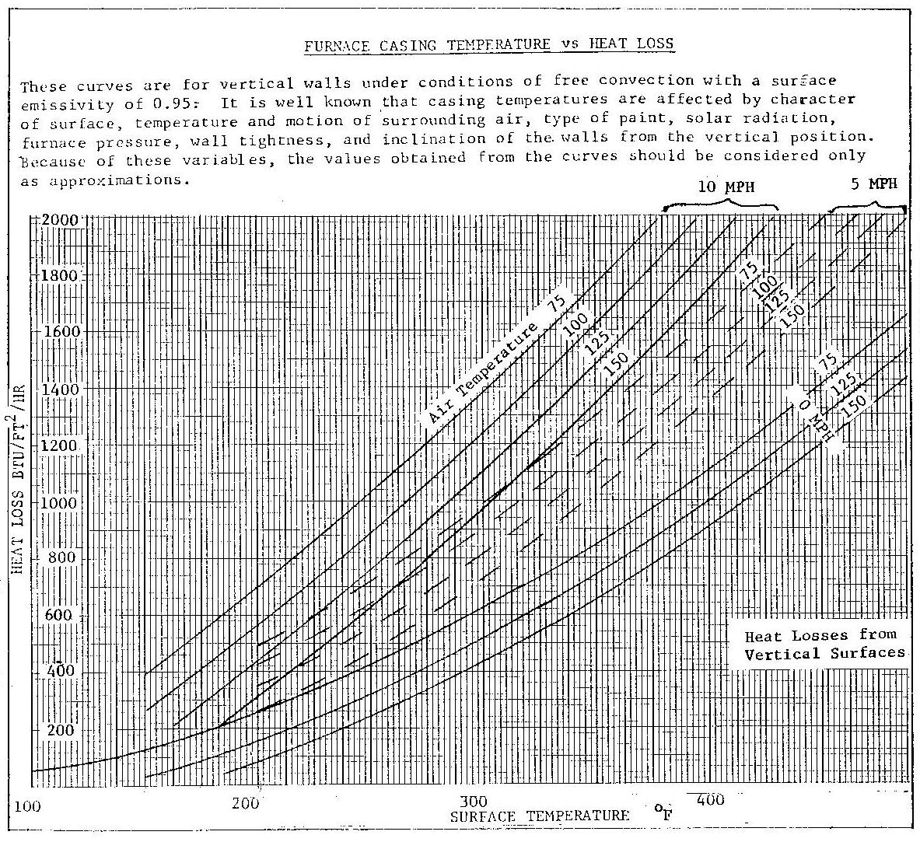

Appendix C: Assumed Gas Composition
The gas composition assumed in the analysis is shown in Table 8.
Table 8. Assumed Gas Composition
Gas Analysis | Molar Volume %
CH₄ | 94.1000%
C₂H₆ | 3.0100%
C₃H₈ | 0.4200%
C₄H₁₀ | 0.2800%
CO | 0.0140%
H₂ | 0.0325%
CO₂ | 0.7100%
O₂ | 0.0100%
N₂ | 1.4100%

Excel based program, Load Balance Tool (ver 1).xls,
Load Balance Tool, Workpaper, Energy and Environmental Analysis, Inc. April 2006.
Oxygen-Enriched Combustion,” Energy Tips – Process Heating, No.3, U.S. DOE, Energy Efficiency and Renewable Energy, September 2005.
Ibid.
All of the relationships and thermodynamic calculations were contained in a preliminary calculation spreadsheet that was developed and provided to The Gas Company by Dr. Arvind Thekdi, EC3M Company. Dr. Thekdi also provided the back-up relationships.
Kotobuki Industries Co., Ltd, Wizard Press, product description.
Arvind Thekdi, private communication, 3/9/06.
Improving Process Heating System Performance: A Sourcebook for Industry, U.S. Department of Energy and Industrial Heating Equipment Association
If the aluminum temperatures are not known, but the change in flue gas temperature is known, the savings can be calculated using the Efficient Combustion Calculation in the Heat Recovery Workbook.
Arvind Thekdi, “Energy Efficiency Improvement Opportunities in Process Heating for the Forging Industry,” FIA Forging Clinic, February 8&9, 2005.
Arvind Thekdi, private communication, 3/9/06.
Combustion Technology Manual, Fourth Edition, Industrial Heating Equipment Association, 1988, pp267-270.
Thekdi, A., private communication.
Trink, W., Industrial Furnaces, Volume 1, 4th Edition, 1951.

