Thermal Oxidizer Energy Efficiency
Review and Acceptance

Information Submitted: |  |  | - Thermal Oxidizer Energy Efficiency, EEA Report No. B-REP-06-599-19A, December 2006  - Thermal Oxidizer Tool, Version 3.0, December 2006
Submitted by: |  |  | Energy and Environmental Analysis, Inc.
Date: |  |  | December 18, 2006
Program Affected:
 |  | Express Efficiency |  |  |  | Energy Efficiency Grant Program (EEGP)
 |  | Process Equipment Replacement (PER) |  |  |  | Custom Process Improvement (CPI)
 |  | Efficient Equipment Replacement (EER) |  |  |  | Residential
 | X | Business Energy Efficiency Program (BEEP)
 |  | Other (please describe)
The undersigned individuals have reviewed the information cited above, and accept this information for determining energy consumption and/or energy savings related to energy efficiency measures.
Tom DeCarlo, PE
Commercial & Industrial Program Manager |  | Date
Southern California Gas Company
Eric Kirchhoff, PE
Energy Efficiency Engineering Supervisor |  | Date
Southern California Gas Company
Christopher Goff, CEM, DGCP
Senior Account Executive |  | Date
Southern California Gas Company
Arvind C. Thekdi, PhD
President |  | Date
E3M, Inc.

Revision History
Revision No. | Date | Description | Author
--- | July 2006 | Original release | EEA (R. Hite, K. Darrow)
1 | December 2006 | Addressed reviewer comments; added methodology description | EEA (R. Hite)
A | January 2007 | Made minor grammatical changes | EEA (R. Hite, R. Tidball)


B-REP-06-599-19A

Thermal Oxidizer Energy Efficiency
Workpaper for PY 2006-2008

December 2006

Prepared for:

Prepared by:

Energy and Environmental Analysis, Inc.

www.eea-inc.com
Headquarters | West Coast Office
1655 N. Fort Myer Drive, Suite 600 | 12011 NE First Street, Suite 210
Arlington, Virginia 22209 | Bellevue, Washington 98005
Tel: (703) 528-1900 | Tel: (425) 688-0141
Fax: (703) 528-5106 | Fax: (425) 688-0180

Disclaimer
The Gas Company has made reasonable efforts to ensure all information is correct. However, neither The Gas Company's publication nor verbal representations thereof constitutes any statement, recommendation, endorsement, approval or guaranty (either express or implied) of any product or service. Moreover, The Gas Company shall not be responsible for errors or omissions in this publication, for claims or damages relating to the use thereof, even if it has been advised of the possibility of such damages.

Executive Summary
Thermal Oxidizer Energy Efficiency
Measure Description
Thermal oxidizers or incinerators are a class of environmental control equipment that oxidizes volatile organic compounds (VOCs) in an exhaust stream of a process into non reactive compounds. This control is required either to eliminate hazardous air pollutants (HAP) or to reduce emissions of VOCs for ozone and smog control. Systems usually require some degree of fuel consumption to ensure complete combustion and destruction of HAP/VOC. For systems with high fuel requirements, various heat recovery options are available that can reduce or even eliminate fuel consumption.
Market Applicability
Thermal oxidizers are required in any business with the potential to emit significant quantities of HAP/VOC. Processes that use solvents such as paint spray booths, printing, coating, and chemical processes commonly need to control VOC emissions. Breweries and large bakeries need to control alcohol emissions.
Natural Gas Savings Analysis
This tool facilitates the following analyses:
- Calculate the energy therm savings for retrofitting an existing non-recuperated incinerator with a recuperator.
- Calculate the energy therm savings for retrofitting an existing recuperated incinerator with a more efficient recuperator.
- Calculate the energy therm savings for retrofitting an existing non-recuperated incinerator with a more efficient regenerator.
- Calculate the energy therm savings for retrofitting an existing recuperated (or regenerated) incinerator with a more efficient regenerator.
- Calculate fuel savings by using the VOC stream oxygen for combustion of auxiliary burner fuel for systems currently using external source of air (i.e., a combustion air blower).

TABLE OF CONTENTS
Page
Executive Summary iii
1. Overview 1
2. Annual Gas Use 4
3. Gas Savings Calculations 5
3.1 Common Data Inputs 5
3.2 Case A: Add Recuperator to Thermal Oxidizer without Heat Recovery 7
3.3 Case B: Add More Efficient Recuperator 10
3.4 Case C: Add Regenerator to a Thermal Oxidizer without Heat Recovery 12
3.5 Case D: Add a More Efficient Regenerator 14
Appendix A. Destruction of VOCs and HAPs 16
Appendix B. Thermal Oxidizer Tool Methodology 22
Appendix C. Variable List 26

LIST OF TABLES
Page
Table 1. Case A 9
Table 2. Case B 11
Table 3. Case C 13
Table 4. Case D 15

LIST OF FIGURES
Page
Figure 1. Simple Thermal Oxidizer System 2
Figure 2. Illustration of Thermal Oxidizer with a Recuperator 3
Figure 3. Illustration of Thermal Oxidizer with a Regenerator System 4
Figure 4. Example of Simple Afterburner Design 17
Figure 5. Recuperated Thermal Oxidizer Schematic of Operation 18
Figure 6. Recuperated Thermal Oxidizer Operating at an SCG Customer Site (Vertis) 18
Figure 7. Schematic of Recuperative Catalytic Thermal Oxidizer 19
Figure 8. RTO at SCG Customer Site M.C. Gill 20
Figure 9. Cutaway View of Three Bed Regenerative Thermal oxidizer 20
Figure 10. Structured Ceramic Media in Regenerator Bed 21

1. Overview
Control of emissions of volatile organic compounds (VOC) is required from stationary sources both to reduce ozone formation from atmospheric reactions of VOC and NOx and where VOCs are defined as hazardous air pollutants. A broad range of industrial processes may need VOC control such as:
- Adhesive Coating
- Asphalt Manufacturing
- Bakery
- Brewery
- Coating
- Composite/Synthetic Materials
- Chemical Processing
- Electronics/Semiconductor
- Food Processing
- Loading/Unloading of materials with organic compounds
- Metals Finishing
- Odor Control
- Paint Mfg/Paint Spray
- Petroleum/ Hydrocarbon
- Pharmaceutical
- Printing/Laminating/Converting
- Roasters
- Sheet Board Manufacturing
- Sheet Coil Coating
- Soil Remediation
- Steel Mills
- Tape Coating
- Utility Boilers
- Vinyl Products
- Waste Heat Cogeneration Systems
- Waste Treatment
- Wood Furniture
Fume incineration is a combustion process that is used in manufacturing processes that generate chemical fumes (collectively referred to as VOCs). A fume incinerator is a thermal oxidizer that oxidizes the VOCs to convert the organics into stable and non-toxic compounds such as CO₂ and H₂O for emission to the atmosphere. Figure 1 shows a simple incineration takes VOC-laden air flows (VOC streams) and passes it through a thermal oxidizer unit which has a burner (indicated by a bumpy blue line across the bottom of the thermal oxidizer unit) to heat the VOC stream to the destruction temperature of the VOCs present. The resulting combustion products are then exhausted to the atmosphere. In this configuration, the natural gas burner provides all of the heat needed to bring the VOC stream, the fuel, and the external combustion air up to the thermal oxidizer exhaust temperature, which might be quite high, depending upon the types of VOC to be incinerated. In this figure, the combustion air for the burner is drawn from the atmosphere. In many instances, there is sufficient air in the VOC stream to support combustion. If so, then external combustion air is not needed and energy savings can be accomplished through excess air reduction.
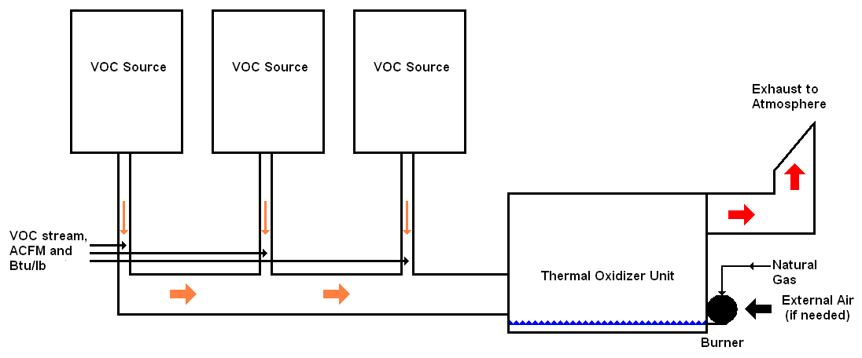
Figure 1. Simple Thermal Oxidizer System
In many instances, energy savings can be accomplished by using the thermal oxidizer exhaust flow to preheat the VOC stream in a recuperator before it enters the thermal oxidizer. Figure 2 illustrates the simplest version of this configuration. The recuperator is a plate heat exchanger; the hot-side inlet stream is the exhaust gases from the thermal oxidizer and the hot-side outlet stream is exhausted to the atmosphere. The cold-side inlet stream is the VOC stream and the cold-side outlet stream goes into the thermal oxidizer for destruction. The heat exchange efficiency of the recuperator is available from the manufacturer and, to be cost effective, runs from 40 to 60%.

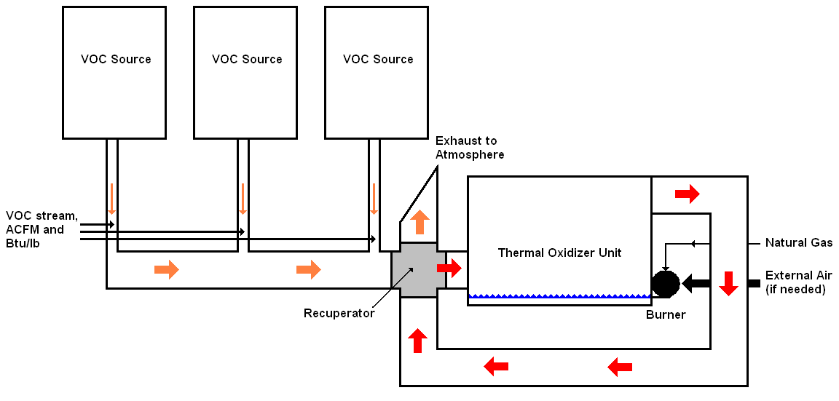
Figure 2. Illustration of Thermal Oxidizer with a Recuperator
An alternate, and usually more efficient, method of preheating the VOC stream before it enters the thermal oxidation is through the use of a regenerator. Unlike a recuperator, the heat exchanger efficiency of a regenerator is usually greater than 80%. As illustrated in Figure 3, however, the regenerator system configuration is much more complex than for a recuperator. In a regeneration process, heat is retrieved alternately in two thermal storage devices (the individual regenerators). At the moment illustrated in the figure, the regenerator on the left has already been heated and is now giving up its heat to the VOC stream before the VOC stream enters the thermal oxidizer. The thermal oxidizer exhaust is sent to the second regenerator (on the right) which receives and stores most of the heat in the exhaust. The much cooler thermal oxidizer exhaust is exhausted to the atmosphere. After a period of time, the roles of the two regenerators are switched: the one on the right that was being heated by the thermal oxidizer exhaust now heats the VOC stream, and the one on the left that was heating the VOC stream is now being heated by the thermal oxidize exhaust. When regenerators are properly sized and selected, they are much more efficient than recuperators.
A startup burner is used to bring the thermal oxidizer up to VOC destruction temperature initially. Once it is hot, the temperature of the thermal oxidizer usually exceeds the VOC destruction temperature without the combustion of any natural gas. Without burning any gas, the thermal oxidizer temperature is the result of the temperature of the VOC stream plus the heating by the regenerator and the heat released by the destruction of the VOCs themselves. If additional heat is needed, one option is to inject natural gas into the VOC stream upstream of the regenerators. This natural gas raises the heating value of the VOC stream to assure that the VOC destruction temperature is achieved in the thermal oxidizer. If a natural gas burner is used rather than injection of natural gas, the burner is called a “raw gas burner” or some other commercial name. In some cases, neither natural gas nor the raw gas burner exhaust is injected into the VOC stream, but the startup burner is used intermittently to maintain the VOC destruction conditions within the thermal oxidizer. The basic requirement is maintain a stable flame inside the thermal oxidizer, preferably using air from the VOC stream and, when necessary, using additional external air.

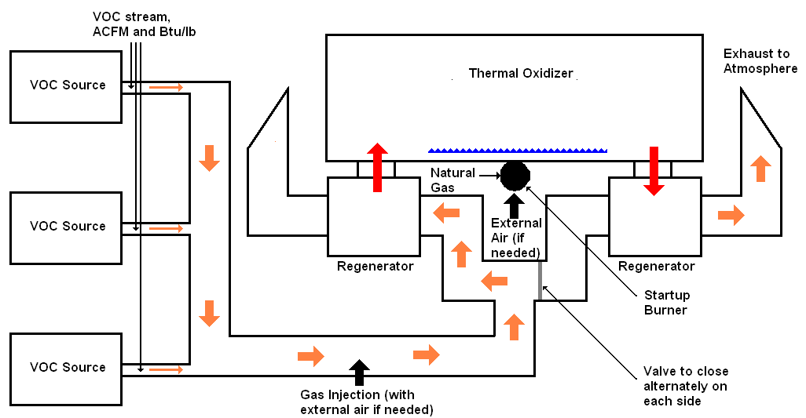
Figure 3. Illustration of Thermal Oxidizer with a Regenerator System
A Thermal Oxidizer Heat Recovery calculation tool using Microsoft Excel© as its platform has been developed to calculate and document the annual gas therm savings of the various methods used to improve the performance of fume incinerators. These energy conservation techniques are more thoroughly described in Appendix A. This tool facilitates and documents the following types of gas savings analyses:
- Calculate the therm savings which will result from retrofitting an existing non-recuperated incinerator with a recuperator
- Calculate the therm savings which will result from retrofitting an existing recuperated incinerator with a more efficient recuperated incinerator
- Calculate the therm savings which will result from retrofitting an existing non-recuperated incinerator with a regenerator system
- Calculate the therm savings which will result from retrofitting an existing recuperated incinerator with a more efficient regenerator system
- Calculate the therm savings which will result from using the VOC stream oxygen for combustion of auxiliary burner fuel for systems currently using an external source of air (i.e., a combustion air blower).

2. Annual Gas Use
If available, a dedicated gas meter should be used to obtain the baseline incinerator or thermal oxidizer annual gas use. However, the gas use by an individual incinerator or thermal oxidizer within a facility is rarely measured directly because there is typically there is only one main gas meter for the whole facility, with no sub-metering of individual equipment. To provide a standardized estimate of the baseline annual gas use, The Gas Company has developed an Excel-based calculation tool: the Load Balance Tool. The tool allows the user to identify and characterize the gas-using equipment within the facility. The tool then allocates the metered facility consumption among the equipment identified within the facility. The assumptions and equations used in the Load Balance Tool are documented in its workpaper. In order of preference, sub-metered equipment gas use data, validated gas use data from the customer, or the gas use calculated with the Load Balance Tool should be used as the gas use input to the thermal oxidizer tool.

3. Gas Savings Calculations
The Thermal Oxidizer Tool allows the user to specify the characteristics of the VOC streams and existing heat recovery equipment, if any, and to specify the characteristics of an efficiency measure. Both are needed to calculate the natural gas savings which will result from installing more efficient heat recovery equipment in the form of either a regenerator or a recuperator.
This section describes the Tool inputs and outputs. In general, there are three common conventions followed in the Thermal Oxidizer Tool:
- All user input cells are shown in blue font with a white background
- Black font on a gray background indicate a calculated value
- Cells and notes which suddenly appear in red font on a yellow background occur when inputs create errors or out of bounds conditions
The numbers of each data input and output below correspond to the numbers in the Excel worksheet.

3.1 Common Data Inputs
The common data inputs are the user inputs which are needed for all efficiency measures. These inputs include customer information, gas equipment information, baseline annual gas use, VOC stream characteristics, certain thermal oxidizer characteristics, and an opportunity for the user to select the efficiency measure.
Customer Information and Gas Equipment Information
1. Customer
2. Billing account ID
3. Gas equipment description
4. Equipment type
5. Equipment use
Equipment Load and Annual Use Calculation
6. The annual natural gas consumption of the thermal oxidizer. The development and origin of this value must be documented (see Section 2 above).
Volatile Organic Compounds Characteristics
7. This step requires the user to select one of three choices to specify the VOC energy data:
  - Type, annual quantity, and heating value – of the VOCs or organic compounds used by the plant– if this option is chosen, the user must first press RESET and go to step 8. RESET may be pressed at any time to reinitialize key internal values if there appears to be a calculation problem with the tool. Selecting this choice will require inputs for Steps 8-9.
  - Btu/lb of VOC stream – Skip Steps 8 and 9 and move onto Step 10.
  - Btu/acf of VOC stream – Skip Steps 8 and 9 and move onto Step 10. (Note: specify acf as actual cubic feet).
8. Chemical Name, Flow (lb/hr) and Energy Content (Btu/lb) – The first five lines allow the input of data for the volatile organic compounds (VOCs) that the customer incinerates in their thermal oxidizer. The information indicated should be available from the customer. Up to five may be added.
9. Percent of VOC use that is sent to thermal oxidizer. If anything other than "Type, annual quantity, and heating value" is chosen, this number is ignored.
10. VOC destruction temperature (°F)
11. VOC stream inlet temperature (°F): This value is close to the outlet temperature of the oven or other VOC emission stream source just prior to entering the thermal oxidizer subsystem. Adjustment by the Account Executive may be necessary if the temperature is actually measured a substantial distance away from the thermal oxidizer.
12. Intermediate Result – VOC Energy (MMBtu/yr). This is total energy content of VOCs of the VOC stream entering the thermal oxidizer. If "Type, annual quantity, and heating value" is chosen above, it is calculated. If either of the other choices is made, then Line 12 is the value inputted at Line 13 (converted from Btu/acf to Btu/lb if necessary) multiplied by the annual mass flow of the VOC stream.
13. VOC Energy in either Btu per pound of VOC stream (Btu/lb) or actual cubic foot of exhaust (acf). If "Type, annual quantity, and heating value" is chosen above, this is a calculated intermediate result. Otherwise it is an input variable. If it is calculated, then Line 13 = Line 12/AnnualMassFlow.
14. VOC Flow Rate Schedule is entered as Flowrate (acfm) and Time at Flowrate (% of operating time). This tool is capable of capturing annual operation with varying duty cycles. There are four flow rates "at load" and one for the oxidizer on standby. The first four lines in this section are for "at load" flow conditions. The last line is the unit's standby flowrate. Enter the acfm and the percentage of operating time at that particular flow rate. The percentage of time that the oxidizer is at standby will be calculated and inferred by the percentages of the other four "at load” flows. The user must enter these data for the before and after condition.
Thermal Oxidizer Characteristics
There are three questions asked with pull down menus for Steps 15 and 17 indicating acceptable choices:
15. Is combustion air for the thermal oxidizer's natural gas burner provided externally with a combustion blower or from the VOC stream stream? The choices are Yes or No for the before and after case.
16. For the cases where the answer is "Yes" at line 15, enter the percentage of excess air used for the thermal oxidizer burner as appropriate for each case.
17. The heat exchanger (recuperator or regenerator) can be specified either by its "Efficiency" or the "Exhaust Temperature" of the exhaust stream as it emerges from the heat exchanger. The user will specify these values below for each of the cases. It is here where the user chooses how to make the specification. Error messages are provided below if the user should enter values for these parameters that seem out of range for commonly used values for the specified heat exchanger.
Select Desired Heat Recovery Approach
The appropriate button shows the selected inputs and results, and hides the inputs and results for the other approaches:
- Case A: Add a Recuperator to a Thermal Oxidizer without Any Heat Recovery. – This measure adds a recuperator to a fume incinerator that does not already have a heat recovery unit.
- Case B: Add a More Efficient Recuperator to a Thermal Oxidizer that Already Has One – This measure replaces a less efficient heat exchanger with a more efficient heat exchanger.
- Case C: Add a Regenerator to a Thermal Oxidizer without Any Heat Recovery – This measure adds a regenerator to a fume incinerator that doesn't already have a heat recovery unit.
- Case D: Add a More Efficient Regenerator to a Thermal Oxidizer that Already Has Heat Recovery (Recuperator or Regenerator) – This measure replaces a less efficient heat exchanger (recuperator or regenerator) with a more efficient regenerator
Selection of the case alters the Thermal Oxidizer Tool structure and logic. Each case inputs and calculations are described individually in the following sections.

3.2 Case A: Add Recuperator to Thermal Oxidizer without Heat Recovery
Inputs (cells with blue font)
18. Standby flow rate (acfm): These values for baseline and new are retrieved from the “Common Data Inputs” at the VOC/Air Flow Rate Schedule (Line 14.) for utility.
19. Depending on the type of heat exchanger specification indicated above, enter either the heat exchanger efficiency (%) or the heat exchanger exhaust temperature (F). If the heat exchanger efficiency is selected, the suggested values are 40-60%. Entering a value outside this range will result in an error message. If heat exchanger exhaust temperature is chosen, a value greater than 100 and less than the VOC destruction temperature (Line 10) must be entered.
Results
20. These results are the annual natural gas consumptions for the base case and the case with the recuperator assuming 8,760 hours per year operation.
21. This is the calculated hours of operation per year. If this number is substantially different from the customer's experience, there may be an error in earlier inputs such as VOC stream characteristics or scheduling. The number will appear red and there will be an error message if the number exceeds 8760 hours.
22. This is the annual natural gas savings calculated as a percentage of current energy use.
23. This is the annual natural gas savings in therms per year. This number is calculated using the percentage at line 22 and the gas consumption used at line 6.
24. Price of Gas in terms of $/therm.
25. This is the dollar savings based on the natural gas price per therm indicated on Line 24.

Table 1 provides an example of Case A, adding a recuperator to an existing thermal oxidizer with no heat recovery. The annual gas consumption for the existing thermal oxidizer is 600,000 therms/year. The VOC loading is specified by type, quantity, and heating value. The VOC stream inlet temperature is 300 °F and the VOC destruction temperature is 1425 °F. The percentage of VOC treated in the thermal oxidizer is set at 95%. The case shows the savings due to adding a 50% efficient heat exchanger to the thermal oxidizer. The addition of this recuperator saves 85% of the annual gas consumption or $485K per year in gas cost savings. The required operating hours to produce the input gas consumption is shown as 8,553 hours/year. Such a high load factor for this equipment should be double-checked by the user.

Table 1. Case A

3.3 Case B: Add More Efficient Recuperator
Inputs (cells with blue font)
26. Standby flow rate (acfm): These values for baseline and new are retrieved from the “Common Data Inputs” at the VOC/Air Flow Rate Schedule (Line 14.) for utility.
27. Depending on the type of heat exchanger specification indicated above, enter either the heat exchanger efficiency (%) or the heat exchanger exhaust temperature (F) in each case. If the heat exchanger efficiency is selected, the suggested values are 40-60%. Entering a value outside this range will result in an error message. If heat exchanger exhaust temperature is chosen, a value greater than 100 and less than the VOC destruction temperature (Line 10) must be entered.
Results
28. These results are the annual natural gas consumptions for the case with the old recuperator and the case with the new recuperator assuming 8760 hours per year operation.
29. This is the calculated hours of operation per year. If this number is substantially different from the customer's experience, there may be an error in earlier inputs such as VOC stream characteristics or scheduling. The number will appear red and there will be an error message if the number exceeds 8760 hours.
30. This is the annual natural gas savings calculated as a percentage of current energy use.
31. This is the annual natural gas savings in therms per year. This number is calculated using the percentage at line 30 and the gas consumption used at line 6.
32. Price of Gas in terms of $/therm.
33. This is the dollar savings based on the natural gas price per therm indicated on Line 32.
Table 2 provides an example of Case B, adding a more efficient recuperator (55%) to an existing thermal oxidizer with that already has a recuperator (45%). The annual gas consumption for the existing thermal oxidizer is estimated at 110,000 therms/year. The energy value of the VOCs is provided in this case a Btu/lb of oven exhaust. The input and destruction temperatures were assumed as were used previously in the Case A example. The addition of this more efficient recuperator reduces gas consumption by 67% and produces $70K per year in gas cost savings.

Table 2. Case B

3.4 Case C: Add Regenerator to a Thermal Oxidizer without Heat Recovery
Inputs (cells with blue font)
34. Standby flow rate (acfm): These values for baseline and new are retrieved from the “Common Data Inputs” at the VOC/Air Flow Rate Schedule (Line 14.) for utility.
35. Depending on the type of heat exchanger specification indicated above, enter either the heat exchanger efficiency (%) or the heat exchanger exhaust temperature (F). If the heat exchanger efficiency is selected, the suggested values are 60-95%. Entering a value outside this range will result in an error message. If heat exchanger exhaust temperature is chosen, a value greater than 100 and less than the VOC destruction temperature (Line 10) must be entered.
Results
36. These results are the annual natural gas consumptions for the base case and the case with the recuperator assuming 8,760 hours per year operation.
37. This is the calculated hours of operation per year. If this number is substantially different from the customer's experience, there may be an error in earlier inputs such as VOC stream characteristics or scheduling. The number will appear red and there will be an error message if the number exceeds 8760 hours.
38. This is the annual natural gas savings calculated as a percentage of current energy use.
39. This is the annual natural gas savings in therms per year. This number is calculated using the percentage at line 38 and the gas consumption used at line 6.
40. Price of Gas in terms of $/therm.
41. This is the dollar savings based on the natural gas price per therm indicated on Line 40.
Table 3 provides an example of Case C, adding a regenerator to an existing thermal oxidizer with no heat recovery. The annual gas consumption for the existing thermal oxidizer is estimated at 600,000 therms/year, and the energy value of the VOCs is provided in this case as Btu/acf. The input and destruction temperatures were assumed to be the same as in the Case A example, but the hours of operation are considerably reduced from 8,553 to 4,836. The case shows the savings due to adding a regenerator to the thermal oxidizer that would reduce the exhaust temperature to the atmosphere to 350 F. The addition of regenerator practically eliminates all need for gas firing and produces $568K per year in gas cost savings.

Table 3. Case C

3.5 Case D: Add a More Efficient Regenerator
Inputs (cells with blue font)
42. Standby flow rate (acfm): These values for baseline and new are retrieved from the “Common Data Inputs” at the VOC/Air Flow Rate Schedule (Line 14.) for utility.
43. Depending on the type of heat exchanger specification indicated above, enter either the heat exchanger efficiencies (%) or the heat exchanger exhaust temperatures (F) in each case. If the heat exchanger efficiency is selected, the suggested values are 40-95%. Entering a value outside this range will result in an error message. If heat exchanger exhaust temperature is chosen, a value greater than 100 and less than the VOC destruction temperature (Line 10) must be entered.
Results
44. These results are the annual natural gas consumptions for the case with the old recuperator and the case with the new recuperator assuming 8760 hours per year operation.
45. This is the calculate hours of operation per year. If this number is substantially different from the customer's experience, there may be an error in earlier inputs such as VOC stream characteristics or scheduling. The number will appear red and there will be an error message if the number exceeds 8,760 hours.
46. This is the annual natural gas savings calculated as a percentage of current energy use.
47. This is the annual natural gas savings in therms per year. This number is calculated using the percentage at line 46 and the gas consumption used at line 6.
48. Price of Gas in terms of $/therm.
49. This is the dollar savings based on the natural gas price per therm indicated on Line 48.
Table 4 provides an example of Case D, adding a more efficient regenerator to an existing thermal oxidizer with either an existing regenerator or recuperator. The annual gas consumption for the existing thermal oxidizer is estimated at 120,000 therms/year. The option for specifying VOC loadings is to provide the Btu/acf energy content in the exhaust. The case shows the savings due to replacing a 45% efficient recuperator with a 80% efficient regenerator. This change saves 97% of the annual gas consumption and produces $111K per year in gas cost savings.

Table 4. Case D

Appendix A. Destruction of VOCs and HAPs
Thermal oxidizers are a type of incinerator for the destruction of volatile organic compounds (VOC) and hazardous air pollutants (HAP). Thermal oxidizers allow facilities to control VOC emissions, and such control is required by EPA and AQMD regulations. The control is achieved by oxidizing the VOCs in a gas flame, hot air stream, or a heated catalyst bed. The selection of the appropriate equipment is a function of a number of factors including:
- Level of control required
- Types of VOCs to be removed
- VOC concentration in the air stream
- Total volume/flow of the air stream
- Operating costs
- First costs of equipment
The VOC concentration in the process exhaust air stream is judged by comparison to the lower explosion limit (LEL) of such VOCs in air. The LEL is the lowest concentration of (the same distribution of) VOCs in air at room temperature that can be ignited. When the concentration is above the LEL (and below the upper explosion limit), no additional fuel is needed to maintain the flame and keep the thermal oxidizer combustion zone above the destruction temperature. When the concentration is below the LEL, additional fuel (normally natural gas) is required to maintain the flame and keep the combustion zone hot. If the process exhaust air is preheated before entering the combustion zone by a heat exchanger, the amount of additional fuel is reduced.
Normally the VOC concentration is below the LEL, so thermal oxidizer specifications include the lowest concentration at which the thermal oxidizer can operate. The specification is expressed in terms of VOC concentration as a percentage of the LEL. Some types of thermal oxidizers can operate with much lower concentrations than others. LEL is both a convenient and pertinent way to express VOC concentrations.
The following five types of thermal oxidizers for the destruction of volatile organic compounds are discussed below:
- Afterburner (thermal oxidizer with no heat recovery)
- Recuperative thermal oxidizer
- Recuperative catalytic thermal oxidizer (catalyst in combustion chamber allows it to operate at lower temperature)
- Regenerative thermal oxidizer (RTO) system (has at least two regenerators)
- Regenerative catalytic thermal oxidizer system (catalyst in combustion chamber allows it to operate at lower temperature)
Afterburner
The afterburner is a simple thermal oxidizer system with no heat recovery. Figure 4 shows an example of a gas-fired afterburner. The typical afterburner consists of a burner, a burner train, a combustion blower and, if necessary, a process fan. Usually, this simple method to incinerator VOCs is used on low-volume emissions streams with a high concentration of the VOCs -- high enough to yield available energy to heat the products of combustion up to the chosen oxidation temperature. Note that the user does not have an option of raising the VOC concentration arbitrarily. There are regulations that do not permit VOC concentrations above a certain threshold. The heating value of the compounds usually makes up a significant portion of the heat required for combustion, thereby keeping the addition of supplemental fuel (usually natural gas) to a minimum.
Source: Stelter & Brinck
Figure 4. Example of Simple Afterburner Design
Afterburners may be used for applications below the LEL. One manufacturer’s product specifications state that their afterburner can tolerate VOC concentrations down to 40% of the LEL. However, when oxidizing such low concentrations of VOCs in the gas stream, the afterburner requires the addition of significant quantities of natural gas to maintain ignition and to maintain the afterburner at the VOC destruction temperature, which leads to high operating costs.
Recuperative
Another method is a recuperative thermal oxidizer. Figure 5 shows a schematic representation of thermal oxidizer with recuperative heat exchange. Figure 6 shows a photograph of a recuperative thermal oxidizer operating at an SCG customer site. If the LEL of the process stream is somewhat lower, the need for supplemental fuel goes up. The addition of a metallic heat exchanger allows for heat recovery of up to 70 percent, which preheats the process stream and keep fuel usage to a minimum. In a recuperative unit, the basic operation of the afterburner is retained except that much of the waste heat is captured. The fact that the system can capture this heat allows for it to operate very economically. In this type of system, a metallic tube or plate-type heat exchanger is built into the exhaust end of the combustion chamber of the oxidation system. Typically, a plate heat exchanger is used when the exhaust gas stream does not contain elevated amounts of particulate matter and the maximum amount of heat recovery is desired. Recuperative systems generally are smaller and lighter in weight than other thermal oxidizer systems (except afterburners), allowing for skid-mounted installations.
Figure 5. Recuperated Thermal Oxidizer Schematic of Operation
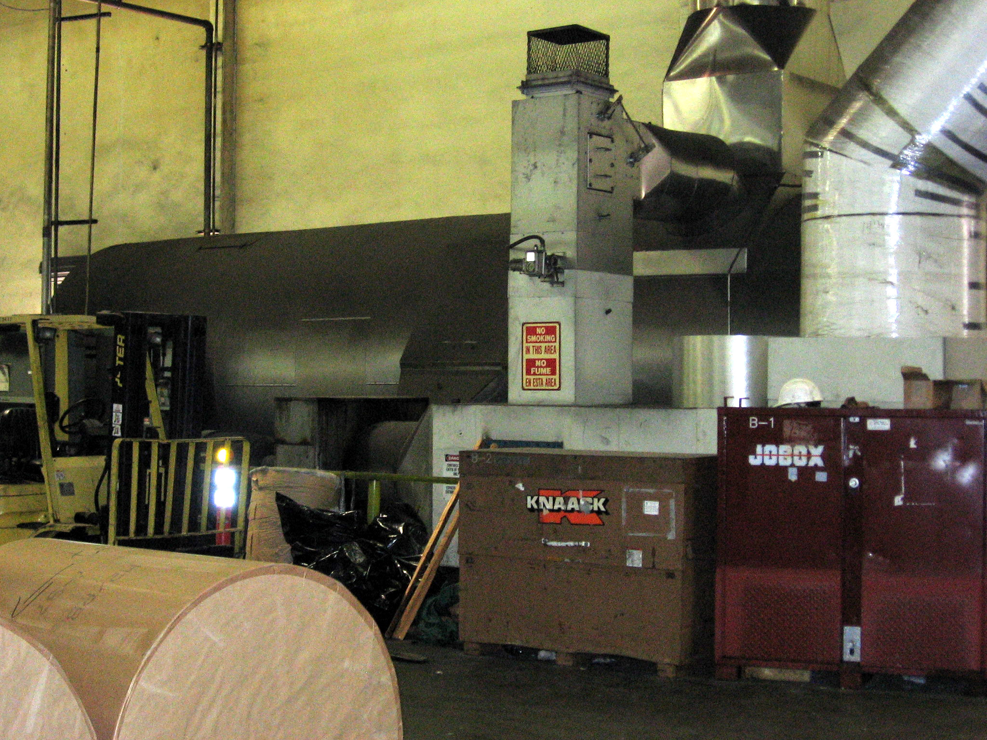
Figure 6. Recuperated Thermal Oxidizer Operating at an SCG Customer Site (Vertis)
Recuperative Catalytic
A recuperative catalytic thermal oxidizer is shown in Figure 7. For the most dilute streams, a zeolite concentrator can be used to collect compounds on a rotary wheel, which can then be desorbed into a smaller air stream and oxidized more efficiently in an appropriate thermal oxidizer. These units are similar in design to recuperative units, but oxidize solvents with precious metal or metal-oxide based catalysts, instead of open flames. Operating at about half the temperature of thermal oxidizers, catalytic units have small footprints and relatively low operating costs. Recuperative catalytic thermal oxidizer systems are prone to fouling and catalyst deactivation. Their use should be carefully matched to the type of VOC stream to be oxidized.
Source: Remtech
Figure 7. Schematic of Recuperative Catalytic Thermal Oxidizer
Regenerative
Regenerative thermal oxidizers (RTO) allow the highest thermal energy recovery (up to 95 percent) and ensure that fuel consumption is reduced, even for air streams with VOC concentrations below 5% of the LEL. Large beds of ceramic heat exchange media allow for this high thermal energy efficiency. VOC concentrations as low as 3% of the LEL can be processed in a self-sustaining mode without burning extra fuel. Initially, the incoming process gas passes through a ceramic heat recovery bed before entering the combustion chamber. It is preheated to within 5% of the combustion chamber temperature. After the process stream exits the ceramic bed, the already hot gases are further heated to the desired combustion chamber temperature. These gases are then sent through another heat exchange bed, where energy is absorbed and stored to heat the next cycle of contaminated air. Up to 95 percent of heat energy can be recovered with this multiple-bed approach.
Figure 8 shows a typical RTO installation at an SCG customer site. Regenerative systems are generally larger and heavier than recuperative systems. The basic system has two regenerative beds, but systems may have three (as shown in Figure 9) or more beds to allow for decontamination of beds and to reduce intermittent blow-by of unburned VOCs. .Regenerative systems often have high blower power requirements due to pressure drop in the bed. This requirement is reduced by the use of structured media as shown in Figure 10.
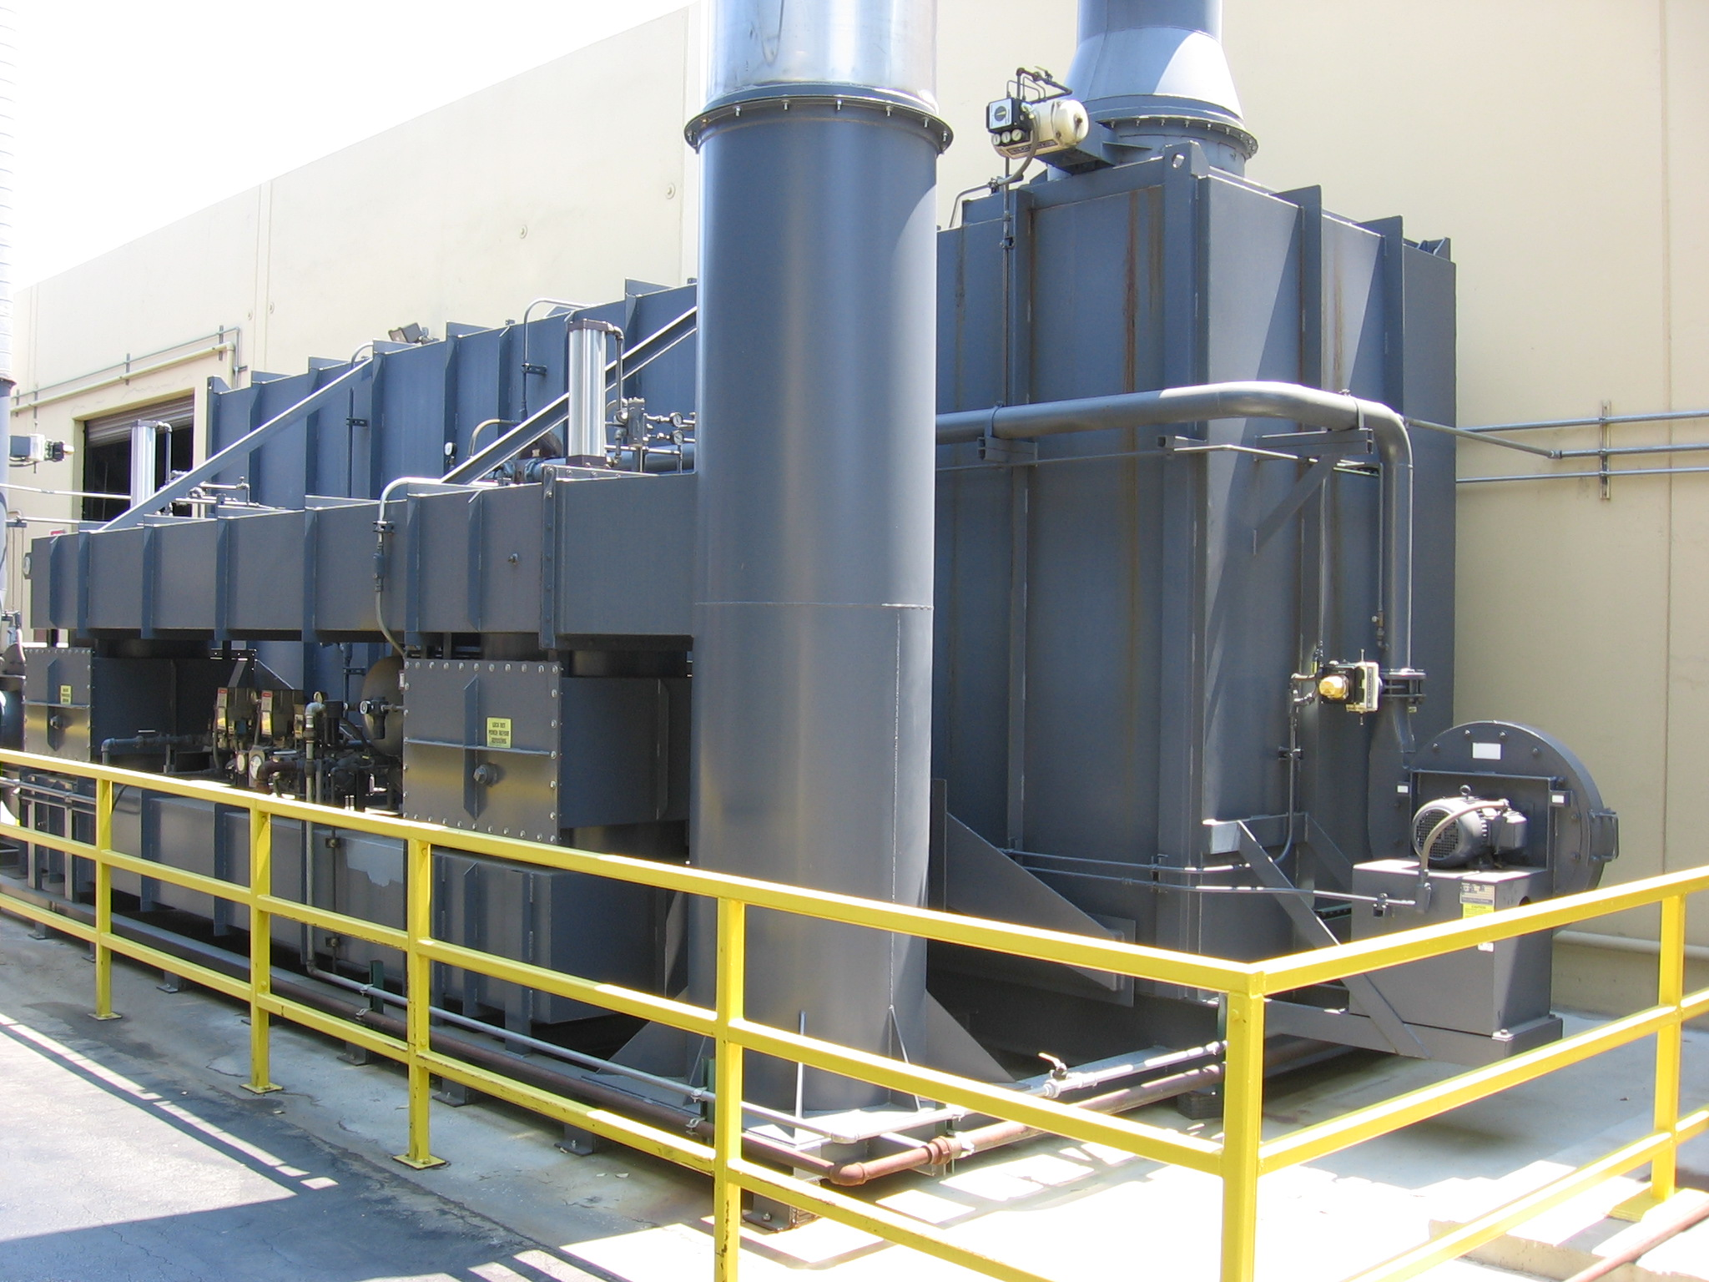
EEA Photograph at M.C. Gill
Figure 8. RTO at SCG Customer Site M.C. Gill
TABC, Inc.
Figure 9. Cutaway View of Three Bed Regenerative Thermal oxidizer

Source: EEA Photograph at SCG Customer Site M.C. Gill
Figure 10. Structured Ceramic Media in Regenerator Bed
Regenerative Catalytic
The regenerative catalytic thermal oxidizer is a more recent addition to the thermal oxidation technologies available. This device is very similar in operation to an RTO, but with a layer of catalyst in the combustion chamber to reduce the temperature required in the combustion chamber and the gas needed to achieve destruction of the VOCs. Both precious metal and metal oxide-based catalysts are presently in use. This technology has only recently been developed, with long term success or failure still to be determined.

Appendix B. Thermal Oxidizer Tool Methodology
A thermal oxidizer heat recovery gas savings calculation tool was developed using Microsoft Excel© as its platform. The tool calculates and documents the annual gas therm savings of the various methods used to improve the performance of fume incinerators. This tool facilitates and documents the following methods of gas savings analyses:
- Calculate the therm savings which will result from retrofitting an existing non-recuperated incinerator with a recuperator
- Calculate the therm savings which will result from retrofitting an existing recuperated incinerator with a more efficient recuperated incinerator
- Calculate the therm savings which will result from retrofitting an existing non-recuperated incinerator with a regenerator system
- Calculate the therm savings which will result from retrofitting an existing recuperated incinerator with a more efficient regenerator system
- Calculate the therm savings which will result from using the VOC stream oxygen for combustion of auxiliary burner fuel for systems currently using an external source of air (i.e., a combustion air blower).
The baseline configuration is before the new recuperator or regenerator is installed, and the new measure configuration is after. In each of the methods, the annual natural gas consumption (assuming full load operation of 8,760 hours per year) is calculated (for baseline and new measure) for each of the flowrates scheduled at Line 14 of the tool. The calculation is made the same way in every case. These theoretical values are compared to the measured natural gas consumption in the base case to ultimately calculate an annual cost savings. The primary variables that have the most influence on the consumption of natural gas are either the heat exchanger efficiency or the exhaust temperature of the thermal oxidizer. The user must specify whether the heat exchanger efficiencies or the thermal oxidizer exhaust temperatures are going to be provided in both the baseline and new measure. In Cases A and C, where the baseline thermal oxidizers are assumed to have no heat recovery, the efficiency of the heat exchanger is fixed at zero. In Cases A and C, where the thermal oxidizer exhaust temperature is specified, it is presumed to be the same as the VOC destruction temperature (see Line 10). The difference in the calculation methodologies between recuperators and regenerators are simply the efficiencies (or the thermal oxidizer exhaust temperatures) that are entered as inputs. Whether external air is or is not being provided for the natural gas burner (and also the amount of excess air) also has a bearing on the results. These variables can be set for both the baseline and measure case as well.
The calculation of the annual cost savings is developed for a case in which the heat exchanger efficiency is specified. Figure B1 presents the variables associated with the calculation of the annual natural gas consumption.
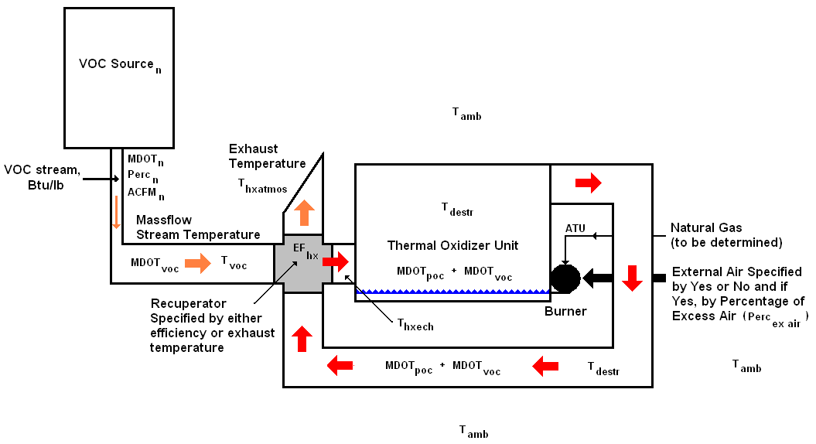
Figure B1. Thermal Oxidizer Schematic
The first equation calculates a value of the thermal energy transferred into the VOC stream by the heat exchanger. As a simplifying assumption, the exhaust stream out of the thermal oxidizer is considered to be a mixture of the products of combustion (POC) and air. To calculate the annual mass flow of the POC, the annual therms are used. The calculation approximates a weighted average mass flow of the CO₂ and the H2₀ that would be the products of combustion. The equation is given by:
MDOT_{poc} = 12.5*ATU_{calc} * 100/13
The annual therms used (ATU) is actually a result of this entire calculation process, therefore the tool must iterate in its calculation of ATU. The mass flow of the VOC stream (MDOT_{voc}) is calculated as follows:
MDOT_{VOC} $=\sum{}$MDOT_{n} * Perc_{n} * 8760
and (by neglecting the density effect of the VOC) the mass flow of the “n^{th}” VOC stream is given by:
MDOT_{n} = ACFM_{n} * 520 * 0.0763 / (T_{amb} + 460)
With these mass flows calculated, the energy transferred into the VOC stream is given by:
Q_{hx} = (MDOT_{voc} * Cp_{air} * ( T_{destr} - T_{amb}) + MDOT_{poc} * Cp_{poc} * ( T_{destr} – T_{amb} ) * EF_{hx}
With the energy transfer calculated, it is now possible to calculate the temperature of the VOC stream emerging from the heat exchanger. This temperature is given by:
T_{hxech} = ( Q_{hx} / MDOT_{voc} * Cp_{air}) + T_{voc} )
The next value to be calculated is the theoretical temperature that the VOC stream would achieve because of the energy value of the VOCs themselves. This temperature is only theoretical because sufficient energy will be added by the natural gas burner for the VOC stream to achieve the VOC destruction temperature. First, the total energy content of VOCs of the exhaust stream leaving the source and entering the thermal oxidizer (HV_{voc}) has to be calculated. If "Type, annual quantity, and heating value" is chosen at line 7, it is given by:
HV_{voc} $=\sum{}$Flow _{n} * Energy Content_{n}
If either of the other choices is made, then Line 12 is the value input at Line 13 (converted from Btu/acf to Btu/lb if necessary) times the annual mass flow of the VOC stream. The theoretical temperature of the VOC stream is then given by:
T_{voctheo} = HV_{voc} / Cp_{air} + T_{hxech}
The next value to be calculated will be the heat exchanger exhaust temperature to the atmosphere:
T_{hxatmos} = T_{destr} - Q_{hx} / ( MDOT_{voc}* Cp_{air} + MDOT_{poc}* Cp_{poc} )
In addition to the above calculated variables, the user is allowed to specify whether or not external combustion air is provided to the natural gas burner. If external air is provided, the percentage of excess air needs to be specified. Using this data as well as the heat exchanger’s exhaust temperature to the atmosphere (T_{hxatmos}), the available heat for the process as a percentage of total heat in the VOC stream can be calculated. If there is no external air provided to the natural gas burner, then the available heat is 100%. If there is external air provided to the natural gas burner, then the amount of available heat is given by the following equation:
AH = 95 – 0.025 * T_{hxatmos}/100 – (-2 + 0.02 * T_{hxatmos} ) * Perc_{ex air}/100
At this point, the natural gas requirement to heat the particular flow in question can be calculated. The natural gas requirements are summed for the five flows scheduled (four at load flows plus the standby flow) to obtain the thermal oxidizer’s total natural gas needs:
HTU_{n} = (T_{destr} - T_{hxech}) * MDOT_{n} * Cp_{air} / 100,000 / AH
And, the annual therms used is given by the equation:
ATU_{calc} = HTU_{n} * Perc_{n} * 8,760
This is the annual therms used presuming an 8,760 hour per year operation. This is also referred to as the theoretical annual therm usage. The user is asked to enter the annual therm consumption of the thermal oxidizer (at Line 6) that was measured or obtained from the Load Balance Tool. This tool compares the calculated annual therm usage with the measured annual therm usage to calculate the thermal oxidizer’s annual operating hours:
Ophours = 8,760 * ATU_{mea}/ ATU_{calc}
If this number varies substantially from what the user knows to be the actual operating hours, there is a problem with other variables such as the quantity or heating value of the VOCs being oxidized. Any number returned here that exceeds 8,760 hours generates an error message.
The annual therms used calculated for the baseline configuration is compared to the annual therms used calculated for the new measure configuration, and the gas savings is calculated as a percentage of the baseline:
GS = (ATU_{calc1} - ATU_{calc2})/ ATU_{calc1}
The annual therms savings is now calculated:
ATS = GS * ATU_{mea}
The annual cost savings is calculated:
CS = GR * ATS
If instead of specifying the heat exchangers by their efficiencies, they are specified by their heat exchanger exhaust temperatures; energy transferred into the VOC stream is given by:
Q_{hx} = MDOT_{voc}* Cp_{air} * (T_{destr} - T_{hxatmos}) + MDOT_{poc} * Cp_{poc} * (T_{destr} - T_{hxatmos})
The balance of the calculations with which to calculate the cost savings proceeds then as above.

Appendix C. Variable List
The following is a reference list of variables used throughout this paper:
ACFM_{n} = Actual cubic feet per minute of the flow into the thermal oxidizer for the percentage of time_{n}
AH = Available heat in the VOC stream
ATS = Annual therms savings
ATU_{calc} = Calculated annual therms used by the thermal oxidizer
ATU_{mea} = Measured annual therms used by the thermal oxidizer
Cp_{air} = Specific heat of air at a constant pressure
Cp_{poc} = Specific heat of the products of combustion at constant pressure
EF_{hx} = Heat exchanger efficiency
Energy Content_{n} = Energy content of a VOCn in Btu/lb
Flow_{n} = Annual flowrate of VOCn in lbs/year
GS = Gas savings calculated as a percentage of the calculated annual therms saved in the “before” case
GR = Gas rate in $/therm
HV_{voc} = Heating value of the VOC
HTU_{n} = Hourly therms used for a given VOC flow
MDOT_{n} = Mass flow of air during time interval n
MDOT_{poc} = Mass flow of the products of combustion
MDOT_{voc} = Mass flow of the VOC stream
Ophours = Calculated operating hours
Perc_{n} = Percentage of time for airflow rate n
Perc_{ex air} = If external air is provided by a blower to the natural gas burner, this is the percentage of external air being provided in excess of that needed for stoichiometric combustion
Q_{hx} = Energy transferred from heat exchanger
T_{amb} = Ambient temperature
T_{destr} = VOC destruction temperature
T_{hxatmos} = Heat exchanger exhaust temperature to the atmosphere
T_{hxech} = VOC stream temperature emerging from the heat exchanger
T_{voc} = VOC stream temperature
T_{voctheo} = Theoretical temperature of the VOC stream based on VOC combustion only

The Clean Air Act Amendments lists 189 "Hazardous Air Pollutants"; of them, 160 are VOCs.
The heat exchanger efficiency is the ratio of the heat transferred from the hot side to the cold side of the heat exchanger to the theoretical amount of heat that would be transferred if the temperature of the hot side mass flow was reduced to the ambient temperature at the heat exchanger’s exhaust.
It is shown below that this particular part of the analysis is intrinsic to each of the four previously listed analyses.
Excel-based program, Load Balance Tool (ver 1.43).xls.
Load Balance Tool, Workpaper, Energy and Environmental Analysis, Inc., April 2006.
Fans are usually specified in actual cubic feet (acf). This tool automatically uses the density at the temperature specified to calculate the actual mass flow rate from the actual cubic feet.
A variable list can be found in Appendix C.
The methodology for calculating the annual natural gas consumption for all of the cases can be found in Appendix B.
The methodology for calculating the annual natural gas consumption for all of the cases can be found in Appendix
The basic information for this section comes from the Energy Solutions Center Description of thermal oxidation processes augmented as noted by other sources.
For convenience, the term VOC is used herein to represent both volatile organic compounds and hazardous air pollutants.
Rich Grzanka, “New Emission Regulation to Change Limits,” Anguil Environmental Systems Inc., PF Online Article.
Stelter & Brinck, product descriptions.
Mike Van Asten & Charles Martinson, “The clock is ticking for paint and coating operations to reduce HAP emissions and meet EPA guidelines,” CMM Group llc, PF Online.
James P. Wikenczy, “ New thermal oxidizer eliminates solvent emissions and reduces operating costs,” TABC, Inc. Long Beach, California, PF Online
RTO Savings Calculator v3_0, December 2006.
This particular part of the analysis is intrinsic to each of the four previously listed analyses.
A variables list is shown in Appendix C.

