QUESTION 1:

The response to TURN DR 1-6 does not include the total procurement cost estimate. Please provide the total procurement cost estimate broken down into major plant equipment, labor, materials, overheads, related fees, contingency, and AFUDC, and reconcile the cost groups to the response to TURN DR 1-6 (e.g., identifying inflation, etc.)

RESPONSE 1:

The response to TURN DR 1-6 was formulated to breakdown costs associated with those in the Aliso Project Design and Description (see Appendix A to the Application at pages 32-33) that represented the EPC costs from the pre-engineering (feasibility study) estimates escalated as appropriate to reflect total project spending. The feasibility study cost breakdown from the consultants by account number is attached. The project costs in the Project Design and Description was developed from the attached estimate and represents a more traditional form of showing engineering, procurement, and construction costs. TURN DR 1-6 was answered by a further itemization of the costs from the Project Design and Description. As can be seen from the attached file, in 2008 dollars, the mark-ups are:

Insurance 1%
Sales Tax 8.25%
Bonds 0.5%
Freight 8.0% of equipment and materials
Spares 1.5% of equipment
Fee 10% of all costs

Also, as indicated in TURN DR 1-6, the dollars are not escalated and are taken directly from the feasibility study attachment. Escalation from the 2008 dollars in the Project Design and Description is calculated by laying out the cash flow in 2008 dollars over the 30 month EPC schedule. Then, based on the year that a particular cost was incurred, it was escalated to reflect spending in that year. Therefore, the $153.2 million in 2008 escalates to $163.9 million in total spending, an average escalation of 7%.

QUESTION 2:

Regarding salvage and cost of removal of the old plant:

  - Please identify the gross salvage, cost of removal, and negative net salvage of the existing system (divided into Accounts 351 and 354) that are contained in SoCal’s capital cost estimate.

  - Identify the amount of cost of removal assigned to each cost element in the construction category of the EPC contract and all other fees and overheads in Question 1-6 and by broader categories in Question 2-1.

  - Explain the methodology SoCal proposes to use to divide the costs of this facility between costs of removal and new capital costs

RESPONSE 2:

The procedure to be used to dismantle the existing Turbine Driven Centrifugal Compressors (“TDCs”) is in the Project Design and Description at page 12. Due to its age and condition, it would be speculative to estimate if anyone will bid on purchasing the existing equipment. Also, the demolition item in the feasibility estimate and account #01 in the previously attached spread sheet does not relate to the existing TDC area but is for the proposed plant area (i.e., culverts, drains, misc. piping etc.).

Any of the unsold equipment and material remaining (e.g., pipe, steel, supports, etc.) removed will be offered for salvage sale. Since we don’t know what the ultimate disposition of these items will be, it is inappropriate to estimate costs/revenue at this time.

Also, it is important to note that customers have already contributed toward paying the cost of removal of the existing compressor in current rates (an estimate of these net costs have already been included in existing rates and charged to customers as part of the negative salvage embedded in the composite depreciation rates for FERC accounts 351 and 354). In addition, customers have also received some of the benefits of any salvage sales associated with the existing compressors when they are removed from service.

Finally, the cost of removal of the existing assets will be tracked separately in construction work orders. Likewise, the cost of the new equipment and installation will also be tracked in separate construction work orders.

QUESTION 3:

Please explain why there are $13.92 million in contractor fees and $4.74 million in additional construction management costs. Explain what value is being added by the construction management services; the basis for quantifying these amounts, and identify who will provide them (SoCal staff, a different contractor, etc.)

RESPONSE 3:

As discussed in the Project Design and Description (at page 34) a third party construction management team will be contracted to oversee costs, schedule, and progress and inform SoCalGas of any pending problems and develop a strategy to rectify. Depending on the final details of the EPC contract, the scope of the construction manager’s responsibility will vary. The reference to a construction manager in the EPC feasibility study is an estimate of an activity not a commitment to the EPC contractor. The contractor’s fee is 10% of all costs (see TURN DR 2-1).

QUESTION 4:

Please provide a complete work plan showing estimated major timelines during the construction process.

RESPONSE 4:

A detailed summary schedule layout is attached, with activities delineated during the 30-month EPC schedule

QUESTION 5:

Please explain why earthwork and concrete expenses of $20 million are required given that SoCal is working with an existing site.

RESPONSE 5:

The existing site, Photo 1 below, contains the administrative and operation offices, parking and equipment. As part of the feasibility study, a preliminary geotechnical study indicated that the area considered for the new facility was not engineered fill. Thus, the existing soil down to bedrock must be removed with a portion reengineered and compacted at the new site to withstand the weight and seismic load of the new equipment. When removing the soil, the existing slope ratio on the north side of the plot cannot be maintained. A retaining wall must be constructed to separate the existing slope from the new plant site, as shown in Photo 2. The cost sheet in response to TURN DR 2-1, including account numbers 03 and 04, shows the cost of the soil excavation and retaining wall.

Photo 1 – Existing Plant Site – New Compressors to be located here.
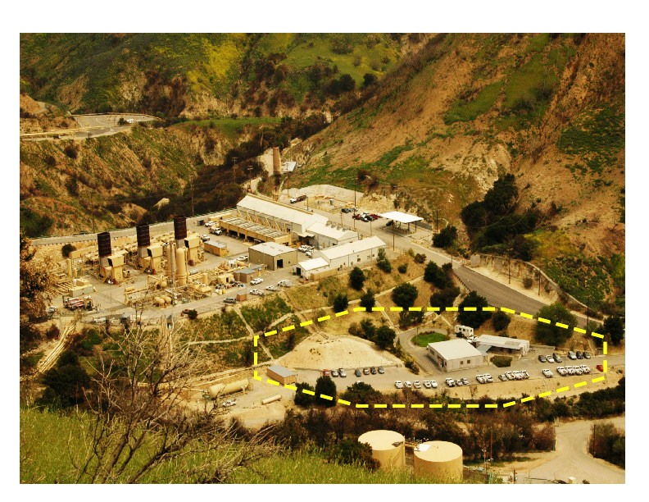

Photo 2 – Artist Rendition of the new compressor station with retaining wall (This is Figure 6 from page 14 of the Project Description).

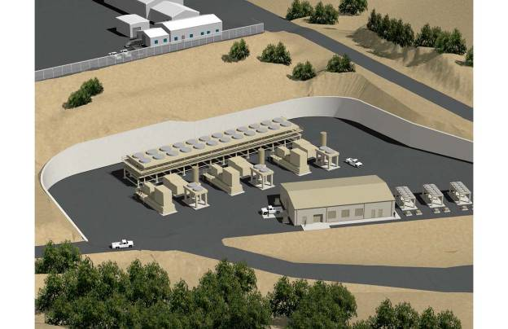

QUESTION 6:

What is the basis of $5.58 million in freight expenses? Provide a further breakdown and identify specific items to which the freight costs apply.

RESPONSE 6:

As referenced in TURN DR 2-1, at the feasibility level, freight is estimated at 8% of equipment and material. This is directly from the feasibility cost estimate account number 22 and is not escalated.

QUESTION 7:

Please identify the amount of contingency requested for this project. Identify the percentages of contingency applied to major plant equipment (each element if different), construction labor, construction materials, and fees (by type if there are differences).

RESPONSE 7:

There is no contingency represented for this project either as a line item, nor applied to any other element of the cost categories.

QUESTION 8:

Please provide workpapers supporting the 1.21% property tax rate that is assumed.

RESPONSE 8:

See attached file.

