QUESTION 1.1:

- Please provide a working electronic copy of every Excel spreadsheet (or other Excel model) that was used in preparing testimony. As used throughout this data request, working Excel spreadsheets contain all data used and all formulas employed to derive the tables and charts shown in the testimony or otherwise support figures stated or conclusions drawn in the testimony. Working Excel spreadsheets contain all links to other Excel spreadsheets in active format.

RESPONSE 1.1:

Attached are the work-papers in Excel format which were used in preparing the testimony of witnesses: Schneider, Rivera, Shepherd and Lenart. Detailed pipeline replacements excel files for witness Rivera are provided electronically on CD due to the size and number of files (100+ files ~270 mb). All other excel files for witness Rivera are provided.

Witness Schneider

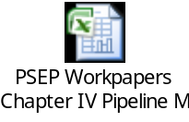

Witness Rivera (pipeline replacement detailed excel files are provided electronically on CD due to the size and number of files (100+ files ~270 mb).

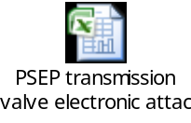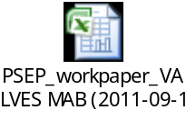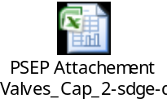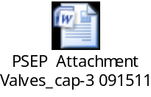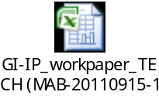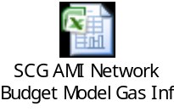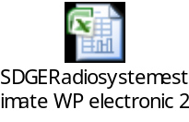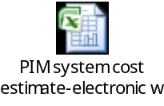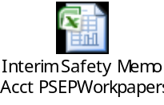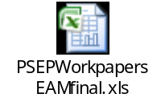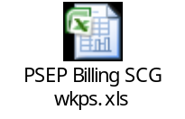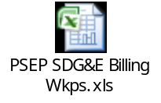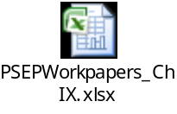
Witness Shepherd

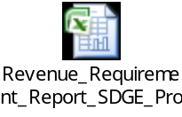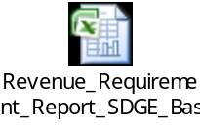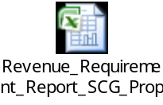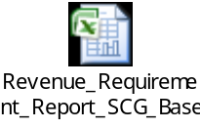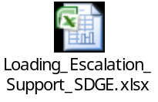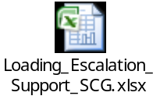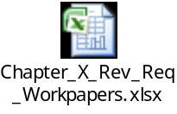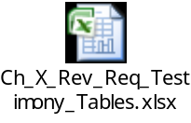
Witness Lenart
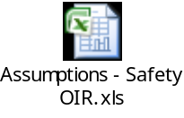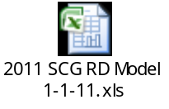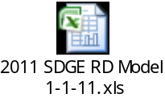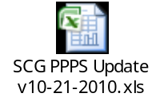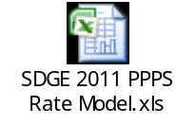

QUESTION 1.2:

- Please provide all workpapers that support this testimony. Please ensure that the workpapers are provided for each table presented in the testimony including those in the appendices.

RESPONSE 1.2:

Workpapers have been provided electronically and on CD. Workpapers are also available at the following links on the SoCalGas and SDG&E websites.

http://www.socalgas.com/regulatory/R11-02-019.shtml

http://www.sdge.com/regulatory/R11-02-019.shtml

QUESTION 1.3:

- Please post all data requests received in this proceeding and the responses to those data requests on SoCalGas’ website including all attachments to those responses. Please post all spreadsheets so provided in active format as defined in Q.1.1.

RESPONSE 1.3:

All data requests that SDG&E and SoCalGas receive for R.11-02-019 will be posted at SDG&E’s and SoCalGas’ website under the webpage “Proceedings Before the California Public Utilities Commission (CPUC)” found at the links below.

http://www.socalgas.com/regulatory/R11-02-019.shtml

http://www.sdge.com/regulatory/R11-02-019.shtml

QUESTION 1.4:

- Please provide a detail explanation of the differences between the pipeline replacement, pressure testing, in-line-inspection work proposed in this application and the “3X2-Transmission Pipelines—Replacements and Pipeline Integrity Management Program (PIP)” that SoCalGas proposes in its general rate case application, A.10-12-005. (For example, see RKS-11 of Ex SCG-5 in the latter proceeding.)

RESPONSE 1.4:

The work proposed in SoCalGas’ Test Year 2012 General Rate Case (GRC) is to meet the requirements of the existing Pipeline Integrity Program (PIP) and related regulations. The work proposed in the Pipeline Safety Enhancement Plan (PSEP) is in response to the Commission Decision D.11-06-017, and is in addition to what was proposed in the TY 2012 GRC.

As stated in Chapter 10 Section C.2.E:
“Our 2012 General Rate Case Applications are currently before the Commission and are not reflected in this filing.”

Although, pressure testing, replacement or in-line inspection of a pipeline is fundamentally the same between the two proceedings, in preparing the PSEP, care was taken to leverage the PIP work contained within the GRC, and optimize work within the PSEP. For example, pipelines that have been or will be in-line inspected (re-assessed) as part of the GRC are not forecast to be retrofit as part of the PSEP, and only the additional costs associated with the incremental use of a transverse flux inspection (TFI) tool are forecast as part of the PSEP. As stated in Chapter 9 section B.2.:

“During the re-assessment, in addition to running the MFL tool, a transverse flux in-line inspection (TFI) tool will also be utilized to allow for evaluation of the condition of the long seam as well.”

The costs associated with the reassessment (including tool launching and receiving, cleaning tools, and standard corrosion inspection tools) are included in the GRC. The incremental inspection costs associated with the TFI tool are included in the PSEP. The use of the TFI tool was not forecast as part of the GRC.

Similarly, the costs for pressure test forecast as part of the PSEP were not forecast in the GRC.

The replacement costs forecast in the GRC are for the retrofit of pipelines to allow the use of in-line inspection tools and associated validation excavations and repairs. The PSEP does not include retrofit or repairs associated with the baseline or reassessment of pipelines.

QUESTION 1.5:

- Comparing the mileage presented in Table IV-5 to the cost projections shown in Appendices B and C under Pipeline Replacement:

  - Please state in detail the assumptions that SoCalGas relied upon in developing the cost figures.
  - Did SoCalGas assume that each pipeline that was tested had to be replaced?
  - If the answer to the previous question is “no,” please state what percentage of the pipelines tested SoCalGas assumed would require replacement and explain how SoCalGas developed its assumption.
  - Did SoCalGas use a $/mile replacement cost assumption for projecting costs?
  - If the answer to the previous question is “yes,” please provide the data or study that SoCalGas relied upon to develop the $/mile replacement cost figure.
  - If the answer to the question preceding the prior question is “no,” please explain in detail how SoCalGas developed its pipeline replacement costs figure for each year.

RESPONSE 1.5.1:

Appendix E – Pipeline Replacement Estimate Assumptions provides the detailed assumptions used to develop the estimated cost figures for pipeline replacements.

RESPONSE 1.5.2:

No

RESPONSE 1.5.3:

None of the pipelines identified for pressure testing were forecast to be replaced.

Assumptions used to develop estimates for pipeline replacements were developed in accordance with the decision tree shown in Figure IV-1. There are three outcomes that identify replacement exclusively:

- Replacement of pipelines segments that satisfy NTSB criteria, are longer than 1000 ft., cannot be removed from service to allow for pipeline work, and are unpiggable (Replace and Abandon – box 2),
- Replacement of pre-1946 pipeline segments that satisfy NTSB criteria, are longer than 1000 ft., can be removed from service to allow for pipeline work, and are unpiggable (Note 1 of box 4),
- Replacement of pre-1946 pipeline segments in unpopulated areas that are unpiggable (Replace - box 7).

RESPONSE 1.5.4:

No, an assumed $/mile value was not used when projecting replacement costs. SPEC Services provided SoCalGas with pipeline specific replacement cost estimates as well as a broader cost estimating matrix. Each of these methodologies was employed to develop the replacement costs included in the filing.

RESPONSE 1.5.5:

N/A

RESPONSE 1.5.6:

The methodology used to forecast pipeline replacement costs are discussed in Chapter 9, section B.1.b. and appendix E.

SPEC Services provided SoCalGas with numerous pipeline specific replacement cost estimates. These estimates were used in the development of Phase 1A costs to replace pipeline segments that do not have sufficient documentation of pressure testing to meet the requirements set forth in D.11-06-017 and could not be taken out of service for pressure testing.

To formulate these estimates, SPEC Services obtained material cost quotes from suppliers. Construction costs are based on recent construction estimates and/or bid data from other SPEC Services projects. SPEC studied maps and aerial photos of the pipelines in order to distinguish between various construction labor types for segments along the route. One of seven different Construction Types was assigned based on the relative complexity of the construction effort in that area. No engineering was completed in preparing the estimates. Material take-offs were developed assuming the replacement pipe would parallel the existing pipe. Actual material take-offs would be developed after detailed engineering is performed on pipe routing.

Further detail on the cost estimating methodology can be found in Appendix E of the testimony and the pipeline cost estimates can be found in Appendix IX-1-A and Appendix IX-1-B of the workpapers.

SPEC Services also provided SoCalGas with a replacement cost estimating matrix that considers replacement length and pipeline diameter to arrive at a replacement cost per foot. This cost matrix was used in the development of Phase 1B costs to replace pre-1946 non-piggable pipeline segments. Further detail is provided in the workpapers supporting Chapter IX of the Testimony, beginning on page WP-IX-1-44 and ending WP-IX-1-56.

QUESTION 1.6:

- Considering the “Mitigation of Pre-1946 Construction Methods” category shown in Appendix B:

  - Does this category include replacing the pre-1946 pipes or “surgical replacement of oxy-acetylene girth welds and wrinkle bends” or other activity?
  - If the answer to previous question is “other activity,” please define the other activity in detail.
  - Why should SoCalGas’ ratepayers pay $1.08 billion to mitigate pre-1946 construction methods” when they will also pay for $818 million in pipeline replacement that is expected to replace pre-1946 pipelines?

RESPONSE 1.6.1:

This category reflects both the surgical replacement of oxy-acetylene girth welds and wrinkle bends on piggable pipelines, as well as the replacement of unpiggable pre-1946 pipelines that are located in unpopulated areas,

RESPONSE 1.6.2:

N/A

RESPONSE 1.6.3:

The $1.08 billion for “Mitigation of Pre-1946 Construction Methods” piping is above and beyond the $818 million estimated for “Pipe Replacement”. The scope and cost estimates for these two categories are mutually exclusive.

